**VLF and gravity signatures of the chromite ore in Jacurici Valley, northeastern of Bahia state, Brazil**

Vito Varjão Freire Clavijo¹, Joelson da Conceição Batista¹, Marcos Alberto Rodrigues Vasconcelos¹, Florivaldo Oliveira Sena³, José Haroldo da Silva Sá¹, Eduardo Henrique Rodrigues Pereira², ¹Universidade Federal da Bahia, ²Companhia de Ferro Ligas da Bahia, ³ServiGeo Geologia e Geofísica Ltda.

Copyright 2023, SBGf - Sociedade Brasileira de Geofísica

This paper was prepared for presentation during the 18th International Congress of the Brazilian Geophysical Society held in Rio de Janeiro, Brazil, 16-19 October 2023.

Contents of this paper were reviewed by the Technical Committee of the 18th International Congress of the Brazilian Geophysical Society and do not necessarily represent any position of the SBGf, its officers or members. Electronic reproduction or storage of any part of this paper for commercial purposes without the written consent of the Brazilian Geophysical Society is prohibited.

# Abstract

Chromium, an essential raw material for several steel products, is the subject of extensive exploratory research. The Jacurici Valley in Bahia is known worldwide as one of Brazil’s most promising areas for exploting this metal. This research is part of a joint effort established by UFBA and FERBASA to identify typical geophysical signatures related to the chromite ore in the Jacurici River Valley. This work applied the Very Low Frequency (VLF) and gravimetric methods to provide the geophysical signatures expected for the chromite ore. The mentioned geophysical information was used together with geological information and a description of drill cores to support their interpretation. Thus, VLF data showed that the ultramafic rocks that host the chromium mineralization depicts a conductive signature, and gravity data depicts a lower-density signature

# Introduction

The study area is located in the mining region of the Companhia de Ferros Ligas da Bahia (FERBASA), within Jacurici’s Valley, covering the municipalities of Queimadas, Cansanção, Andorinha, Monte Santo, and Uauá, all belonging to the state of Bahia, Brazil (Figures 1 and 2). This region is famous for containing occurrences and deposits of chrome.

The first exploration of chrome deposits in Jacurici Valley began to be mined initially in 1977 by FERBASA. The chromiferous district of Jacurici Valley consists of an elongated strip running north-south, about 100 km long. Laterally, this strip is 10 km wide and follows the contour of the Jacurici River Valley. The localization of deposits explored is on the western edge of the Serrinha block. Its main east and west limits are Sergipe fold belt and Salvador-Curaçá belt (Barbosa, 1997). According to information from FERBASA, mafic and ultramafic rocks have been confirmed from boreholes to the south of Ipuera mine. According to Almeida et. al (2017), these rocks could have irregular distribution but must follow a north-south direction. The mafic bodies that harbor chromite mineralization are originated from a sill and are intruded in metamorphic supracrustal rocks, such as gneisses, amphibolites, marbles and diopsidites .

The main chromite deposits of the Jacurici Valley are located in the Ipueira – Medrado sill, which consist of a layered mafic-ultramafic intrusion with a thickness of approximately 124 m (Barbosa de Deus and Vianna, 1982). From the base to the top, dunite (serpentinite), peridotite, pyroxenite and gabbro are constituted. The main ore body has an average thickness of 5-8 m of mostly massive chromite embedded in peridotite (harzburgite)

Therefore, this research combined Very Low Frequency (VLF) and gravimetric methods to characterize the country rocks were the chromite ore is located.

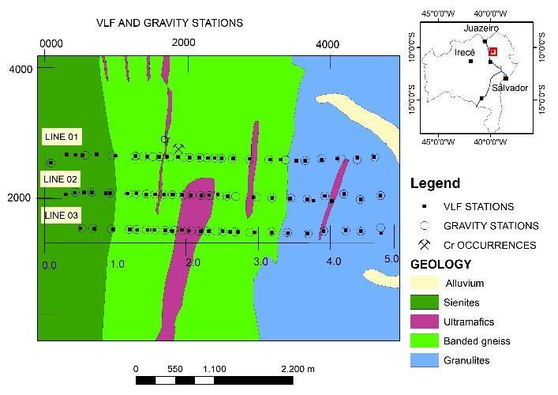

**Figure 1:** Simplified geological map with location the VLF and gravimetric stations

**Methodology**

VLF and gravity stations were acquired along three E-W lines that cross the N-S regional trend of the geological unities. (Figures 1). The gravimetric method was employed due to the density difference of ultramafic rocks about the bodies' surroundings, helping to delimit domains. In contrast, the VLF method was employed to detect and locate vertical and sub-vertical fractures and faults at moderate depths, helping to delimit lateral resistivity variations (Telford et al., 1976; Ward & Hohmann, 1988). Finally, the data were collected, processed and interpreted throughout three lines (Figure 1), and surface geological information supported the interpretation of this research.

*Gravimetric Method*

The gravitational acceleration field (*g*), created by a body with a mass equal~~s~~ *m*, measured at any point *P*, can be calculated through the expression:

$g\left(P\right)=-γ\frac{m}{r^{2}}\left(1\right)$,

where *r* is the distance between the point P and the mass *m*.

Relative gravimeters are generally used in gravimetric surveys. They can measure only the vertical component of *g*, considering the vertical distribution of the density in materials in the subsurface. For this reason, a more general form of Equation 1 will be given by (Blakely, 1996):

$g\left(x,y,z\right)=-γ∭_{V}^{}ρ\left(x´,y´,z´\right)\frac{z-z´}{r^{3}}dx^{'}dy^{'}dz'\left(2\right)$

where, ρ is the volumetric density distribution of a body with volume V. From Equation 2, one can construct models that reflect the geometric feature characteristics and the density distribution within an environment. Therefore, gravimetric modeling involves the construction of a geophysical model that produces a gravimetric response that most closely approximates field measure data and that reflects the density distribution and geometry of the crossed subsurface bodies by the survey profile coherently.

According to Blakely (1996), the gravimetric field generated by any region, divided into N-parts, can be obtained through the expression:

$g_{m}=\sum_{n=1}^{N}{}ρ_{n}φ_{mn}\left(3\right)$,

where, $g_{m}$ is the measured field in the point *m*, $ρ_{n}$ is the density of the sub-region n, and $φ_{mn}$ is the gravimetric attraction in the point *m*, due to volume *n*, with unity density

*Bouguer Anomaly*

Observed gravity ($g_{obs}$) is a sum of many gravitational contributions from underground sources, such as terrain altitude, latitude, mass of rocks in the region, etc. These contributions must be identified and subtracted to obtain only the contributions in the field caused by the studied lithological variation.

Therefore, performing the latitude, free air, the Bouguer correction and subtracting these quantities from the observed gravity, we arrive at the so-called Bouguer anomaly (Equation 4)

$∆g_{B}=g_{obs}-g_{φ}-g_{FA}-g_{B}\left(4\right).$

These corrections are made in our data and the results can be visualized in Figure 5.

*VLF method*

The VLF is an electromagnetic (EM) geophysical survey method that uses high-power transmitting antennas worldwide as a signal source. This source generates EM spherical fields. In cases where their reception is carried out at a sufficiently large distance, such spherical wavefronts will behave and be recorded as plane wavefronts.

The EM signal travels between the subsurface and the ionosphere and can be reflected in it, penetrating and propagating in the Earth’s subsurface. The presence of conductors bodies in the subsurface will induce an electrical current flow, and this current, in turn, will generate a secondary field that the VLF receiver can detect. From that, you can detect and locate the presence of bodies with more or fewer conductors, vertical or sub-vertical fractures, and failures in moderate depths, delimiting lateral resistivity variations.

*Elliptical Polarization*

A primary EM field, emitted by a source, which propagates inside the earth when interacting with a conductive body in the subsurface, causes the appearance of an electric current in that body. The current will create a new magnetic field, called a secondary field, and vectors of primary and secondary fields can be interpreted as minor and major axes or a polarization ellipse formed from the polarization of these fields, being calculated by the following expression (Stratton, 2007):

$\frac{X^{2}}{H_{x}^{2}}+\frac{Z^{2}}{H_{z}^{2}}-2\frac{XZcos\left(∆φ\right)}{H_{z}H_{x}}=sin\left(∆φ\right)$ (5).

The ellipsoid described by equation 5 has two axes; each axis has a measure equivalent to the module of one of the fields (primary and secondary). The angle that one of these field vectors forms with the x-coordinate axis is called tilt angle (α) and can be calculated by the expression:

$α=±\frac{1}{2}\tan^{-1}\left[\frac{2\left(\frac{Hz}{Hx}\right)cos⁡\left(∆φ\right)}{1-\left(\frac{Hz}{Hx}\right)²}\right]\left(6\right).$

The ratio between primary and secondary fields is called Ellipsity (ε) and can be calculated through the expression:

$ε=\frac{H_{2}}{H_{1}}=\frac{H_{z}H_{x} sin⁡\left(∆φ\right)}{|H_{x}e^{i∆φ}sin\left(α\right)+H_{x}cos⁡\left(α\right)|²}\left(7\right).$

Equations 6 and 7 can be rewritten in function of the real and imaginary parts of the vertical magnetic field (Hz). The tilt angle and the Ellipsity can be related respectively to the real and imaginary components of the vertical magnetic field if $H_{z}$ << $H_{x}$. Therefore, for fields with that characteristic we can still rewrite equations 6 and 7, as the following approximations:

$α=±\frac{1}{2}\tan^{-1}\left[2R\left(H_{z}\right)\right]\left(8\right),$

$ε=I\left(H_{z}\right)\left(9\right).$

This approximation shows that the tangent of the Tilt Angle is proportional to the real component of the vertical field. In addition, there is also a correspondence approximation between Ellipsity and the imaginary component of that field.

*Fraser Filtering*

The Fraser filter (Fraser, 1969) applied in Tilt Angle data was used, and the results can be seen in Figure 2. This filter converts the crossover points of the Tilt Angle to positive anomalies, giving the interpreter a more accurate sense of the position of the anomalous conducting body in space. It means that in Figure 2, the hotter color, most conductive are the sources. The Fraser filter on a map can also provide preliminary information regarding the intensity of the current anomaly relative to neighboring bodies.

*Karous & Hjelt Filtering*

Using the methodology proposed by Karous and Hjelt (1983), we can generate pseudosections of Tilt Angle VLF data (Figure 3).

This filter methodology consists of using the Biot-Savart Law that transforms the magnetic field (b) collected into values of surface density of electric current (j). These results are arranged in a pseudosection format and this allows a better visualization and interpretation of the zones with more presence or absence of these current flows (Equation 10).

$b\left(r\right)=\frac{μ_{0}}{4π}\int_{C}{}\frac{j\left(r^{'}\right)×u_{r}}{r^{2}}dl\left(10\right),$

where, $u_{r}$ is the unit vector of *r’, dl* is the vector along the path *C*, and $μ_{0}$ the magnetic constant.

VLF method does not directly measure absolute values ​​of resistivity or electrical conductivity. This method provides the relative values of apparent conductive/resistivity areas. In other words, the hotter color, most conductive are the sources (Figure 3).

**Results**

After the respective processing for each data, we have interpolated them to analyze the outcomes through maps and sections. The VLF data, for example, are presented in terms of Tilt Angle data, whereas the gravity data is presented in terms of Bouguer anomaly.

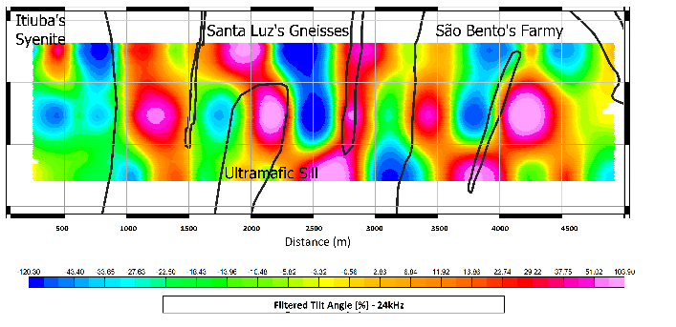

**Figure 2**: Map of theFraser filter applied in VLF data

The data depict an agreement between higher values of the VLF data after the application of the Fraser filter and the geological contact Santa Luz gneiss/Itiuba syenite. It means that the contact between both geological units is clearly conductive.

The ultramafic rocks at the center of the area present an apparent conductive anomaly that disagrees with the country rocks. This was expected since rocks containing more ferromagnesian (ultramafic) minerals tend to be more conductive than rocks with a higher predominance of siliceous minerals.

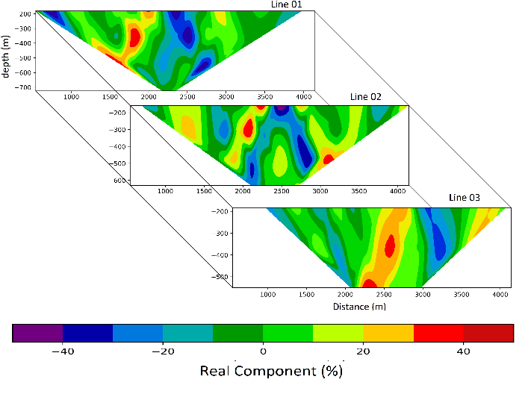

**Figure 3:** Pseudosections of Karous & Hjelt Filter in VLF data

The results obtained through Karous-Hjelt filtering show a conductive anomaly at the innermost area that dips westwards with values ranging between 10% and 40% (Figure 4). This anomaly is present in Line 1 at 400 m depth, Line 2 at ~300 m depth , and in Line 3 slightly shifted at ~500 m depth. It is not possible to confirm whether this conductive anomaly consists of a single source. However, it is expected a promising contrast between mafic rocks, which are usually more conductive, and felsic rocks.

All pseudosections show a less conductive zone, at ~2500-3000 meters from the origin, with real component ranging between -40% and -10% dipping eastwards.

*Gravity data*

From the left to right, the Bouguer map clearly shows the apparent contact between the Itiuba syenite (less dense) and the Santa Luz gneiss (denser) (Figure 4)

The ultramafic sill that contains the chromium mineralizations, localized at the center, shows intermediate gravity values, which contrasts with the surrounding gneiss rocks. Despite mafic/ultramafic rocks are usually denser than gneiss, the sill of Jacurici Valley has several occurrences of lower-density marbles, and also undergone an accumulation of fluid and subsequent serpentinization.

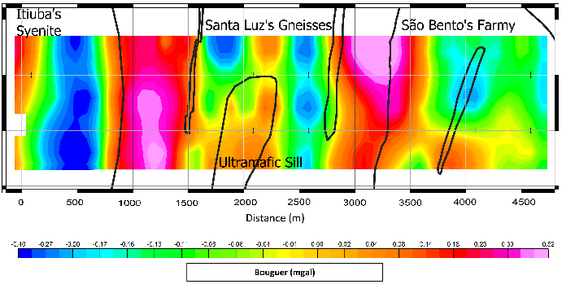

**Figure 4:** Map of theBouguer anomaly.

*Gravity forward modeling*

As a final tool for the proposed interpretation, gravity modeling of the three lines of gravimetric measurements through the GM-SYS extension of the Oasis Montaj by Geosoft inc. The results of these modeling and the geological domains interpreted can be seen in Figures 6, 7 and 8. This procedure of modeling was based on the use combined with the information obtained through filtering Karous & Hjelt VLF data, already discussed in Figure 3.

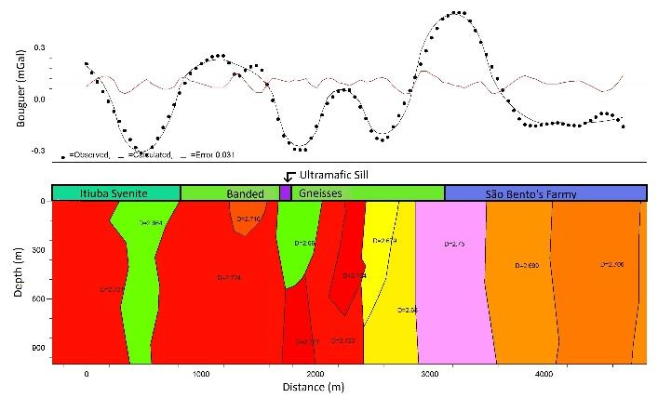

**Figure 5:** Forward gravity modeling along Line 01

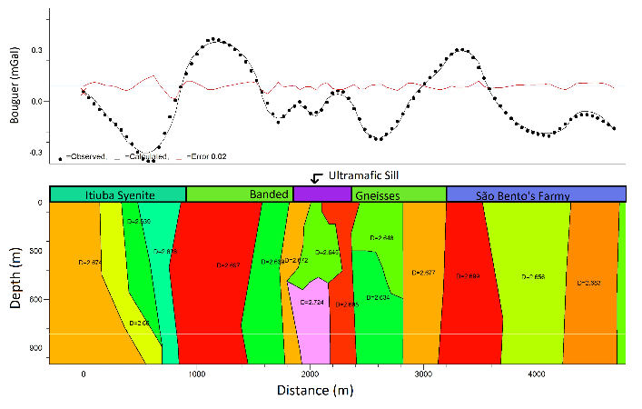

**Figure 6:** Forward gravity modeling along Line 02

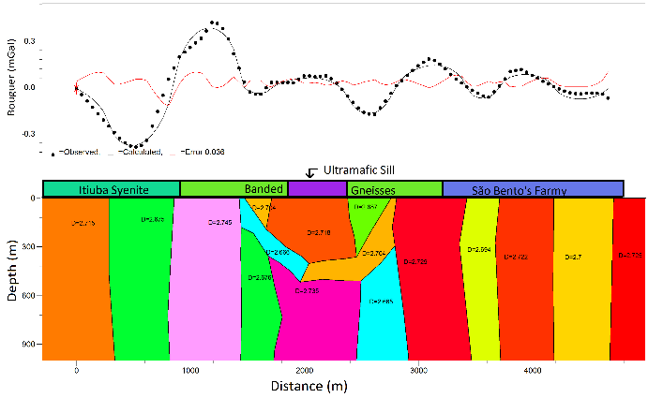

**Figure 7:** Forward gravity modeling along Line 03

Comparing the VLF pseudosections with the knowledge surface geology of the region, there was a positive spatial correlation between the conductive anomalies and the ultramafic rocks of the Jacurici Valley sill (approximately 2000 m from the origin of the horizontal axis). This spatial correlation took place in a more coherent way in Lines 01 and 02. Based on this understanding, gravity modeling was developed using VLF pseudosections as a starting model. Thus, we used the geometry of the conductive sources found from VLF sections to support the initial gravimetric model. Considering that the study area has a strong lithological variation in the east-west direction, the rest of the model was represented by verticalized dykes with different densities.

Based on these definitions, we proceeded with the model fit, which refers to adjusting of calculated data to those observed in the field. the large lateral density variability, resulting in RMS fit error values ​​of 0.031, 0.02 and 0.036 for lines 01, 02 and 03, respectively (Figures 5, 6 and 7). Also, all profiles show lower Bouguer values ​​at the center, which agreed with the hypothesis of serpentinized ultramafic rocks. In fact, geological mapping and descriptions of drill core show that the chromite mineralization is localized in the center of the profiles.

As mentioned, the westernmost part of the study region belongs to the domain of Itiúba syenite. For this reason, the westernmost blocks of the data were modeled using typical densities of such sort of rocks.

For this research, we used the geometry provided by the VLF Karous & Hjelt Filtering to model the bodies involving the mineral of economic interest. It was noted, however, that the VLF anomalies coincides with areas with lower gravity anomaly.

Such low gravity signature allows us to interpret that the ultramafic rocks underwent some hydrothermal process. This hypothesis would be a possible explanation for the ultramafic model source showing densities of approximately 2.65 kg/cm3. The authors Almeida et al. (2017) propose that the ultramafic sill, which hostel the chromium mineralizations, is composed of serpentinized rocks and consequently of low density.

**Conclusions**

Our data show conductive sources in VLF data, which coincides with lower gravity signatures and might be associated with ultramafic rocks, where the chrome ore is found. Through the description of drill cores, such rocks are comprised of serpentinized ultramafic rocks, which is a hydrothemal process that tends to reduce the density of the rocks. The joint analysis of our data allows us understand that both geophysical methods were capable of distinguish the country rocks that contain chromite mineralization.

# Acknowledgments

The authors would like to thank FERBASA for financial support and the Center for Research in Geophysics and Geology at UFBA (CPGG-UFBA) for the logistical support, both essential, to carry out of this project.

**References**

de Almeida, H. L., Cabral, E. B. & Bezerra, F. X.,  
2017. Evolução deformacional das rochas do vale do  
jacurici: implicações para a estruturação dos corpos  
cromitíferos máfico-ultramáficos, Geologia USP. Série Científica, vol. 17(2): 71–88.

Barbosa, J. S. F., 1997. Síntese do conhecimento  
sobre a evolução geotectônica das rochas metamórficas arqueanas e paleoproterozóicas do embasamento do cráton do são francisco na bahia, Brazilian Journal of Geology, vol. 27(3): 241–256.

Barbosa de Deus, P. e Viana, J. d. S. (1982) Jacurici Valley chromite district, In: Internacional. Symposium on Archean and Early Proterozoic Geologic Evolution and Metalogenesis, Salvador, 1982. Abstracts and Excursions. Salvador, SBG/CPM, pp. 97–107.

Blakely, R. J., 1996. Potential theory in gravity and  
magnetic applications, Cambridge university press

FRASER, D., 1969. Contouring of vlf-em data, Geophysics, vol. 34(6): 958–967.

Karous, M. & Hjelt, S., 1983. Linear filtering of vlf dip-angle measurements, Geophysical prospecting, vol. 31(5): 782–794.

Stratton, J. A., 2007. Electromagnetic theory, vol. 33, John Wiley & Sons.

Sundararajan, N., Ramesh Babu, V., Shiva Prasad, N.  
& Srinivas, Y., 2006. Short note: Vlfpros-a matlab code  
for processing of vlf-em data, Computers & Geosciences,  
vol. 32(10): 1806–1813.

Telford, W., Geldart, L., Sheriff, R. & Keys, D., 1976.  
Applied geophysics, cambridge univ, Press, NY: 1–860.  
Ward, S. H. & Hohmann, G. W., 1988. Electromagnetic  
theory for geophysical applications, in: Electromagnetic  
Methods in Applied Geophysics: Voume 1, Theory, Society of Exploration Geophysicists, 130–311.