**Laboratory Measurements of the Biot Coefficient of a Pre-salt Oil Field, Santos Basin**

Marcio Morschbacher, Guilherme Vasquez, Julio Justen, Marcos Figueiredo, Flavia Falcão, Ana Lucia Maria (Petrobras)

Copyright 2023, SBGf - Sociedade Brasileira de Geofísica

This paper was prepared for presentation during the 18th International Congress of the Brazilian Geophysical Society held in Rio de Janeiro, Brazil, 16-19 October 2023.

Contents of this paper were reviewed by the Technical Committee of the 18th International Congress of the Brazilian Geophysical Society and do not necessarily represent any position of the SBGf, its officers or members. Electronic reproduction or storage of any part of this paper for commercial purposes without the written consent of the Brazilian Geophysical Society is prohibited.

# Abstract

The Biot’s coefficient is an important parameter in geomechanical models of hydrocarbon reservoirs, with direct influence over the stress distribution in space and time during the production history. We measured the Biot Coefficient of rock samples from a Santos basin oil field through stress-strain experiments. We observed good correlations between these quasi-static measurements and the estimates from dry rock ultrasonic elastic velocities. There are also good correlations between the Biot’s coefficients and the effective porosity of the rocks, as well as with the acoustic impedances. These results suggest the feasibility of deriving poroelastic parameter logs in well locations, which can be used for geostatistical interpolation between wells and used to build more accurate reservoir geomechanical models, or even generate a tridimensional distribution based on acoustic inversion of seismic data. In this paper we will present our measurement methods, discuss our results and draw some comments, conclusions and recommendations for future developments.

# Introduction

The Biot’s coefficient (Biot, 1941; Biot and Willis, 1957) is defined as:

|  |  |
| --- | --- |
| $$α=1- \frac{K_{b}}{K_{m}}$$ | (1) |

It is an important parameter for geomechanical models because it defines the effective stress that acts on the rocks and governs its elastic moduli: $σ_{ef}= σ- α P_{p}$.

There are other relevant applications of the Biot’s coefficient in geophysics as well, in seismic production monitoring, for instance.

In soil mechanics, the effective stress is simply the difference between external stress and pore pressure ($σ_{ef}= σ- P_{p}$). Thus, any increase or decrease in fluid pressure is equivalent to an equal increase or decrease in external or confining stress.

However, in consolidated rocks, due to cementation, pore geometries and other factors, not all the variation in pore pressure is transferred to the effective stress. For these rocks the effective stress is the difference between the external stress and the pore pressure weighted by a factor α, the Biot coefficient ($σ_{ef}= σ- α P_{p}$).

In equation (1), $K_{b}$ is the bulk modulus of the rock, which gives the resistance of the rock to hydrostatic stress variations, while $K_{m}$ is the bulk modulus of the solid fraction, including grains and cement materials.

It is important to note that the moduli of rocks with low Biot’s coefficient is less sensitive to pore pressure variation. Thus, in a reservoir with low Biot’s coefficient, the risk of geomechanical issues with injection or depletion may be much lower compared to unconsolidated rocks.

Laboratory measurements of the Biot coefficient is not so common because the solid fraction bulk modulus is difficult to measure due to the low matrix compressibility. Thus, very low strain values are involved in the usual stress-strain relations:

|  |  |
| --- | --- |
| $$K= \frac{Δσ_{ii}}{ε_{v}}$$ | (2) |

These values are generally in the limit of sensors (strain gages) sensitivity.

Rock bulk modulus may be easily and accurately evaluated in experiments with hydrostatic stress variations (with constant pore pressure). The matrix bulk modulus measurements are possible with hydrostatic stress variations as well, but with unjacketed rock samples, so that the confining and pore pressures are identical and vary exactly the same amount, so that only the solid phase of the rock will deform.

Experiments involving stress-strain measurements are known as static or quasi-static measurements, because the frequency of the stress (and strain) changes is very low, even in cyclic stress variation protocols.

If the rocks can be considered as elastic and isotropic media, the drained rock bulk modulus could be estimated from elastic-wave velocities measurements in dry rock samples, because:

|  |  |
| --- | --- |
| $$V_{P}=\sqrt{\frac{K+ \frac{4}{3} μ}{ρ}}$$ | (3) |
| $$V_{S}=\sqrt{\frac{μ}{ρ}}$$ | (4) |

This kind of estimate is referred as dynamic bulk modulus, because it involves the propagation of relatively high frequency pulses, or oscillations, through the rock (e.g., 800 kHz).

One alternative to evaluate the solid fraction bulk modulus is the use of reference tables, compositional information, and some averaging scheme, as the Voigth-Reuss-Hill average, for instance.

We present results of real laboratory measurements of the Biot coefficient for the reservoir rocks of one oil field from the Brazilian Pre-salt, Santos basin. We compare the experimental results from stress-strain experiments with those derived from velocity propagation measurements and we propose some schemes to derive the Biot’s coefficient from elastic logs (sonic and density) and compositional information. This procedure may give a detailed and high-resolution Biot’s coefficient input to geomechanical models.

# Sample Selection

We made this study to check the feasibility of obtaining good Biot’s coefficient measurements and evaluate if it may be related to other properties which are easier and faster to measure, as the dynamic bulk modulus, porosity or impedance.

We selected eleven samples from two wells of the oil field of interest, all from the Barra Velha Formation (which is the main reservoir unit of the field) with one exception from the very top of Itapema Formation.

This selection was strongly based on sample homogeneity, porosity, permeability, and the fact that we observed good waveforms on these rock samples in previous dry rock velocity measurements. Moreover, we have good compositional control of these samples based on X-ray diffraction analysis (XRD).

Sample properties and compositional information are listed in tables 1 and 2.

Table 1: Facies, zone and composition of the samples used in this study.



Table 2: Petrophysical properties of the samples used: matrix density rm, porosity f, permeability k and dry bulk density rd.



# Measurement Method

We made all the necessary measurements in a commercial equipment, AutoLab1000 (made by New England Research Inc.). This system allows to measure one compressional and two shear-wave velocities propagating along the symmetry axis of the cylindrical core plugs, as well as hydrostatic stress-strain measurements with the aid of resistive strain-gages.

The nominal average frequency of the ultrasonic pulses used in velocity measurements is around 750 kHz. Based on velocity measurements on reference materials and repeated measurements on rocks we estimate that the uncertainty of our dynamic results is below 2% in usual situations.

The samples were jacketed with a copper foil to isolate the pore space from the confining fluid. We attached two horizontal and two vertical strain gages in each sample. First, we measure the dry rock velocity and the dry rock bulk modulus with quasi-static oscillations of the confining stress according to a jigsaw function. We measured the velocities and dry rock bulk modulus from 1000 to 6500 PSI (6.89 to 44.82 MPa) with 500 PSI (3.45 MPa) steps.

After the dry rock experiments for each sample, we saturate the sample with the confining oil (OMA mineral oil) and measured the velocities and drained bulk modulus with the pore pressure generally fixed at 0.5 MPa. In order to measure the matrix bulk modulus, we opened the pore pressure to the confining pressure vessel, detaching the pore pressure tubes. Thus, the pore pressure and confining pressure are totally communicated.

We experimented several stress variation amplitudes. Most experiments were done with a 4 MPa amplitude.

As we had attached two vertical and two horizontal strain-gages to the samples, we made some estimates of bulk modulus measurement uncertainties based on all possible combination of strain gages.

We estimated the dry rock (dynamic) bulk modulus from the velocities:

|  |  |
| --- | --- |
| $K_{d}= ρ_{d} \left(V_{P}^{2}- \frac{4}{3} V_{S}^{2}\right)$ | (3) |

To estimate the dynamic Biot’s coefficient, we calculate the matrix bulk modulus from the XRD composition and reference tables for mineral bulk modulus using the Voigth-Reuss-Hill averaging scheme. We estimate an uncertainty for the results based the different values observed in a compilation of data from the literature, according to Wang (2000), Mavko et al. (2009) and Schön (2011). These values are listed on Table 3.

Table 3: Mineral bulk modulus with uncertainty estimated from different reference publications (see text).

|  |  |  |
| --- | --- | --- |
| Mineral | Bulk Modulus (GPa) | Density (g/cm3) |
| Calcite | 70 ± 7 | 2.71 |
| Dolomite | 83 ± 12 | 2.87 ± 0.01 |
| Quartz | 37 ± 0.5 | 2.65 |
| Clay | 1.5 to 35 | 2.13 to 2.75 |
| Silica | 25 | 2.35 |

We estimate the static or quasi-static Biot coefficient using only the results from stress-strain experiments (rock and solid bulk modulus).

# Results

A comparison between the dynamic and quasi-static bulk modulus is shown in the scatter plot of Figure 1. The dynamic modulus is greater than the static one, as expected (Fjaer et al., 2008). For some samples the two measurements are virtually equal, within the estimated experimental error. There is one exception for a sample composed mainly by dolomite. However, this discrepancy is not so high if we considered the estimated measurement uncertainties.

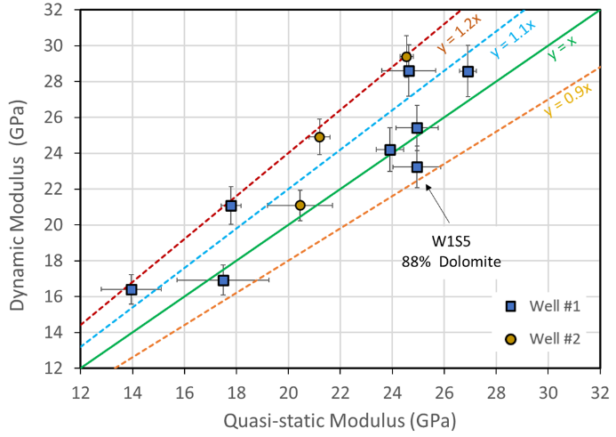

Figure 1: Scatter plot for the results of quasi-static and dynamic drained rock bulk modulus at 5500 PSI (37.92 MPa) confining stress.

Figure 2 illustrate a scatter plot for the drained rock bulk modulus for rock samples from well #1. There are several points corresponding to dry rock bulk modulus calculated from legacy velocity measurements (dynamic), and the new stress-strain bulk modulus measurements (static). The static and dynamic moduli show similar trends, and there is a good correlation between modulus and porosity.

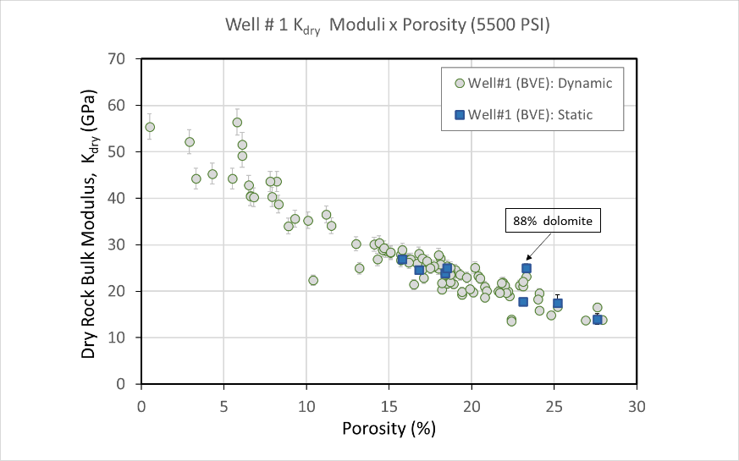

Figure 2: Dry rock bulk modulus as a function of porosity for well #1 samples at 5500 PSI (37.92 MPa).

We have several legacy velocity measurements in samples with XRD compositional information of rocks from the same field. As discussed, with velocity data and compositional information we can estimate the dynamic Biot’s Coefficient. In Figure 3 we present a scatter plot for the Biot Coefficient as a function of sample porosity, including static and dynamic estimates. There is an approximate linear relation between Biot Coefficient and porosity. This observation suggest that we can use the porosity from geological model as a proxy to the Biot coefficient. Another alternative would be using the porosity log to derive the coefficient and interpolate between wells using seismic amplitude or seismic inversion as an external drift. However, in the presence of composition estimates derived from litogeochemical logs, we can calculate the dry rock bulk modulus from sonic and porosity logs and fluid information using Gassmann’s equation and estimate the matrix modulus from the compositional logs. We observed good agreement between these estimates and our laboratory results as well, as shown in Figure 4.

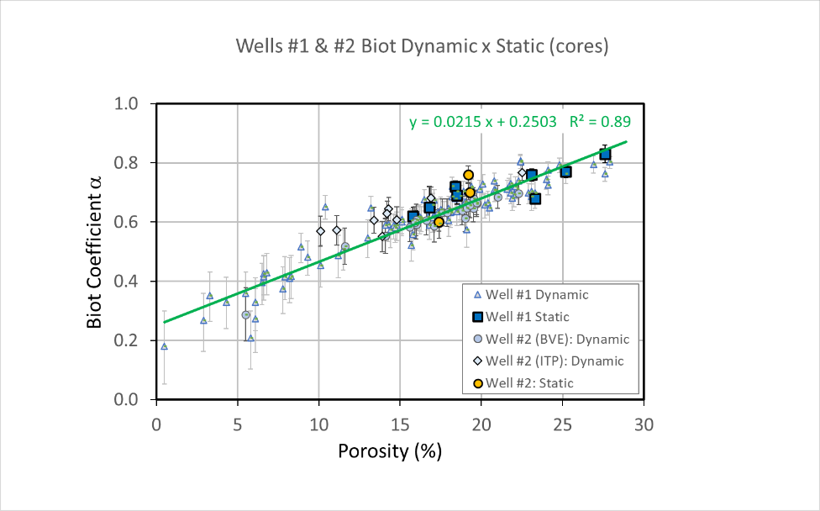

Figure 3: Biot Coefficient as a function of porosity for all samples, including legacy data (for the “dynamic” case).

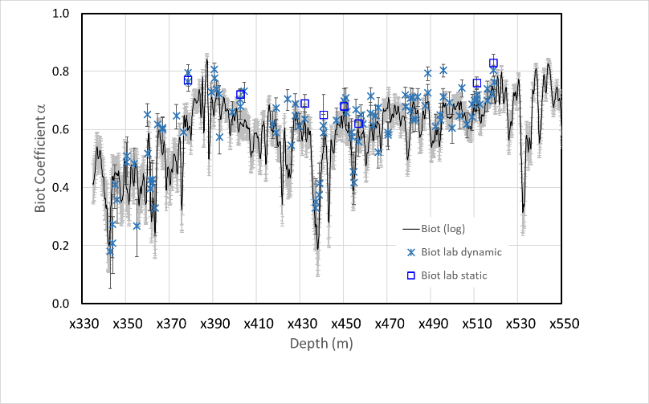

Figure 4: Biot’s coefficient log for well #1 (continuous line) estimated from acoustic and porosity log and compositional information. The data represented by squares are the Biot Coefficient (static) measured in the laboratory by stress-strain experiments, and the “Xs” represents the values calculated from laboratory velocity data and composition.

Other interesting correlation is illustrated on figures 5 and 6. In Figure 5 we show a scatter plot for the Biot coefficient versus core porosity including the laboratory measurement using stress-strain experiments (blue squares and yellow discs) and the coefficient derived from elastic wave velocities in dry rocks and mineral composition (yellow diamonds and blue triangles). With the impedance in this units (km/s.g/cm3) we obtained the relation

|  |  |
| --- | --- |
| $$α=1.311-0.067 I_{P}$$ | (4) |

With R2 = 0.972. Note that the impedance, in this case, refers to dry rocks, because the drained condition in geophysics is attained only in fluid free pore space.

In Figure 6 we present a similar version of this graph but including only the Biot coefficient measured by stress-strain experiments. In this plot we included also the ultrasonic saturated rock impedance measured in the laboratory. A good correlation is observed and the corresponding linear regression for saturated rocks is

|  |  |
| --- | --- |
| $$α=1.402-0.067 I_{P}$$ | (5) |

With R2 = 0.872. Note that the slope of the curve for saturated rocks is equal to the one for dry rocks.

# Comments

We observed several correlations between the Biot coefficient and rock properties (e.g, porosity, impedance). Based on these observations we can suggest some methods to estimate Biot coefficient which can be used to build more accurate reservoir geomechanical models:

* Estimate the Biot coefficient from geological model or even from the flow simulation model. This approach may be relatively easy and fast, it would require no interpolation, but probably would not be the best method, especially if we use the large-scale cells from flow simulation model.
* Estimate the Biot coefficient from porosity logs and interpolate between wells with the aid of seismic amplitude or even impedance as an external drift. This approach sounds good, but as we observed that there is a good correlation between Biot coefficient and acoustic impedance, maybe it would be better to use acoustic impedance logs as the starting point.
* Estimate directly from acoustic impedance volumes, because there is a good correlation between the Biot coefficient and acoustic impedance. This would be relatively fast and would require no interpolation, and the details would be related to the seismic resolution.
* Calculate the Biot coefficient at well locations based on the elastic logs, composition, and fluid substitution, and then interpolate between wells with the aid of some seismic attribute, maybe the acoustic impedance. This approach requires good control of saturation, fluid properties and compositional logs, and may consume more time compared to other ones.

Most of these comments about the possible approaches to estimate the Biot coefficient are based on intuition and guesses. It would be nice to do some small pilot test to verify the best method.

Figure 5: Scatter plot for the quasi-static and dynamic Biot’s coefficient versus dry rock acoustic impedance.

Figure 6: Scatter plot for the quasi-static Biot’s coefficient versus acoustic impedance for dry and oil saturated rocks.

# Conclusions

We measured the Biot coefficient for a Pre-salt oil field from Santos basin and observed good correlations between these measurements and the estimates based on dry rock velocity measurements, as well as with the porosity and elastic properties of the rocks.

There is also an excellent agreement between our measurements and the Biot’s coefficient calculated from well logs.

We suggest some methods to estimate Biot coefficient logs and 3D volumes based on our observations, which can be used to build more accurate reservoir geomechanical models. The choice of the best method demands some practical pilot test.

# Acknowledgments

We thank Petrobras for permission and support to publish this expanded abstract. Thanks to Ana Paula Martins de Souza and Tiago Manes Nunes. We would like to thank Andre Romanelli Rosa for encouraging the studies and help to show the importance of geophysicist to geomechanical studies.

**References**

Biot, M.A. [1941]. General theory of three-dimensional consolidation. Journal of Applied Physics, 12, 155-164.

Biot, M.A. and Willis, D.G. [1957] The elastic coefficients of the theory of consolidation. ASME Journal of Applied Mechanics, 24, 594–601.

Fjær, E., Holt, R.M., Horsrud, P., Raaen, A.M. and Risnes, R. [2008] Petroleum Related Rock Mechanics. 2nd ed., Elsevier Scientific.

Mavko, G., Mukerji, T. and Dvorkin, J. [2009] The Rock Physics Handbook: Tools for Seismic Analysis of Porous Media, 2nd Ed. Cambridge University Press, NY (2009), 552 p.

Nur, A. and Byerlee, J.D., 1971. An exact effective stress law for elastic deformation of rock with fluids. Journal of Geophysical Research,76, 6414-6419.

Schön, J., 2011. Physical Properties of Rocks. A Workbook. Handbook of Petroleum Exploration and Production Volume 8. Elsevier, Amsterdam.

Vasquez, G.F., Morschbacher, M.J. and Justen, J.C. [2019] Experimental efforts to access 4D feasibility and interpretation issues of Brazilian presalt carbonate reservoirs. Interpretation, 7(4), SH1–SH18.

Wang, Z., 2000. The Gassmann equation revisited: comparing laboratory data with Gassmann’s predictions. In: Seismic and Acoustic Velocities in Reservoir Rocks: Recent Developments (Geophysics Reprint Series No. 19) (Geophysics Reprint Series Number 19) A. M. Nur (Author, Editor), Zhijing (Zee) Wang (Author), Zhijing Wang (Editor) 8-23. SEG, Tulsa, OK.