**Petrophysical evaluation of arkoses sandstones reservoirs based on well logs and plug samples: a case study from Alagamar Formation, SE portion of Potiguar Basin**

Victor Hugo Lima Ferreira1,2, Wagner Moreira Lupinacci2,3,Antonio Fernando Menezes Freire2,3

1PetroReconcavo S.A., 2Departament of Geology and Geophysics, Universidade Federal Fluminense, 3National Institute of Science and Technology of Petroleum Geophysics (INCT-GP/CNPQ)

Copyright 2023, SBGf - Sociedade Brasileira de Geofísica

This paper was prepared for presentation during the 18th International Congress of the Brazilian Geophysical Society held in Rio de Janeiro, Brazil, 16-19 October 2023.

Contents of this paper were reviewed by the Technical Committee of the 18th International Congress of the Brazilian Geophysical Society and do not necessarily represent any position of the SBGf, its officers or members. Electronic reproduction or storage of any part of this paper for commercial purposes without the written consent of the Brazilian Geophysical Society is prohibited.

# Abstract

The Potiguar Basin is a sedimentary basin located in northeastern Brazil. It covers about 48000km2 and extends from onshore to offshore (Bertani et al., 1990). The basin is thought to have formed during the Late Cretaceous and Early Paleogene (Pessoa Neto et al., 2007), as a result of the opening of Equatorial South Atlantic Ocean. It is filled with a thick sequence of sedimentary rocks, including sandstones, shales, and limestones, which were deposited in a variety of environments, including marine, deltaic, and fluvial. The basin has been explored for oil and gas since the 1970s and several large fields have been discovered and developed in the area. The study area is in a mature field in the southern portion of the basin (Figure 1) and the reservoir is composed of arkoses sandstones deposited by alluvial fan and fluvial systems of the Upanema Member of the Alagamar Formation, which belongs to the post-rift phase of Potiguar basin (Pessoa Neto et al., 2007). Recently, new drilling campaigns revealed an important reservoir heterogeneity in this formation, which requested new methods for the petrophysical evaluation. Using all the conventional logs, such as gamma ray, induction resistivities, sonic, density and neutron, and petrophysical laboratory analysis of 94 plug samples, this study evaluated the best way to calculate the effective porosity and to understand the stratigraphic controls that influence the distribution of these properties (mainly porosity and shale content). The reservoir zones are called zones 1, 2, and 3. The basal one, zone 3, has disconnected sand bodies and bad reservoir characteristics (low porosity and high shale content); zone 2 has better petrophysical properties and better lateral distribution and connectivity between the fans and; zone 1 is the better reservoir zone with larger sand bodies, high porosity values, and the alluvial fans are better connected in the study area.

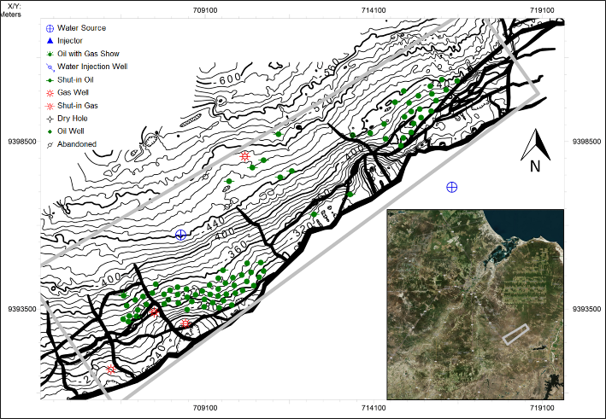

***Figure 1*** *– Study area location map. Oil wells are represented in green, gas wells in red, water source wells in blue and shut-in wells in black.*

# Introduction

The characterization of heterogeneities and the understanding of their distribution play an important role when planning the development plan for an oil and gas field. In alluvial fans and fluvial depositional systems, these heterogeneities could manifest in the form of discontinuous sand bodies with high variations in reservoir qualities (porosity and permeability, mainly), making reservoir zonation a challenging task for reservoir geologists. Therefore, in order to better understand the petrophysical properties distribution and its link with the depositional environment, it is important to integrate rock sample data with the well log analysis analysis.

The Upanema’s Member sandstones, in the study area, have a significant feldspar content and, as a consequence, GR logs show higher values in arkoses than other reservoirs with high quartz content sandstones (Figure 2). This factor makes it difficult to identify in GR the difference between clean sandstones and shaly intervals. For this reason, the shale volume (*Vshale*) was calculated using several methods such as Larionov Old Rocks and Tertiary Rocks (Larionov, 1969), Clavier et al. (1984), and Stieber (1970).

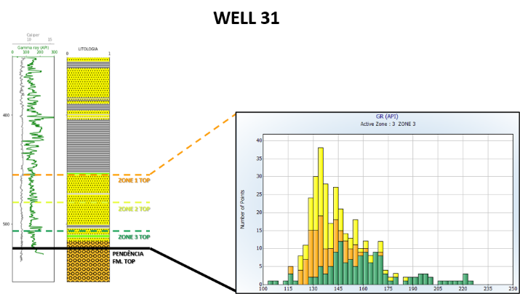

***Figure 2*** *– Example of Well 31 that shows the values of total gamma-ray logs of the 3 (three) original reservoir zones in a histogram.*

In light of these calculations, we use each *Vshale* method to calculate the effective porosity and then correlate it with the one measured in plug samples. By doing so, identifying the best way to estimate clay volume and using this method in each zone for all 73 wells, and, finally, using kriging to distribute it in the study area.

We propose net sand maps to identify the petrophysical properties distribution and use it to identify possible critical fluid-flow barriers for each reservoir zones in the study area.

# Method

The study is based on a dataset derived from 73 wells drilled in one mature field located in the Southeastern portion of the Potiguar Basin (Figure 1). We used the basic suite well logs (GR, ILD, ILM, NPHI, and RHOB), micro-resistivity (MSFL), and, sonic (DT). Available mud logging data was also used.

The initial zonation was made separating the sandstone intervals from the shales using well logs. As an example, the initial zonation carried out in well 21 is shown in Figure 3.

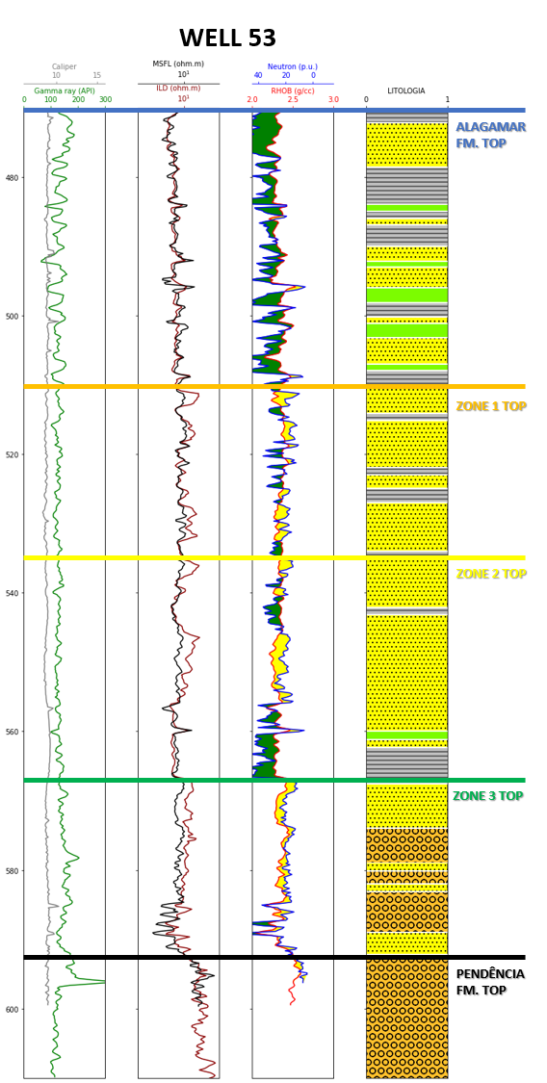

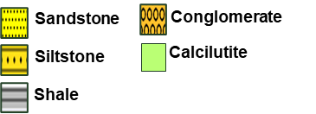

***Figure 3*** *– Example of Well 21, showing how the initial zonation methodology is. Few variations on GR, NPHI, RHOB, ILD, and MSFL logs make it difficult to identify* *the reservoir zones. Alagamar Formation top is marked in blue and Pendência Formation is in black. The dashed lines mark the original reservoir zones (orange is zone 1, yellow is zone 2, and green is zone 3).*

After the zonation, the first step is to establish the best clay volume equation to use before calculating the effective porosity. In order to do so, the Gamma Ray Index (IGR or APIGR) is calculated by the following equation (Schlumberger, 1974):

$$IGR = (GR - GRmin) / (GRmax - GRmin)$$

where:

* *IGR* is the volume of shale
* $GR$ is the gamma ray reading of the formation
* $GRmin$ is the minimum gamma ray reading in the formation (usually found in the cleanest sandstone or limestone layers)
* $GRmax$ is the maximum gamma ray reading in the formation (usually found in the purest shale layers)

This equation assumes that the gamma-ray log response of the cleanest sandstone or limestone layer represents the minimum, while maximum gamma-ray values represent shaly intervals, respectively, for a given formation. The equation calculates the shale volume by comparing the gamma-ray response of the formation to these reference values. This equation is widely used and has been developed and refined over time by petrophysicists and geoscientists through the analysis of numerous well logs and field data.

After calculating the *IGR*, *Vshale* was calculated using several methods like Larionov Old Rocks, Larionov Tertiary (Larionov, 1969), Clavier et al. (1984) and Stieber (1970):

$$Vsh LarionovOldRocks = 0.33*(2^(2*IGR) -1)$$

$$Vsh_LarionovTertiary = 0.083*(2^(3.7*IGR) -1)$$

$$Vsh_Clavier = 1.7 – (3.38 – (IGR + 0.7))^1/2$$

$$Vsh_Stieber = IGR / (3 – 2*IGR)$$

After calculating these different Vshales, the next step was to estimate the total porosity (PHI) and effective porosity (PHIE). PHI could be calculated through the density (RHOB) and/or neutron (NPHI) log. To convert bulk density to total porosity, there is a widespread industry equation:

$$ɸ RHOB = (RHOma – RHOB) / (RHOma – RHOf)$$

where:

* $ɸ RHOB$ = porosity from density log;
* $RHOma$ = matrix density;
* $RHOB$ = formation bulk density (log value);
* $RHOf$ = density of the fluid saturating the rock immediately surrounding the borehole – usually mud filtrate (1.11 for saltwater mud in this study).

Neutron energy loss can be related to porosity because, in porous formations, hydrogen is concentrated in the fluid filling the pores. Reservoirs which pores are gas-filled may have a lower porosity than the same pores filled with oil or water because gas has a lower concentration of hydrogen atoms than either oil or water. So, the neutron log values are used as total porosity ( $ɸ$ NPHI).

Usually, after calculating porosities using both equations, they are combined into a total porosity:

$$ɸ Total = ((ɸ NPHI^2 + ɸ RHOB^2) / 2)^1/2$$

There are various definitions of 'effective' porosity e.g.Juhasz (1986), Hill-Shirley-Klein (1979), and Clavier-Coates-Dumanoir (1977). However, the most common definition is from Schlumberger (1987):

$$ɸ Effective = ɸ Total *(1- Vshale)$$

This equation was used to calculate $ɸ Effective$ for each one of the $Vshale$ methods and then correlated with the $ɸ$ measured in the plug samples. After calculating the $ɸ Effective$ for each well, were defined the following cut-offs for defining Net Sand intervals:

$ɸ Effective$ > 10%

$Vshale$ < 50%

Finally, Net Sand values were used to generate maps and understand the distribution of the reservoir quality heterogeneities.

# Results

After calculating the effective porosity using all four $Vshale$ methods for the four wells that were cored and plugged, the correlation between then was analyzed (Figure 4). The method that best fit for this dataset was $Vshale$ calculation through Larionov Tertiary Rocks (Larionov, 1969), with an R2 of almost 0.97.

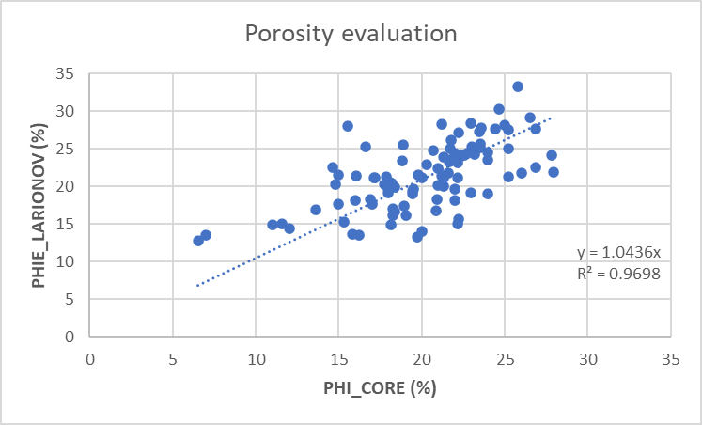

***Figure 4*** *– Correlation between the petrophysical laboratory measurement of effective porosity in 94 plug samples in four wells (PHI_CORE) and the effective porosity calculated using the Larionov Tertiary Rock method (PHIE_LARIONOV).*

After choosing Larionov Tertiary Rocks as the best way to estimate $ɸ Effective$, this petrophysical parameter was calculated for the 69 remaining wells. The distribution of this property could be analyzed in the histograms generated for all 3 zones in the 73 wells (Figure 5).

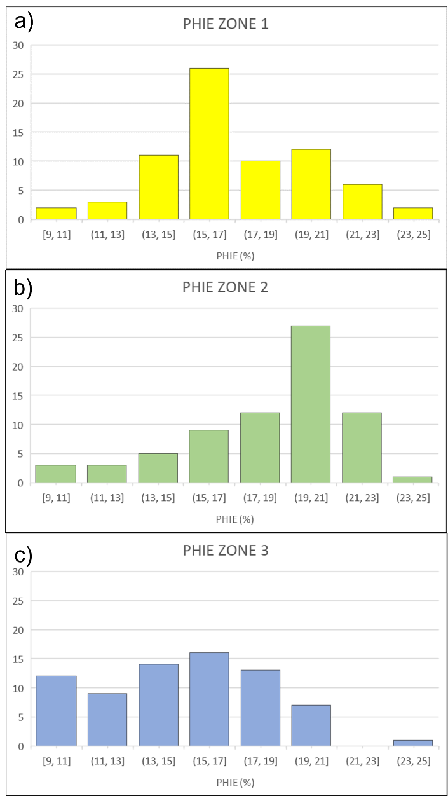

***Figure 5*** *– Histograms of effective porosity calculated for all the wells in the study area. a) PHIE ZONE 1: histogram for the highest reservoir zone; b) PHIE ZONE 2: histogram for the intermediary zone, and; c) PHIE ZONE 3: histogram for the basal zone.*

In Zone 3, the basal one, it`s notable that most of the PHIEs calculated were lower than the other two zones, which can result in worst productions from this zone. The other two zones have better PHIE values estimated, as Zone 2 has the highest PHIE values of all zones.

In order to estimate the distribution of the best sand bodies in the study area, the Net Sand maps were generated (Figure 6) together with the structural map of each reservoir.

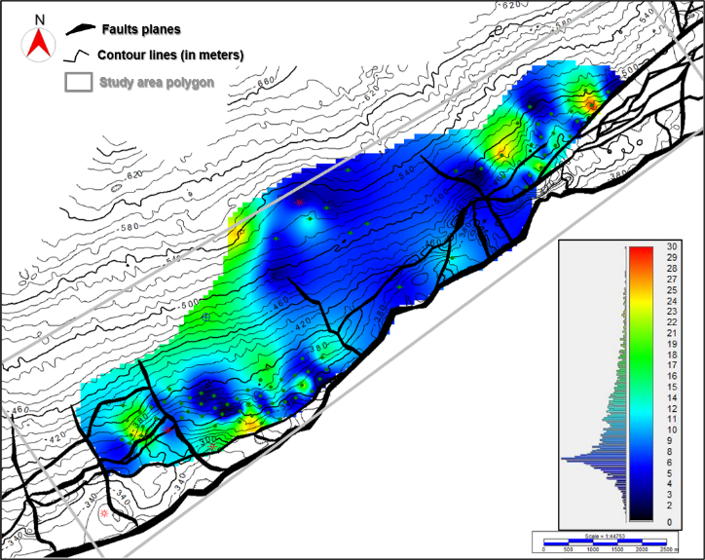

a)

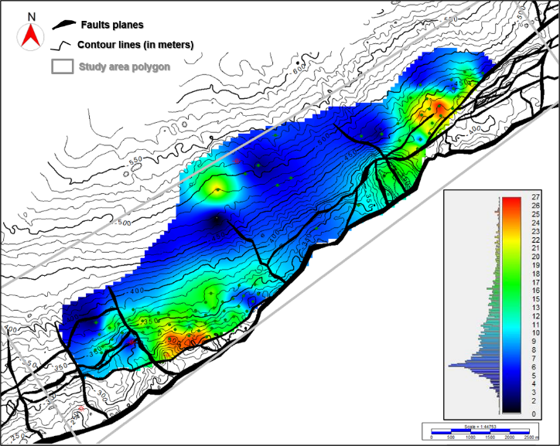

b)

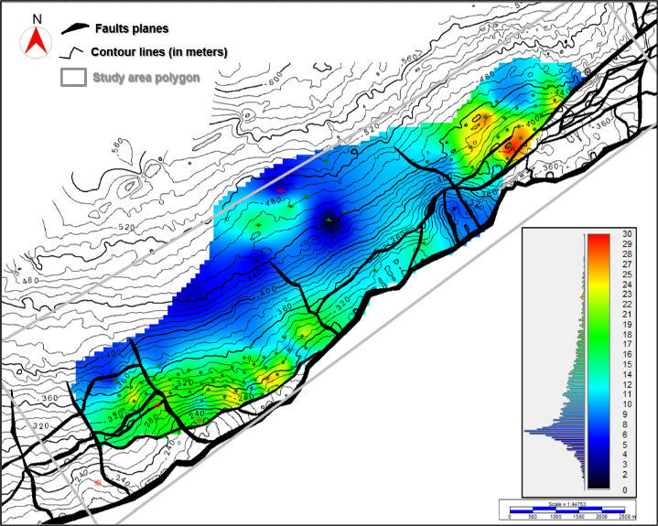

c)

***Figure 6*** *– Net Sand Maps generated using the cu-off of 10% for PHIE values and <50% for Vsh. a) Zone 3 Map; b) Zone 2 Map; c) Zone 1 Map.*

The first net sand, from zone 3, has more disconnected sand bodies and they seem to go downdip towards the lowest in depth. The second one represents the net sand map for zone 2, with the highest $ɸ Effective$ values and with a better lateral continuity, which could be associated with better connectivity between the high porosity zones. The last map is from zone 1, very similar to the zone 2 maps, but with better lateral continuity of sand bodies than the other two zones.

# Conclusions

Identifying the best way to calculate shale content in the rocks could be a lot easier using rock samples data. The reservoir rocks from Upanema`s Member have a very good correlation when comparing the $ɸ Effective$ values from plug samples and the ones calculated from well logs using the Larionov Tertiary Rocks method to estimate shale content.

In the study area, this reservoir is divided into three zones, and using net sand maps to understand the distribution of best zones, in terms of $ɸ Effective$ and $Vshale$, has proved to be an efficient way to do it. Zone 2 has the highest $ɸ Effective$ values, while Zone 1 has the best connectivity between the sand bodies.

As Upanema Member deposits are associated with continental transgressions, it`s possible to associate the sand bodies’ geometry and connectivity with the distribution of $ɸ Effective$ and $Vshale$. We interpretate that from Zone 3 to Zone 1, there is an increase in the $ɸ Effective$ and decrease in $Vshale$, that leads to a better connectivity and lateral continuity of the sand bodies`. In the Zones 1 and 2, the high $ɸ Effective$ and low $Vshale$ sand bodies are concentrated close to the Carnaubais Fault System.

# Acknowledgments

This research is carried out in association with the ongoing my ongoing master’s degree of the corresponding author at UFF (Universidade Federal Fluminense) which studies the heterogeneities of the Upanema`s Mb. Reservoir zones in the southeastern portion of Potiguar Basin. We thank PetroReconcavo, especially Najara Sapucaia, and Gabriel Archilla, for the dataset and support in this study.

# References

BERTANI, R.T.; COSTA, I.G.; MATOS, R.M.D. 1990. Evolução tectono-sedimentar, estilo estrutural e habitat do petróleo da Bacia Potiguar. In: Raja Gabaglia, G.P., Milani, E.J. (Eds.), Origem e Evolução de Bacias sedimentares, p. 291-310. Rio de Janeiro, Petrobras.

CLAVIER, C., Coates, G., and Dumanoir, J. 1984. The Theoretical and Experimental Basis for the ‘Dual Water’ Model for the Interpretation of Shaly Sands: Soc. Pet. Eng. Jour., v.24, pp.153–168.

HILL, H.J., SHIRLEY, O.J., KLEIN, G.E. 1979. Bound Water in Shaley Sands - Its Relation to Qv and Other Formation Properties, Log Analyst, May-June 1979.

JUHASZ, I. 1986. Assessment of the distribution of shale, porosity and hydrocarbon saturation in shaly sands, paper AA, in 10th European formation evaluation symposium transactions, Society of Professional Well Log Analysts, Aberdeen Chapter, 15 p.

LARIONOV, V.V. 1969. Radiometry of boreholes (in Russian): NEDRA, Moscow.

MELO, A.H.; MAGALHÃES, A.J.C.; MENEGAZZO, M.C.; FRAGOSO, D.G.C.; FLORENCIO, C.P.; LIMA-FILHO, P. 2021. High-resolution sequence stratigraphy applied for the improvement of hydrocarbon production and reserves: A case study in Cretaceous fluvial deposits of the Potiguar basin, northeast Brazil. In: Marine and Petroleum Geology 130 (2021) 105124.

NERY, G.G. 2013. Perfilagem Geofísica em Poço Aberto – fundamentos básicos com ênfase em petróleo. – Rio de Janeiro: SBGf, 222p.

PESSOA NETO, O.C.; SOARES, U.M.; SILVA, J.G.F., ROESNER, E.H., FLORENCIO, C.P., SOUZA, C.A.V. 2007. Bacia Potiguar. Boletim de Geociências da Petrobras 15 (2), p. 357-369.

SCHLUMBERGER. 1974. Log Interpretation Manual/Applications. Vol. 2. Schlumberger Well Service, Inc., Houston.

SCHLUMBERGER. 1987. Log Interpretation Principles/Applications. Schlumberger Education Services, Houton, 69-94.

STIEBER, S. J. 1970. Pulsed neutron capture log evaluation — Louisiana Gulf Coast: Society of Petroleum Engineers Annual Fall Meeting Proceedings, SPE 2961.