Geochemistry Analysis in the Pimienta fm., an Unconventional Resource in Mexico

Ana Paola da Silveira Martins¹, Alexis Rosa Nummer ¹, Douglas J. Betancourt², Efrain J. Betancourt²; Efren Solorzano³, Joelma Leandra Paz Rabe⁴;1. Rural Federal University of Rio de Janeiro, 2. Universidade Central University of Venezuela, 3. 3. University of Oriente, 4. SeaSight Enviromental Solutions

Copyright 2023, SBGf - Sociedade Brasileira de Geofísica
This paper was prepared for presentation during the 18th International Congress of the Brazilian Geophysical Society held in Rio de Janeiro, Brazil, 16-19 October 2023.
Contents of this paper were reviewed by the Technical Committee of the 18th International Congress of the Brazilian Geophysical Society and do not necessarily represent any position of the SBGf, its officers or members. Electronic reproduction or storage of any part of this paper for commercial purposes without the written consent of the Brazilian Geophysical Society is prohibited.

Abstract

This study present a geochemical model developed to understand how its properties can be used to define sweet spot for optimun hydraulic operations in the Pimienta fm.
The results indicated that the Pimienta formation presented an expected TOC of approximately 2.41%, type II/III, with a thermal maturity ranging between 0.6 and 1.4%. The mineralogy analysis indicated that mudstone, wackestone and packstone constituted 79.6% of the carbonate and 20.4% of clay consisting of illite, montmorillonite, glauconite and kaolinite. Pimienta Shale went through three maturation windows (oil window, transition between oil and gas windows (condensate window) and gas window) as it dips south. The results shows that the best zones for stimulation represent zones of high TOC, around 2.41% (hydrocarbon > 1,200 ppm), kerogen type II-III and low brittleness around 67%. The study was able to identify sweet spot zone and propose an integrated workflow for optimum hydraulic fracturing stimulation in the studied unconventional reservoir.

Introduction

Unconventional reservoirs represent a strategical reservoir to guarantee in the energy transition additional oil and gas assets.Produce in low reservoir require unique strategy to identify best zones to alocate each hydraulic fracturing stages. They are argillaceous sediments rich in organic matter, which were deposited in such a way, that they preserve an important part of their original organic matter, which ultimately functioned as raw material for the generation of hydrocarbons (Patino et al., 2011). Once the hydrocarbons were generated, most of them remained trapped in the very low permeability (Salazar et al., 2022) rock matrix that did not allow them to migrate (Rabe et., 2011; Rabe et al., 2021)).
Oil/gas shales (Hoxha and Rabe, 2021) are defined as conventional existing reservoirs in which shales with high generation capacity and retention of dry gas (methane, CH4) is the main generation source. Gas can be retained in two main ways, adsorbed on organic matter or as free gas in nano pores and fractures. This type of fine-grained sedimentary rock with abundant organic matter has traditionally been considered as source rock and at the same time act as a seal rock for hydrocarbon deposits, turning out as unconventional reservoir rock, where the fundamental elements are the generation and retention capacity. The first one is on function of the organic richness (% TOC) and thermal maturity (% Ro) and the second in function of the diameter of the pores (Iqbal et al., 2022).
The recent development of unconventional plays of oil and gas shales in similar formations of the Mesozoic Eagle Ford, in the Haynesville and Niobrara areas in the United States, recently confirmed that such formations continue towards to the Mexican territory, with the objective Upper Jurassic in the Burro-Picachos area within the Sabinas and Burgos Mesozoic Basins, demonstrating commercially exploitable dry, wet and oil gas productions.
The objective is to evaluate the Play Superior Jurassic Pimienta of the Tithonian age. It is estimated that the size of the gas resource at the time of its approval has the following values: P₁₀ = 171 MMMpcg, P50 = 67 MMMpcg. and P90 = 7 MMMpcg, the probability of geological success (PG) of 81% of finding some wet gas.

Study location

The Pimienta formation is in the southern portion of the Burgos Basin, Mexico. The Figure 1 shows the location of the Well-B, Well-A and Well-A wells. The same unconventional resources extend to the Tampico-Misantla basin. Burgos Basin present reserves of approximately 10.8 MMMbcpce and, with substantial reserves. In the south region exists another important basin, called Tampico Misantla with 34.9 MMMbpce.
The stratigraphic column of Pimienta fm. consists of the Lower Oligocene, which is made up of calcareous light gray shale, the Lower Eocene is constituted by light, gray, calcareous shales, in which at the bottom of formation traces of light gray sandstones, with fine to medium quartz grains and dark lithics been identified. The Upper/Lower Paleocene is made of light gray shale, calcareous. Traces of light gray sandstones, from fine grains to quartz media and dark lithic material were identified. Sub-rounded, regularly classified, and regularly consolidated in a clay matrix and calcareous cement with light impregnation of oil with yellow fluorescence.
Upwards, the Pimienta Formation gradually passes into Lower Tamaulipas Formation. This was originally described as fine-grained, compact limestone with well-marked beddings, predominately gray in color. It concludes many chert lenses and nodules of irregular shape at its top.
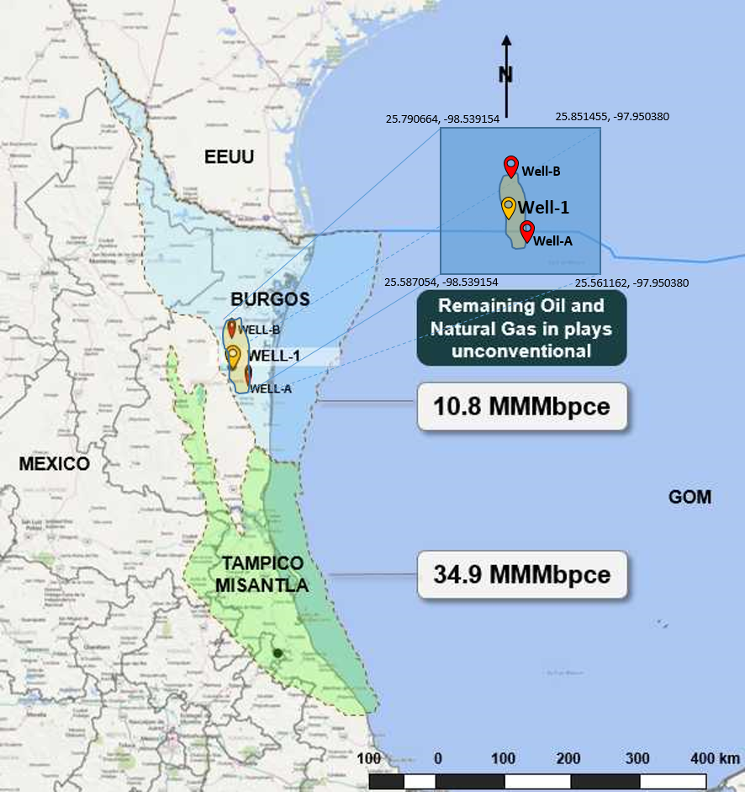
Figure 1. Regional map, field location

Geochemistry analysis

The key objective of the geochemical analysis is to describe shale resource system in terms of their organic geochemical characteristics.

Gas chromatography
This analytical technique was used to separate organic compounds based on their volatilities in the core samples. In addition, it was used to provide qualitative and quantitative information on the components present in a mixture.
The study of geochemistry in unconventional reservoirs is very important for characterizing the generating rock in order to evaluate the potential of the generating rock using the Rock-eval Pyrolysis technique (Espitalie et al., 1977). With this tool, geochemical parameters that determine quantity, quality and maturity of the generating rocks are measured, such as total organic carbon (TOC), which measures the organic richness present in the rock, the quality is represented by the Hydrogen Index (IH) depending on the type of organic matter, the type of hydrocarbons to be generated will be determined.
Oil and gas in Pimienta Formation is dry gas dominated by hydrocarbon gas. Hydrocarbon gas contains 1,302 ppm-23,138 ppm methane, and a small amount of ethane（87ppm-3,471ppm）and trace amount of propane（60ppm-542ppm）. Drying coefficient of natural gas (C1/C1+) is 0.9975-0.9985, belonging to typical mixed type II-III and oil-gas-prone type III gas prone. Non-hydrocarbon gas includes carbon dioxide, nitrogen, helium, hydrogen and hydrogen sulfide etc.
Gas chromatography tests were executed in the laboratory to determine the Gas concentration. The results show that the gas concentration (ppm) in ranges 1,678 - 26,779 were distributed as: C₁ (ppm) 1,302-23,138; C₂ (ppm) 87-3,471; C₃ (ppm) 60-542, IC₄ (ppm) 7-19; NC4 (ppm) 34-203; IC₅ (ppm) 5-24, NC5 (ppm) 9-36; CO₂ (ppm) 0 - 0 and H₂S 0 ppm.
The min/m min- max- average -4.1-50.1, aver. 10.4; gas ppm (1678- 22779; aver. 9922.9 ppm); C₁ (1302-23138 ppm- 8327.6 ppm); C₂ (87-3471ppm- aver. 1255.6ppm); C₃ (60-542-221.8 ppm); IC₄ (7-19-9,9ppm); NC₄ (34-203, 79.8ppm); IC₅ (5-24-12.4ppm); NC₅ (9-36 – 15.7 ppm). All gas chromatography laboratory tests were executed on all member.
Geochemistry for the studied well of the unconventional deposits was also executed with its core-profile calibration and the evaluation criteria of the generating rock: TOC, S₂, Tmax, Kerogen & Hydrocarbon Type.
Quality of Rock classification: generator S₂ is less than 2 Hydrocarbon is less than 200; Poor have S₂ 2-3 and hydrocarbon 200-500 ppm; regular S₂ between 3-5 and 500-800 ppm; good with S₂ between 5-10 and hydrocarbon superior to 1200 ppm. Very good with S₂ bigger than 10.

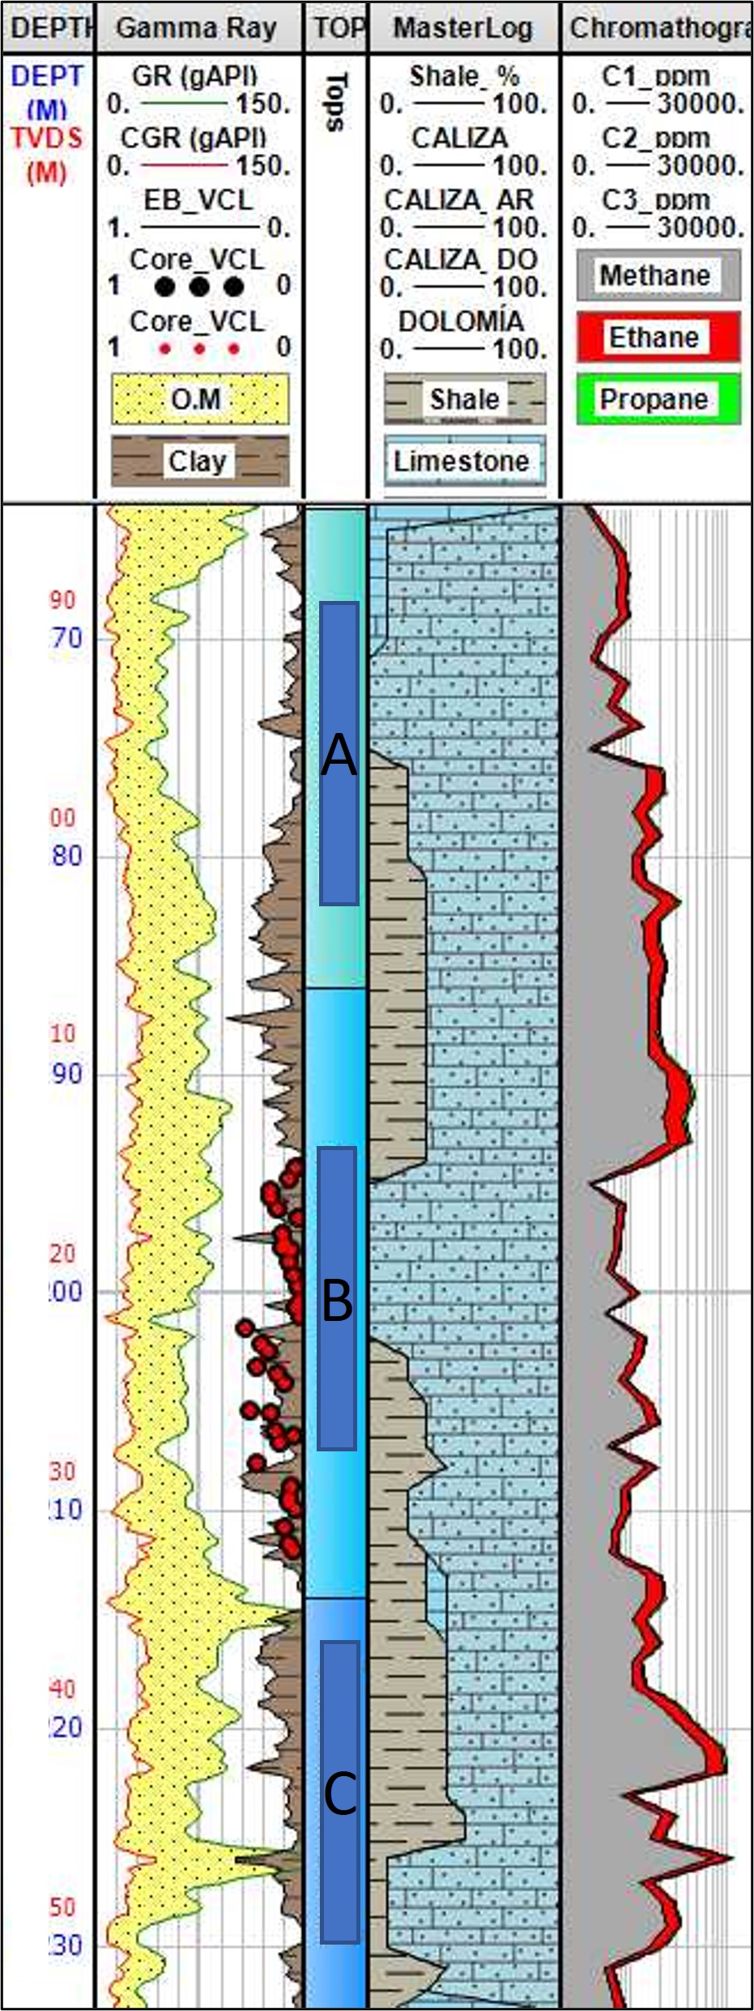
Figure 2. Gas chromatography Analysis

Vitrinite reflectance (VR)

VR measurements were made using a microscope with motorized fourfold turret for reflectance. The microscope was fitted with oil immersion objectives. The white light source was a 12 V 100 W halogen lamp with a LED illumination slider 29 × 11.5 mm in the incident light axis. Random VR (% Ro) measurements were carried out at 546 nm, and between 6 and 32 points count were taken depending on the number of recognizable vitrinites particles available for measurement in each sample.
The results are present in Figure 9 are indicating that hydrocarbon emanations, all over the place, complemented with geological-geochemical models, it was possible to establish the presence of a hydrocarbon generator system for the Superior Jurassic Play in the Well-A well location.

Rock Eval pyrolysis and Total Organic Carbon (TOC)

Analysis were conducted on the initial and pyrolysis non-extracted and extracted rocks from the sequential experiments. The study of pyrolysis provides knowledge about the chemical composition and maturity of the organic matter contained in our generating rock (Pepper). The criteria for evaluation are given by the following interpretation table. The laboratory tests indicated that the water saturation is about 25.5%, oil Saturation is about 55.7%, gas saturation is about 18.8%. Dry helium porosity % is about 7.7%.

To estimate TOC from geophysical records, the methodology developed by Passey et al. (1990), which is based on a practical method, using the ∆log R technique. This technique uses the superposition or separation of the porosity curves (scaled appropriately) and the deep resistivity curve. In clean, water-saturated reservoirs, these two curves overlap, as both curves respond to variations in formation porosity. However, in reservoirs saturated with hydrocarbons or in rocks with a high content of organic matter, they tend to separate.

TOC = (Eq. 1)

where: TOC is the Total Organic Carbon (% in weight), Volker = volume of Kerogen (% in volume), = density of kerogen (gr/cc), = formation density (gr/cc), K is the unit conversion (~1.2).

TOC was estimated using the Passey equation (Passey et al, 1990; Salazar et al., 2021) and was calibrated with gas chromatography field measurements. TOC is one of the most critical parameters for the evaluation of shale reservoirs. This property indicates the quality of the shale in term of oil or gas quantity. On the other hand, well log data is used to generate a continuous curve of a proxy to TOC. One of the most common method to provide TOC from well logs is based on a combination of resistivity and acoustic logs and the proper definition of baseline and can be expressed as (Passey et al., 1990):

(Eq. 2)

where is the curve separation measured in logarithmic resistivity cycles, R is the measured resistivity, is the P wave transit time , is the resistivity corresponding to value when the logs are taken in non-source, clay-rich rocks. The empirical Passey equation for calculating TOC in clay-rich rock from ΔlogRt is (Passey et al, 1990):

(Eq. 3)

where TOC is the total organic content and LOM is the maturity.

The results show that through the analysis that TOC present in Pimienta is a good rock quality (Quality Generating Rock sources). TOC is superior to 1% varying from 0.4% until 5.2%), Kerogen types II and III, Thermal maturity superior to 0.9% (Ro), Tmax> 440°C. The analysis indicated free oil / gas in the porous spaces (micro, nanoporosity) and gas adsorbed on the Kerogen and the clays particles. TOC is for member A from 0.6%to 3.3%, for member B from 1.73% to 4% and for member C from 0.1% to 4.7%.

Hydrogen Index (HI) and Oxygen Index (OI)

The index is obtained from the relationship between hydrogen and TOC; is defined as:

HI = 100* (Eq. 4)
HI is proportional to the amount of hydrogen contained in the Kerogen. It is an indicator of the presence of non-oxidized hydrogen in the system, a high HI indicates a greater potential for oil generation. The type of Kerogen can also be inferred from this index. If hydrogen type is between 50-200 is hydrocarbon is gas, between 200-300 gas and oil and superior 300 is oil (Figure 13).

The oxygen index is obtained from the relationship between CO₂ and TOC; is defined as:

OI = 100* (Eq. 5)

The oxygen index is related to the amount of oxygen contained in the kerogen, is an indicator of the gas richness and is useful for the analysis of the maturity or the type of Kerogen. The results presented in figure 2 indicated that HI varies from 67.65 to 345.75. For member A from 149 to 287, for member B from 203 to 309 and for member C from 74 to 332. Based on these analyzes, the type of Kerogeno, its thermal maturity and the TOC (Total Organic Carbon). It has been established that during the thermogenic maturity of Kerogeno type I, liquid hydrocarbons tend to be generated, Kerogeno type II generates gas and oil, Kerogeno type III generates gas, coal and in extreme conditions, oil. Kerogen type IV is generally considered not to be capable of generating hydrocarbons. As a result of the evaluation the type of Kerogeno is II / III and Hydrocarbon Oil / Gas.
The geochemical results using 21 samples indicated an average TOC equal to 2.3%, S₁ equal to 0.17; S₂ equal to 3.74; S₃ equal to 0.46, Tmax equal to 444ºC; HI 168, OI equal to 22; S₂/S₃ equal to 8.13; S₁/TOC*100 equal to 8.14 and PI equal to 0.05 and S₁/TOC *100 equal to 139 (Figure 3).

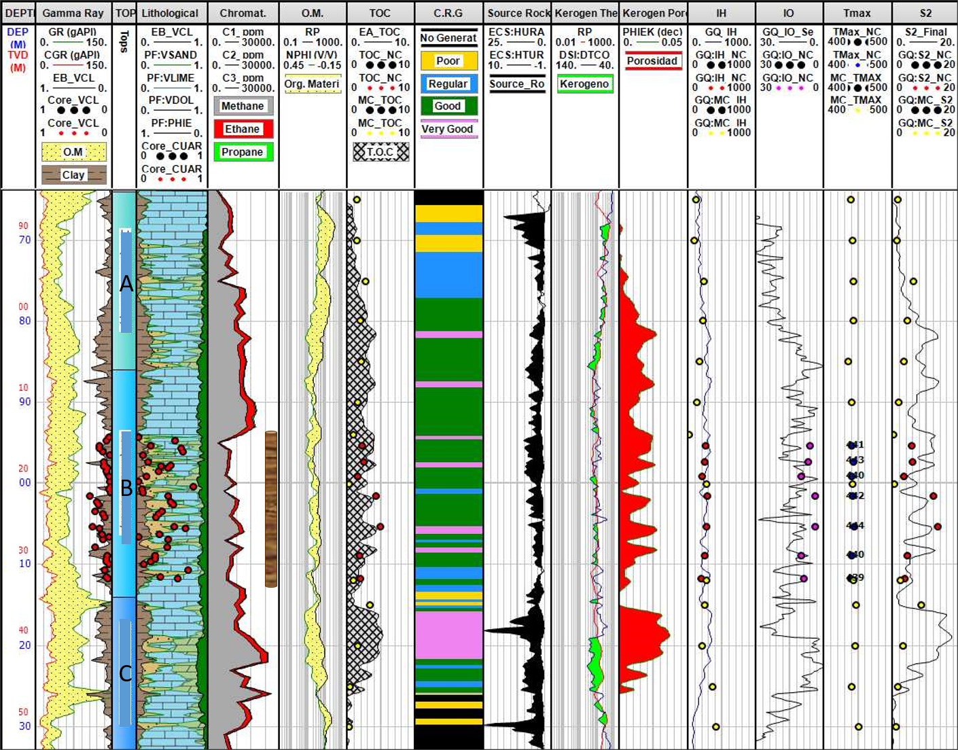
Figure 3. Geochemistry analysis.

Kerogen type

Conversely, some authors estimate that the direct relationship between Kerogen and OCD (f) can be between 2 and 2.5. The following approaches can be used to estimate Kerogene (% by volume):

Ker (% in volume) = TOC (% in weight) x f ~ 2 – 2.5 (Eq. 6)
Ker (% in volume) = (Eq. 7)

where: Φ is the porosity (%), is the matrix density (gr/cc), is de kerogen density (gr/cc) and Cker is the carbon concentration in kerogen (% in weight).

To establish the type of Kerogen present in the rock and its potential to generate hydrocarbons, a laboratory analysis of formation samples was executed to calibrate the model. This process that focuses on methods of combustion, pyrolysis, chemical degradation, spectral fluorescence, or petrography. For this, the samples obtained was used allowing us to do the core-profile calibration and the type of Kerogeno, type of hydrocarbon and its total organic richness can be defined.

Using the gamma ray log, the reservoir intervals was identified and separated from the analysis. The separation of these curves in the rich ranges of organic matter, is mainly due to two effects: the porosity curve responds to the presence of low density and low velocity of Kerogen and the resistivity curve responds to the formation fluid. In immature rocks rich in organic content, where hydrocarbon has been generated. The separation is observed, which is only due to the porosity response. In mature rocks, coupled with porosity, resistivity increases due to the presence of the generated hydrocarbon. The magnitude of curve separation in non-reservoir zones is calibrated in total organic content (TOC).

When making the cross graph, the hydrocarbon generating potential (S₂) is related to the total organic carbon (TOC), and the Kerogeno quality graph is obtained, obtaining the Kerogeno type is type II / III corresponding to oil / gas and Kerogeno III type which corresponds to gas (Figure 3).
By relating the hydrogen index (IH) with the oxygen index (IO) obtained from the rock-eval analysis (pyrolysis), the Van Krevelen diagram (Figure 4) is obtained, which is used to evaluate the type of matter organic that is associated with rocks. This graph shows that the organic matter present in this formation is mainly of type II/II-III, prone to generate hydrocarbon of the oil and / or condensed gas type at its highest potential (Figure 5). The results are indicating kerogen type I (HI=577), type II (oil prone usually marine), HI ranging from to 120 and 220 type II – III (oil-gas prone), with HI ranging from 100 to 200. For member A from149 to 287, for member B from 203 to 309 and for member C from 74 to 332.
When comparing the values ​​that serve to evaluate both the maturity of the organic matter and the generation zones and the Tmax, we have that the values ​​of Tmax, Ro and and the hydrogen index, coincide in that the section analyzed, it presents organic matter suitable for the generation of oil hydrocarbons, its maturity is sufficient for said organic matter to be converted into hydrocarbon, therefore the integration of all geochemical parameters indicates that the Pimienta formation presents favorable prospective conditions for its carry out an exploitation plan. Figure 16 show the relation between HI and temperature that based on temperature, the reservoir is oil prone and imature. Temperature ranges from 400ºC to 435ºC in the mature and between ranges from 435ºC to 465ºC. For member A from 437 to 443, for member B from 440 to 492 and for member C from 442 to 449.

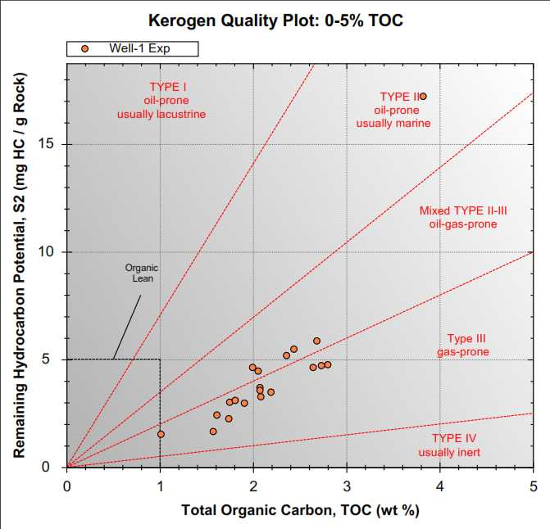
Figure 4. Kerogen Quality vs. TOC

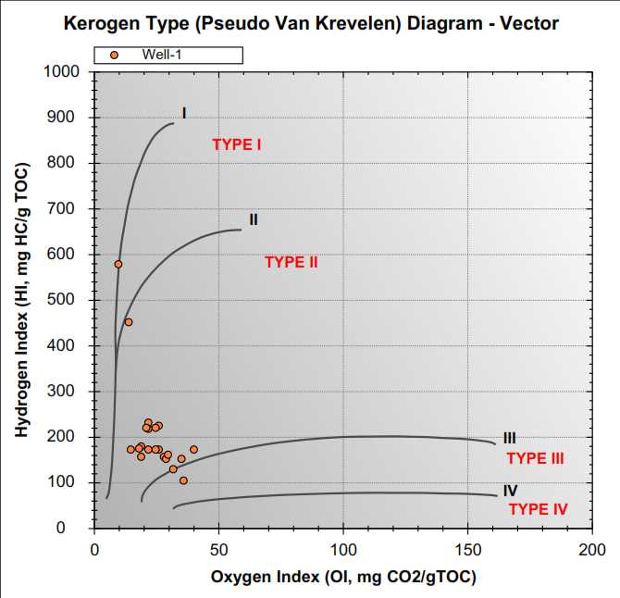
Figure 5. Kerogen Type (Pseudo Van Krevelen) Diagram

Figure 6 shows the relation between maturity and production index indicating that maturing is ranging between 0.01 to 0.36, and for window window between 0.3 to 0.1. The S₁ values ​​correspond to the amount of hydrocarbons present in the rock, S₂ corresponds to the hydrocarbons generated from insoluble kerogen in the heating process and the S₃ values ​​represent the amount of CO₂ released during the thermal alteration of oxygenated organic compounds (Tyson, 1995; Tissot and Welte, 1984).

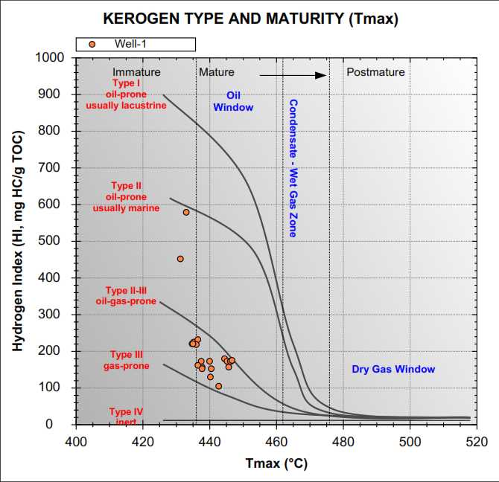
Figure 6. Kerogen Type and Maturity (Tmáx)

The results of the geochemical study of core are presented below, which were analyzed for Well-A. The results presented below from the analysis of cores 1 do not differ from the analyzes presented later on from the channel samples, obtaining very similar results for the following 3 graphs (Figures 6 and 7).
Figure 6 shows that the correlation between TOC and S2 shows mixed type II-III oil-gas prime and Type III gas-prone with TOC between 1.5 to 2.5 and S2 between 0.5 to 6 HC/g rock. For member A from 1.05 to 9.48, for member B from 3.89 to 12.03 and for member C from 0.1 to 15.62.
The analysis also included include the correlation between OI and HI. The results show mixed type II-III oil-gas prime and Type III gas-prone with OI between 5.9 to 27.9 and HI between 120 to 220. For member A from 10.4 to 34.8, for member B from 6.9 to 18.5 and for member C from 3.3 to 27.1. The results also shows that the correlation between HI and temperature shows mature oil window with HI between 120 to 220 and temperature between 439 to 449. For member A from 437 to 443, for member B from 440 to 492 and for member C from 442 to 449.

Results
Geochemistry for the studies of unconventional reservoirs is fundamental. The attached table shows the geochemical study with its core - well logs calibration and the evaluation criteria of the shale oil/gas: TOC, S2, Tmáx, Kerogen & Hydrocarbon Type. Well A shows good results for its extraction-exploitation.
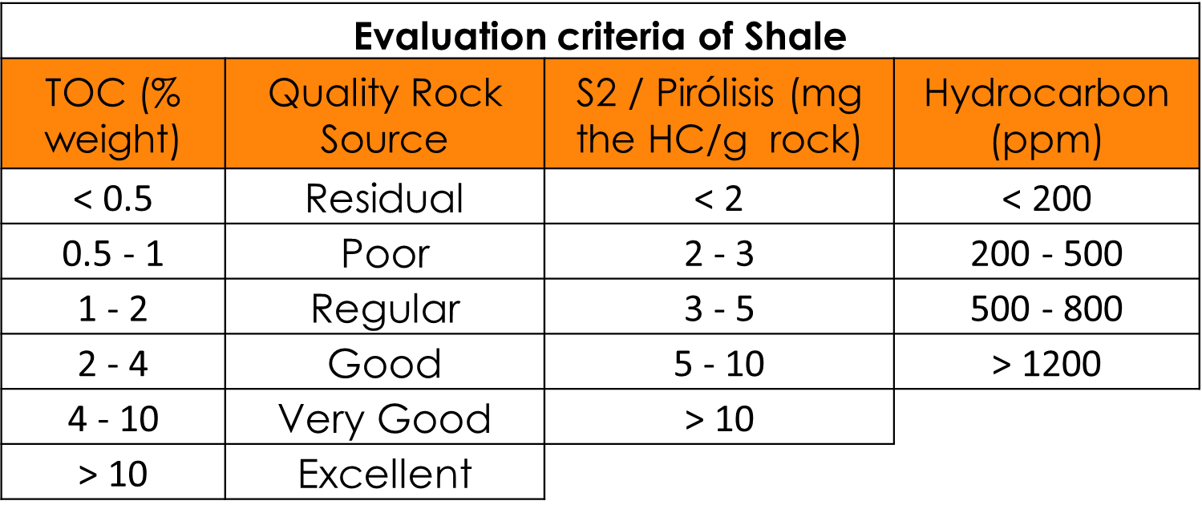
Based on the plug cores and channel samples, the geochemical models were made and their respective core-profile calibration. The Total Organic Content (Total Organic Carbon) of Well A has an average of 2.4, being considered Good. The oil potential of Well A, according to the results of S2: 5.3, classifies them as Good. The interpretation and calibration of the IH vs. IO models correspond to a mixture of type II Kerogen and type of hydrocarbon oil. The state of thermal maturation (thermal maturity) of well A, Tmax: 448 average shows oil.

Conclusions

Pimienta Shale went through three maturation windows (oil window, transition between oil and gas windows (condensate window) and gas window) as it dips south. The results shows that the best zones for stimulation represent zones of high TOC, around 2.41% (hydrocarbon > 1,200 ppm), kerogen type II-III and low brittleness around 67%. The study was able to identify sweet spot zone and propose an integrated workflow for optimum hydraulic fracturing stimulation in the studied unconventional reservoir.

The methodology used in this study was developed to identify sweet spot intervals in multi-stage hydraulic fracturing operations in the Pimienta fm by using geochemistry. The results shows that the best zones are the middle and inferior (lower) zone.

Acknowledgments
The authors wish to thank and acknowledge PEMEX for granting access to use their data and CNH for permission to publish the results from the study.

References
Hoxha, B. M. and Rabe. C. 2021. What shale you are talking!. Abu Dhabi International Petroleum Exhibition & Conference. SPE-207412-MS. Abu Dhabi, UAE, November.
Iqbal, O., Padmanabhan, E., Hughes, A., Abdulkareen, F. A., Rabe, C. and Mumtaz, M., 2022. The competitive adsorption of CO₂ and CH₄ and pore structure characterization: Implication for enhanced gas recovery and carbon sequestration. Second International Meeting for Applied Geoscience & Energy. Image 22. SEG-AAPG Meeting, Houston. Aug, 28th – Sep 01.
Jarvie, D. M., Hill, R. J., Ruble, T. E. and Pollastro, R. M. 2007. Unconventional shale -gas systems: The Mississippian Barnett Shale of north-central Texas as one model for thermogenic shale –gas assessment, AAPG Bulletin, 91(4), pp. 475–499. 10.1306/2F12190606068
Mavko, G., Mukerji, T., Dvorkin, J., 2009. The rock physics handbook, tools for seismic analysis of porous media. Cambridge University Press, 2nd Edition. ISBN-10: 0521861365.
Patino, G. S., Saucedo, N. S., Naveja, F. A. and Rabe, C. 2011. Use of a neural network to build a 3D rock property model for a geomechanical model to optimize multi-stage fracture design in Chicontepec Basin, Mexico. 45th US Rock Mechanics / Geomechanics Symposium, San Francisco. ARMA-11-234.
Rabe. C., Silva, G., Nunes, A. L. L. S. and Silva, C. G. 2018. Development of a New Correlation to Estimate the Unconfined Compressive Strength of a Chicontepec Formation. International Journal of Geomechanics. Volume 18. Issue 8. August. American Society of Civil Engineers (ASCE).
Rabe, C., Salazar, J. P., Rechden, R., Della-Pascua, F. and Stael, G. 2021. Brittleness modeling selects optimum stimulation zone in shale source rocks in the Whangai Formation. New Zealand. AAPG Bulletin. V. 105. No 2. February. pp. 329-355.
Rickman, R., Mullen, M., Petre, J., Grieser, W. and Kundert, D. 2008. A practical use of shale petrophysics for stimulation design optimization: All shale plays are not clones of the Barnett Shale. Society of Petroleum Engineers Annual Technical Conference and Exhibition. Denver. Colorado 21–24 September. SPE-115258-MS, 11 p., doi: 10.2118/115258-MS
Salazar, P. J., Rabe, C. and Papa, A. 2022. An Approach to integrate Petrophysical and Rock Physics Modeling for Hydraulic Stimulation in Carbonate Reservoirs. ICE – AAPG International Conference & Exhibition. 19-22 April. Cartagena. Colombia.
Salazar, J. P., Betancourt, D. J., Rabe, C., Iqbal, O. and Sardelli, E. 2021. Geomechanical and petrophysical interpretation in Shale Formations: A case study in Pimienta, México. 17th International Congress of Geophysical Brazilian Society. August 2021, Rio de Janeiro, Brazil.
Salazar., J., Rabe, C. and Filho, R. 2017. Some Effects of Petrophysics and Geomechanics in Unconventional Reservoir Stimulation, New Zealand. Paper UR38. First EAGE/AMGP/AMGE Latin-American Seminar in Unconventional Resources. 23-24 November. Mexico City. Mexico.
Wang, F. P., Gale, J. F., 2009. Screening criteria for shale-gas systems: Gulf Coast Association of Geological Societies Transactions, 59, 779–793.
Q.R. Passey, Creiney J.B. Kulla, and J.D Strold. 1990. “A practical model for Organic, richness fron porosity and resistivity logs”.

