**Silica zoning and its relationship to acoustic borehole image features in Barra Velha Formation, Santos Basin.**

Igor Lima de Jesus1, 2 (former), *, Francisco Romério Abrantes Jr.,2,3, Wagner Moreira Lupinacci 2,3

1 Reservoir Research Group (PETROCARB), Observatório Nacional (ON)

2 Exploratory Interpretation and Reservoir Characterization Group (GIECAR), Universidade Federal Fluminense (UFF)

3 National Institute of Science and Technology of Petroleum Geophysics (INCT-GP/CNPq)

Copyright 2023, SBGf - Sociedade Brasileira de Geofísica

This paper was prepared for presentation during the 18th International Congress of the Brazilian Geophysical Society held in Rio de Janeiro, Brazil, 16-19 October 2023.

Contents of this paper were reviewed by the Technical Committee of the 18th International Congress of the Brazilian Geophysical Society and do not necessarily represent any position of the SBGf, its officers or members. Electronic reproduction or storage of any part of this paper for commercial purposes without the written consent of the Brazilian Geophysical Society is prohibited.

# Abstract

**Silicification is a diagenetic process commonly observed in Aptian Pre-Salt carbonates sedimentary successions. This process involves the replacement of carbonate minerals with silica, generally altering the original rock texture. Sedimentary studies based on integrating different types of data at different resolution scales allow for a better understanding of diagenetic changes and reduce uncertainties about the characterization of carbonate reservoirs. Therefore, to contribute to this knowledge, this work aims to analyze the behavior of the silica volume correlated to the acoustic Borehole Image (BHI), and rock petrographic data in the Barra Velha Formation (BVF), Santos Basin. For this purpose, one well data provided by ANP was used, and five silica zones were defined. Based on this analysis, an upward trend of increasing silicification was observed associated with a reduction of the permoporous properties in the lower four zones. The upper zone trend presents a different behavior, characterized by expressive silica reduction and permeability increment, interpreted as a hypogenic Karst product. It was also observed local anomalies of silica increased and increment of porosity.**

# Introduction

Over the last decade, the Santos Basin oil production reached the mark of 2.9 Mboe/day, being responsible for 74% of the national oil production in 2022 (ANP, 2023), (Figure 1). To succeed in this campaign, different challenges were overcome, such as the development of technology that would allow drilling and developing well in deep waters, crossing expressive evaporite intervals.

Despite having relatively simple mineralogy, the Aptian

carbonate reservoirs are characterized by depositional and diagenetic processes that resulted in extremely heterogeneous characteristics (Fernández-Ibánez et al., 2022). Eventually, these two processes occurred simultaneously, making it difficult to distinguish.

In different pre-salt fields, diagenetic processes altered and/or reorganized the carbonate framework and, as a consequence, affected the porosity and permeability of the reservoir rocks (Lima & De Ros, 2019). Among these processes, silicification directly affects pore dissolution and cementation features, directly impacting the permoporous properties of pre-salt carbonate reservoirs (De Jesus, 2023).

Silicification of carbonate rocks involves the replacement of carbonate by silica (SiO4-opal and quartz), as well as the precipitation of pore-filling silica cement (Tucker & Wright, 1990; Flügel, 2010). Bustillo (2010) suggests that silicification is a significant diagenetic phenomenon of ancient carbonate rocks that may illuminate the diagenetic aspects of carbonate host rock’s history.

The Barra Velha Formation (BVF) deposits are characterized by Aptian sediments, initially interpreted as a marine setting (Moreira et al., 2007; Carminatti et al., 2009), and recently as an alkaline lake environment (Wright & Barnett, 2015; Pietzch et al., 2018; Farias et al., 2019; Carvalho et al., 2022). This formation presents reservoirs of excellent quality (Szatmari & Milani, 2016), and its main components are spherulites, shrubs, and laminites (Wright & Barnett, 2015).

The aim of this work was to identify different silica zones based on the distribution of the Si content patterns observed in the BVF. After zone definition, the acoustic borehole image (BHI) we used to identify features that may be related to diagenetic processes. This text is a clipping from the doctoral thesis presented by the first author to Universidade Federal Fluminense (UFF), developed within the framework of the Exploratory Interpretation and Reservoir Characterization Group (GIECAR) research project.

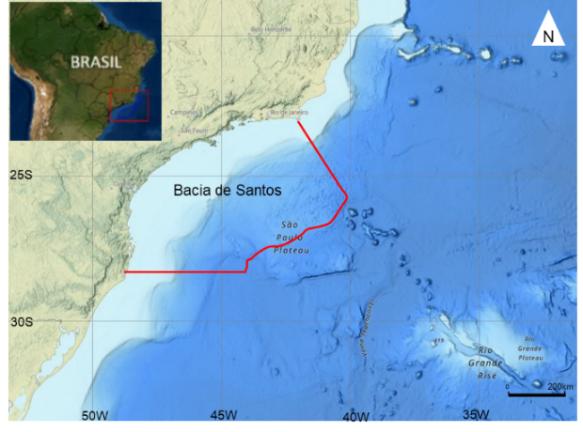

Figure 1: Location of the Santos Basin (De Jesus, 2023).

# Method

For this study, one well from a pre-salt field was used and named as Well A, and the interval analyzed comprises the entire BVF. The well-log data were provided by ANP. The following well-logs were considered: gamma-ray (GR), Caliper (HCAL), calcite, silica and dolomite volumes, T2 distribution, porosity and permeability from NMR, thin section description, and Acoustic Borehole Image (BHI),.

Based on Si, Ca, and Mg content, concentrations measured from the Elemental Capture Spectroscopy tool (ECS), it was possible to estimate silica, calcite, and dolomite volumes by converting the element’s proportion in lithological volume considering molecular weight and elements ratio (Oliveira et al., 2022; De Jesus, 2023). Equations 1, 2, and 3 were used for lithological conversion.

|  |  |
| --- | --- |
| $Silicification=\frac{Si}{0,4674}$ | (Eq.1) |

|  |  |
| --- | --- |
|  | (Eq.2) |

|  |  |
| --- | --- |
|  | (Eq.3) |

Acoustic Borehole Images (BHI) are very effective in feature identification due to their high resolution and 100% coverage on the borehole wall. BHI contributes to reservoir characterization by mapping different structures as fractures, dissolution, or vugs, not observed in conventional logs (Gaillot et al., 2007). In this study, the BHI data were processed by observing quality control, tool centralization, and eventually artifacts due to drilling. In acoustic BHI, dark colors are associated with low amplitude values, interpreted as porous intervals, while bright colors are associated with higher amplitude and indicate cemented intervals.

After ECS lithology conversion and acoustic BHI processing, the BVF was divided into five vertical zones according to the silica pattern and behaviors (Figure 2). The zones were named upward S1, S2, S3, S4, and S5, and then different diagenetic features were identified according to BHI.

**Results**

The BVF on Well A measures 283m (Figure 2). Although the major lithology encompasses shrubs, spherulites, and laminites it can also be observed cherts, and dolomites. Packstones, grainstones, and floatstones were grouped as reworked. The thin section description favored correlating several types of cement and locating dissolution features. It is possible to observe a complementary behavior between calcite and silica volumes along the whole formation. The porosity and permeability values present a decreasing trend upwards while a silica increment can be observed in the same trend.

The S1 zone has 51 meters range (X231.30/X283m), and its lower limit is the Pre-Alagoas unconformity. The zone presents discrete GR reduction, the lowest silica content, and the highest permoporosity averages of the entire BVF (Figure 2). When the BHI is correlated to silica volume, it is possible to observe an increase of silica associated with high amplitude and intercalation of high and low amplitudes. A segment was zoomed in to better observe features (Figure 3B). Therefore, several centimetric pores are boarded by high amplitude, indicating dissolution and intense silicification, partially filling the pore. It is also observed high amplitude patches, which are interpreted as irregular silicification or silica intraclasts (Lai et al., 2018). The thin section (X250m) indicates spherulites with dolomite with dissolution pores partially cemented with quartz (Figure 3).

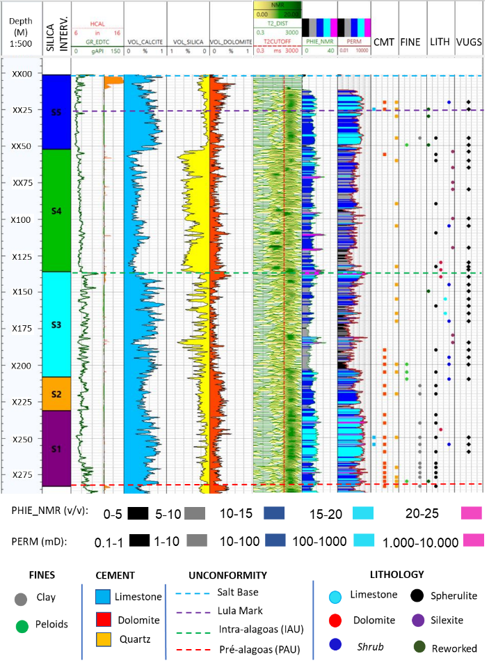

Figure 2: BVF separation into five zones according to silica volume, well-logs and rock data information used in this study.

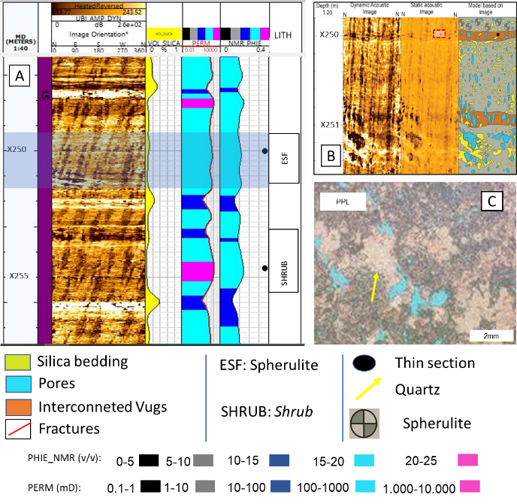

Figure 3: Segment of S1 zone. In A, 1) Depth; 2) Zone; 3) Acoustic BHI; 4) Silica volume; 5) Permeability; 6) Porosity; and 7) Lithology. In B, a Zoomed portion, indicated in the blue rectangle, 1) Depth; 2) Dynamic Image; 3) Static Image; 4) Model Based on image. In C, a thin section image.

The S2 zone has 23 meters range (X208/X231.30m) with lower GR values. An increment of silica volume and a slightly permoporosity decrease is observed when compared to the S1 zone (Figure 2). Here, the silica pattern is uniform along the zone. The depth X209m (Figure 4) is characterized by a local increase of silica presenting several small fractures, in BHI, denoting a brittle behavior. A discrete increase in dolomite volume is reflected as cement in thin sections. The zoomed portion shows two distinct behaviors (Figure 4B): the lower one is characterized by low to intermediate amplitude, high roughness, and visual porosity interpreted as dissolution, presenting good connectivity reflected in the NMR permeability log. The upper portion presents high amplitude with several fractures denoting a brittle behavior and correlated to high silica volume. Despite the fractures in the upper portion, it is possible to observe a decrease in permoporosity when compared to the lower portion (Figure 4). The thin section (X210m) shows shrubs with interparticle porosity partially filled with rhombohedral dolomite and quartz cement and some enlarged fractures.

The S3 zone has 72 meters (X136/X208m) and is characterized by the intercalation of high and low silica values, in a complementary behavior with calcite volume (Figure 2). Although this zone presents the lowest dolomite content of the studied succession, it is noticed a few occurrences as cement-filling pores. It is important to highlight the silica increase and permoporosity reduction trend observed in the former zones also occur in this zone, but in some locations, the silica increase is correlated to a porosity increment and permeability reduction (Figure 5). Apparently, the silicification favored dissolution, generating secondary porosity but able to compromise permeability (De Jesus, 2023). The BHI zoomed portion highlights high roughness, intermediate amplitude, and irregular bedding, but in the upper portion, the sinusoids are better defined and present a higher amplitude (Figure 5). The high amplitude patches present diverse geometry and size, interpreted as silica intraclasts (Lai et al., 2018; Basso et al., 2022). Some of the fractures are enlarged favoring porosity increment. The thin section (X185m) is characterized by silexite and sparse spherulites, several vugs, and some enlarged fractures corroborating BHI observation.

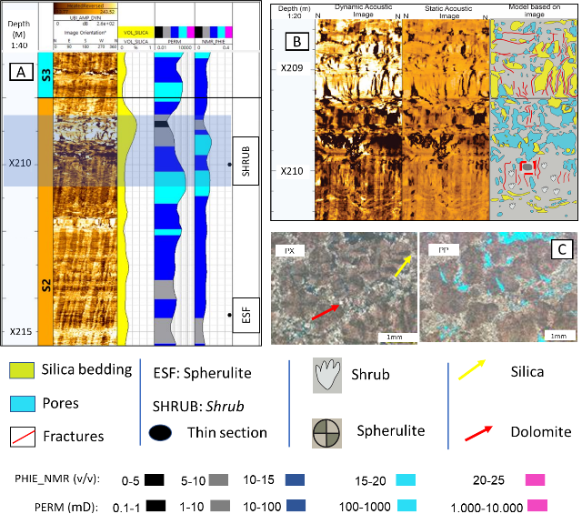

Figure 4: Segment of S2 zone. In A, 1) Depth; 2) Zone; 3) Acoustic BHI; 4) Silica volume; 5) Permeability; 6) Porosity; and 7) Lithology. In B, a Zoomed portion, indicated in the blue rectangle, 1) Depth; 2) Dynamic Image; 3) Static Image; 4) Model Based on image. In C, thin section images.

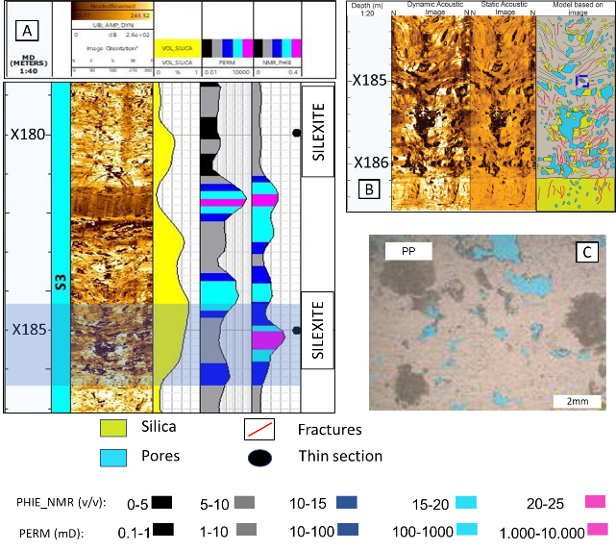

Figure 5: Segment of S3 zone. In A, 1) Depth; 2) Zone; 3) Acoustic BHI; 4) Silica volume; 5) Permeability; 6) Porosity; and 7) Lithology. In B, a Zoomed portion, indicated in the blue rectangle, 1) Depth; 2) Dynamic Image; 3) Static Image; 4) Model Based on image. In C, a thin section images.

The S4 zone has 84 meters (X052/X136m) and its base limited by the Intra-Alagoas Unconformity (X136m). From IAU to the top of the zone, GR presents a slight and continuous reduction trend upwards (Figure 2). This zone is characterized by an abrupt silica increment and consequently a proportional calcite reduction. Although the expressive content of silica, porosity presents values similar to adjacent zones. In contrast, the interval marks the lowest permeability values of the entire BVF. The BHI analysis and silica indicate an increment of high amplitude along the zone, although the intercalation with low amplitude beddings is still observed sparsely. It is also noticed an increase of wide-open fractures along the zone, which favors the generation of secondary porosity (Figure 6). The BHI is characterized by high roughness, intermediate amplitude, and intense fracture features that obliterated bedding identification (De Jesus, 2023). The enlargement of fractures is reflected in porosity increment, but the incipient permeability denotes a lack of connectivity between pores. The thin section (X135m) is described as dolomite with quartz cement. It is observed channel porosity, and vugs corroborating enlarged fractures described in BHI.

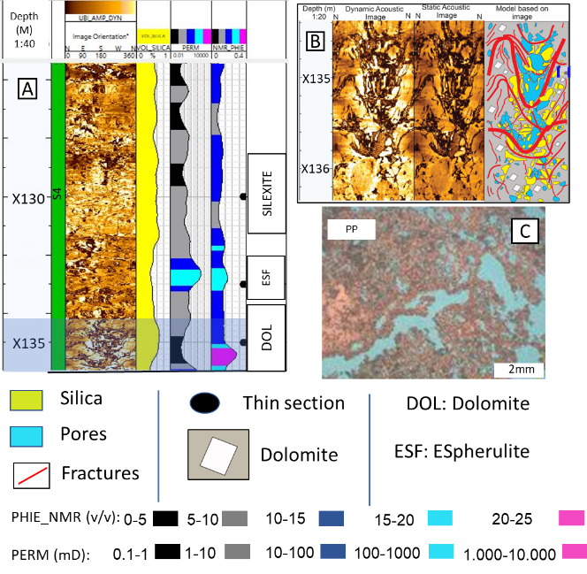

Figure 6: Segment of S4 zone. In A, 1) Depth; 2) Zone; 3) Acoustic BHI; 4) Silica volume; 5) Permeability; 6) Porosity; and 7) Lithology. In B, a Zoomed portion, indicated in the blue rectangle, 1) Depth; 2) Dynamic Image; 3) Static Image; 4) Model Based on image. In C, a thin section image.

The S5 zone has 51 meters (X001//X052m) and encloses the BVF. The GR presents a particular aspect of nine pulses known as Lula Mark (Wright & Barnett, 2017a), interpreted as short and intense episodes of lake-level variation (Figure 2). The Lula Mark is observed in several Santos Basin wells denoting a regional feature (Wright, 2020). This zone is characterized by a brusque silica reduction and a discrete increase of dolomite, possibly associated with Mg-clay destabilization and consequently increment of magnesium (Mg). The lack of microporosity in NMR T2 distribution confirms the absence of clay in the zone and the accumulation of distribution to the right of the cutoff denotes an increment of free fluid (Figure 2). The BHI analysis, together with silica volume points to high and low-amplitude intercalation (Figure 7). A common feature observed here is characterized by a homogeneous appearance, lack of structure, subtle roughness, low visual porosity, and breakout presence probably associated with post-depositional changes of cementation and silicification (Basso et al., 2022). It is also observed intense dissolution characterized by low amplitude pores and expressive high amplitudes patches, which is interpreted as irregular silicification or intraclasts (Lai et al., 2018; Basso et al., 2022; De Jesus, 2023). The thin section (X29.90) shows reworked particles, moderately sorted, mostly composed of spherulites, silica intraclasts, and quartz cement. The contact between particles denotes mechanical compaction.

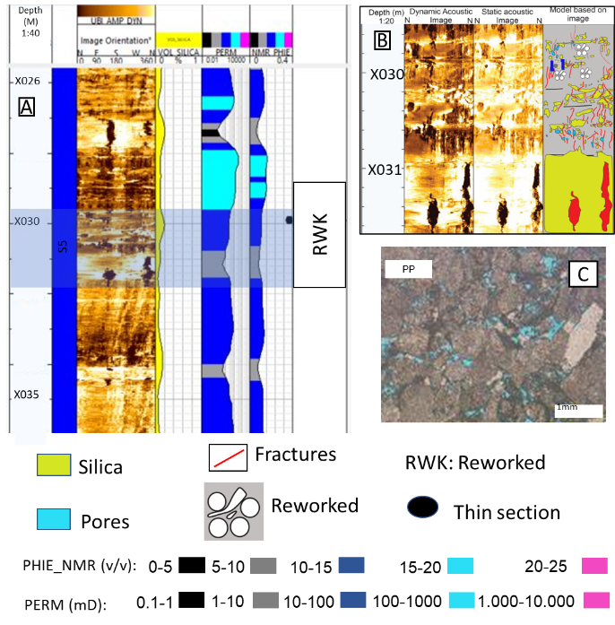

Figure 7: Segment of S5 zone. In A, 1) Depth; 2) Zone; 3) Acoustic BHI; 4) Silica volume; 5) Permeability; 6) Porosity; and 7) Lithology. In B, a Zoomed portion, indicated in the blue rectangle, 1) Depth; 2) Dynamic Image; 3) Static Image; 4) Model Based on image. In C, a thin section image.

# Discussions

The silica beddings are usually well defined in BHI, due to their compaction, making it more brittle and consequently generating amplitude contrast. Another aspect observed is permoporosity properties reduction in silicified intervals (Fernández-Ibánez et al., 2022; De Jesus et al., 2023). Therefore, the amplitude may play an important role in silica identification if correlated with other information such as silica volume or rock data.

The silica distribution on carbonates can be detailed through petrographic studies and when assembled to BHI, it allows comprehend silica content to its diagenetic impact on carbonates and the influence on permoporosity properties along the BVF (De Jesus, 2023).

The absence of Mg-clays in the studied well can be associated with a pH decrease, possibly due to lake level variations or CO₂ increase, which alter geochemical lake conditions and leads to Mg-clays dissolution. Then, Mg and Si ions are released in the solution, favoring carbonate dissolution and the development of secondary porosity, dolomite, and/or silica precipitation (Farias et al., 2019; Herlinger et al., 2020; Wright, 2020). This process is interpreted as the eodiagenetic phase.

The mesodiagenetic phase is associated with fracturing and vug generation (Flügel, 2010; James & Jones, 2016). It is also observed an increase in dissolution intensity close to fractures and faults. This is interpreted as hydrothermal fluids percolation. Occasionally, it favors the complete substitution of limestone fabric (Wright & Barnett, 2020, Carvalho et al., 2022). Although the well is not crossed by an intrusion, the study area presents several spots of intrusions and faults, that may have acted as conduct to hydrothermal fluids, favoring dissolution along fractures followed by dolomite and silica precipitation. Vugs were identified along the whole BVF but mostly in the S3 zone.

Apparently, Si-rich hydrothermal hot fluids percolated through faults and fractures contributing to dissolution. Due to its high temperature and low density, it tends to ascend. Therefore, a higher accumulation of Si-rich fluids is expected in the upper portion of the BVF and, consequently, an increase of silica volume upwards.

The S5 zone presents excellent permoporosity properties, which may be a result of a mixture of meteoric waters and hot CO2-rich fluids ascension. This fluid mixture probably contributed to intense dissolution, generating structures of permeability increment (Klimchouk, 2009; Biehl et al., 2016; Menezes et al., 2019).

# Conclusions

The integration of rock data and analyzes of profiles from different tools favored the identification of the different stages of silicification in order to understand their different influences on the permoporous properties, in addition to establishing a relationship with the different diagenetic events.

Based on the patterns observed in the silica volume, it was possible to divide the Barra Velha Formation into five zones in well A. This division was considered in the analyzes carried out in the study.

The increase in silica volume upwards in the Barra Velha Formation and the opposite trend in permoporosity reduction, indicating how silicification compromises permoporous properties. However, it was possible to identify some local anomalies to this trend, in which the increase in silica is associated with an increment in porosity and permeability.

# Acknowledgments

The authors acknowledge Agência Nacional de Petróleo, Gás Natural e Biocombustiveis (ANP) for public data provided and Equinor for supporting the research project and the first author’s thesis.

**References**

AGÊNCIA NACIONAL DO PETRÓLEO (ANP). 2023. Boletim de Produção de Petróleo e Gás Natural. Disponível em: <www.anp.gov.br/images/publicacoes/ boletins-anp/Boletim_Mensal Producao_Petroleo_Gas_ Natural/boletim-fevereiro-2023.pdf>. Acesso em: 20 fev. 2023.

BASSO. M, SOUZA, J.P.P, HONORIO, B.C.Z, MELANI, L.H, CHINELATTO, G.F, BEILILA, A.M.P, VIDAL.A.C. Acoustic Image log facies and well log petrophysical evaluation of Barra Velha Formation carbonate reservoir from the Santos Basin, offshore Brazil. Carbonates and Evaporites, 37-50, 2022.

BIEHL, B.C., REUNING, L., SCHOENHERR, J., LÜDERS, V. & KUKLA, P.A. Impact of hydrothermal dolomitization and thermochemical sulfate reduction on secondary porosity creation in deeply buried carbonates: a case study from the Lower Saxony Basin, northwest Germany. American Association of Petroleum Geologists Bulletin, 100(4): 597-621, 2016.

BUSTILLO, M. A. Silicification of continental carbonates. Developments in Sedimentology**,** 62, 153-178, 2010.

CARMINATTI, M.; DIAS, J.; WOLF, B. From turbidites to carbonates: breaking paradigms in deep waters. Offshore Technology Conference, 2009.

CARVALHO, A.M.A.; HAMON, Y.; DE SOUZA JR, O.G.; CARRAMAL, N.G.; COLLARD, N. Facies and diagenesis distribution in an Aptian pre-salt carbonate reservoir of the Santos Basin, offshore Brazil: A comprehensive quantitative approach. Marine and Petroleum Geology, 2022, 141, 105708.

De Jesus, I. L. Impacto da silicificação na permoporosidade em reservatórios carbonáticos na Formação Barra Velha, Bacia de Santos. Tese (Doutorado em Geofísica Aplicada) – Universidade Federal Fluminense, Niterói, 2023.

FARIAS, F., SZATMARI, P., BAHNIUK, A. & FRANÇA, A.B. Evaporitic carbonates in the pre-salt of Santos Basin – Genesis and tectonic implications. Marine and Petroleum Geology**,** 105: 251-272, 2019.

FERNÁNDEZ-IBÁNEZ, F.; JONES, G.D.; MIMOUN, J.G.; BOWEN, G.M.; SIMO, J. A.; MARCON, V.; ESCH, W.L. Excess permeability in the Brazil pre-Salt: Nonmatrix types, concepts, diagnostic indicators, and reservoir implications. AAPG Bulletin, 1-38, 2022.

FLÜGEL, E. Microfacies of carbonate rocks: analysis, interpretation and application. Berlim: Springer, 976pp, 2010.

GAILLOT, P.; BREWER, T.; PEZARD, P.; YEH, E. Borehole Imaging Tools Principles and Applications. Scientific Drilling, No. 5., 2007.

HERLINGER, R.J.; FREITAS, N.G.; ANJOS, W.D.; DE ROS, L.F. Petrological and petrophysical implications of magnesian clays in Brazilian Presalt deposits. Proceedings of the SPWLA 61st Ann. Logg. Symp., 24-29 June, 1-13, 2020.

KLIMCHOUK, A. Morphogenesis of hypogenic caves. Geomorphology, 106:100-117, 2009.

LAI J, WANG G, WANG S, CAO J, LI M, PANG X, HAN C, FAN X, YAN L, HE Z, QIN Z. A review on the applications of image logs in structural analysis and sedimentary characterization. Mar Pet Geol., 95:139–166, 2018.

LIMA, B.E.M. & DE ROS, L.F. Deposition, diagenetic and hydrothermal processes in Aptian Pre-Salt lacustrine carbonate reservoirs of the northern Campos Basin, offshore Brazil. Sedimentary Geology, 383: 55-81, 2019.

MENEZES, C.P.; BEZERRA, F.H.R.; BALSAMO, F.; MOZAFARI, M.; VIEIRA, M.M.; SRIVASTAVA, N.K.; DE CASTRO, D.L. Hydrothermal silicification along faults affecting carbonate-sandstone units and its impact on reservoir quality, Potiguar Basin, Brazil. Marine and Petroleum Geology, 110, 2019.

MOREIRA, J. L. P. et al. Bacia de Santos. Boletim de Geociências da Petrobras, 15(2): 531-549, 2007.

OLIVEIRA, F.V.C.R.S., GOMES, R.T.M., RORIZ, C.E.D., SILVA, K.M.S., TOLEDO, R.C. Lithology Identification Through X-Ray Fluorescence (XRF) Analyses on Drill Cuttings While Drilling in Santos Basin. SPE Annual Technical Conference and Exhibition held in Houston, Texas, USA, 2022.

PIETZSCH, R., OLIVEIRA, D. M., TEDESCHI, L. R., NETO, J. V. Q., FIGUEIREDO, M. F., VAZQUEZ, J. C., & DE SOUZA, R. S**.** Palaeohydrology of the Lower Cretaceous pre-salt lacustrine system, from rift to post-rift phase, Santos Basin, Brazil. Palaeogeography, Palaeoclimatology, Palaeoecology, 507, 60-80, 2018.

SZATMARI, P. & E. J. MILANI. Tectonic control of the oil-rich large igneous-carbonate-salt province of the South Atlantic rift. Marine and Petroleum Geology, 77: 567–596, 2016.

TUCKER, M. E. WRIGHT. V.P, Carbonate Sedimentology. Cornwall: Blackwell Scientific, 482p., 1990.

WRIGHT, V.P. & BARNETT, A.J. An abiotic model for the development of textures in some South Atlantic Early Cretaceous lacustrine carbonates. Microbial Carbonates in Space and Time: Implications for Global Exploration and Production, Geological Society, Special Publication, London, 418: 209-219, 2015.

WRIGHT, V.P. & Barnett, A.J. Classifying reservoir carbonates when the status quo simply does not work: A case study from the Cretaceous of the South Atlantic: AAPG Annual Conference and Exhibition, 108–121, 2017A

WRIGHT, V. P. The mantle, CO2 and the giant Aptian chemogenic lacustrine carbonate factory of the South Atlantic: Some carbonates are made, not born. Sedimentology, International Association of Sedimentologists, 47-73, 2020.