From High frequency RTM to AI/ML aided Salt Interpretation-harness the power of the Cloud
Kun Jiao^{*1}, Weishan Han², Julian Chenin³, Cyril Lagrange¹, Mik Isernia¹, Srinivas Tadepalli¹

Copyright 2023, SBGf - Sociedade Brasileira de Geofísica
This paper was prepared for presentation during the 18th International Congress of the Brazilian Geophysical Society held in Rio de Janeiro, Brazil, 16-19 October 2023.
Contents of this paper were reviewed by the Technical Committee of the 18th International Congress of the Brazilian Geophysical Society and do not necessarily represent any position of the SBGf, its officers or members. Electronic reproduction or storage of any part of this paper for commercial purposes without the written consent of the Brazilian Geophysical Society is prohibited.

Abstract
Seismic imaging and interpretation are important workflow for the Oil and Gas (O&G) industry, offering critical subsurface insights for informed decision-making. This paper presents a pioneering case study that effectively harnesses the advanced capabilities of HPC, cloud platforms, and AI/ML aided interpretation to improve and complement the traditional O&G industry workflow processes.

Introduction
Seismic imaging and interpretation play important roles in the process of hydrocarbon exploration. These crucial techniques facilitate an in-depth understanding of subsurface Earth features, providing geoscientists with the essential information to locate and characterize potential reservoirs.
Seismic imaging involves the generation of images of the subsurface. The more complex and heterogeneous of these geological structures are, the more accurate and advanced seismic imaging techniques require to form a clear image about the subsurface. Reverse Time Migration (RTM) (Baysal et. al., 1983, McMechan et. al., 1983) and Full Waveform Inversion (FWI) (Tarantola 1984, Pratt et. al, 1998) are widely used advanced imaging algorithms. However, it still troubles the seismic processing by requiring tremendous amount of computation power. How to increase the efficiency, improve the scalability and resiliency, and finally reduce the computation cost continues to be a big challenge for the industry.
Seismic interpretation entails scrutinizing seismic images to discern and delineate subsurface geological structures. Detailed attention is paid to the morphology, dimensions, and spatial locations of varied geological features, along with the attributes of the rocks involved. Such interpretation typically requires the application of sophisticated software capable of managing intricate data and providing perceptible visual aids to facilitate analysis.
The value of seismic imaging and interpretation is profound. The derived subsurface image and model are instrumental in pinpointing potential prospects, gauging the scale of such prospects, and strategizing. These processes are vital in reducing risks and circumventing expensive errors, thus establishing them as crucial components in the exploration workflow.
In this paper, we introduce a case study that effectively capitalizes on the advanced competencies of High-Performance Computing (HPC), cloud-based platforms, and AI/ML-aided interpretation to augment and synergize with existing workflows in the Oil and Gas (O&G) industry.

Method
RTM is a process that demands substantial computational resources, having a complexity of O(N^6) in a comprehensive seismic imaging endeavour. It also forms the fundamental kernel for FWI and necessitates numerous iterations for constructing geological models. In particular, a twofold increase in RTM frequency corresponds to a computation cost that is multiplied sixteenfold. However, this process can be expedited via algorithmic optimization.
For instance, the employment of precise finite-difference methods (as depicted in Figure 1a) and accurate time dispersion corrections (illustrated in Figure 1b and 1c) (Wang and Xu, 2015) can allow us to extend the numerical spatial and temporal propagation grid sizes to their Nyquist thresholds while maintaining impeccable analytic accuracy. Leveraging coarse temporal grid and adaptive spatial grid, we can significantly reduce computational cost and memory requirements.
Further enhancements include high-quality Perfectly Matched Layer (PML) boundary conditions which confine the migration area across all three dimensions. Adaptive grid and antialiasing interpolation considerably diminish wave propagation computations, and vectorized Fast Fourier Transform (FFT) aids in augmenting the migration speed.
In parallel, we have developed an inversion-based imaging algorithm aimed at accomplishing amplitude-friendly impedance and reflectivity imaging (Zhang et. al., 2014). This not only provides superior seismic imaging quality but also facilitates superior convergence when utilized as the gradient computation for FWI.
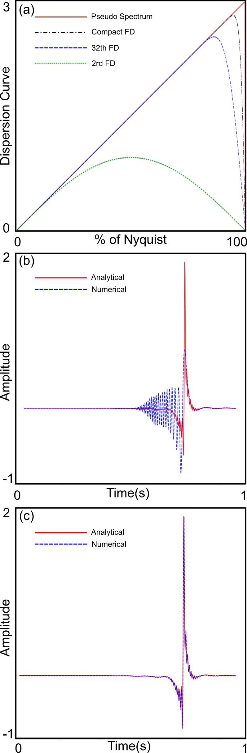
Figure 1 a) The dispersion curves depicted correspond to various central finite difference (FD) schemes used for the numerical approximation of first-order derivatives. The green, blue, black, and red curves symbolize the dispersion relation of 2nd order FD, optimized 32nd order FD, compact FD, and a unique pseudo-spectrum method, respectively. b) The blue curve demonstrates how the 2nd order time-domain finite difference scheme produces significant numerical dispersion in comparison to the analytical solution (represented by the red curve) of the wave equation. c) With the application of a dispersion correction technique, numerical dispersion is effectively eliminated (also indicated by a blue curve), thereby aligning the accuracy of the numerical solution with that of the analytical solution (represented by the red curve).
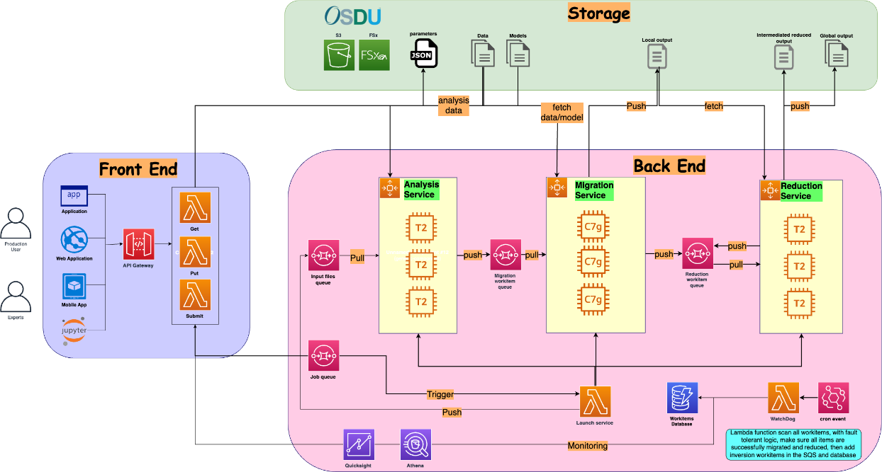
Figure 2 Cloud native RTM architecture design
Utilizing cloud-native services, we have successfully modernized the conventional MPI-based RTM into a cloud-native and more fault-tolerant system. This transition dramatically enhances the resilience, speed, and scalability of our RTM algorithm.
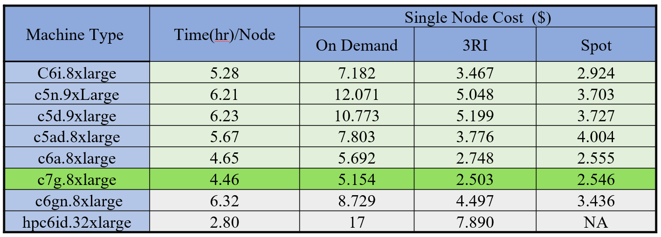
Figure 3 Choosing the most cost-efficient instance.
Moreover, with access to over 500 distinct AWS compute instances, we have the capacity to select the most cost-effective and efficient instance type tailored to the specific task and problem at hand. For instance, Graviton3 proves exceptional for addressing wave equation and imaging tasks due to its substantial memory bandwidth of 300 GB/S, and its high energy efficiency as demonstrated in Figure 3. This astute deployment of resources substantially enhances performance and reduces computational expenses, ultimately priming our RTM algorithm for high-frequency imaging.
Many studies have successfully leveraged machine learning techniques to accelerate and improve the interpretation of different seismic reflection patterns (Chopra and Marfurt 2018; Chenin et al., 2022, Salamoff et al., 2022). In this study, we employ a data-centric, interactive deep learning approach to classify salt, where data labeling/classification, network training, and class predictions happen simultaneously. The geoscientist interacts with the network in real-time to guide the network to identify any feature of interest. The algorithm also provides feedback on the interpreter’s labels. This means that the network will show geologic features that may have been missed during the initial labeling process and can highlight regions to improve labels. This data-centric method was used to quickly obtain a geologically-accurate and detailed salt prediction in under a day within the complex study area.

Examples
The SEAM Subsalt TTI benchmark model (Fehler, 2009), inspired by the geological structure of the deep-water Gulf of Mexico, was used in our study. A mirrored RTM was employed on the Ocean Bottom Node (OBN) dataset, with a maximum offset and recording time of 17.5km and 16s respectively. This procedure concurrently generates band-limited impedance and reflectivity images within a single execution. The dataset under analysis is composed of 1476 OBN nodes and a total of 876876 shots. The nodes are uniformly distributed over the seafloor, spaced one kilometre apart in both directions. Shots are set at a depth of 20 meters, maintaining a horizontal spacing of 40 meters in both directions. The resulting image volume encompasses a length of 40km, a width of 35km, and a depth of 15km. Figure 4 depicts the impedance and reflectivity images of a 40hz TTI RTM for a standard inline, a crossline, and the SEG logo depth slice, respectively. The benchmark illustrates that leveraging cloud computing capabilities allows for the production of high-resolution and high-quality images in a financially efficient way.
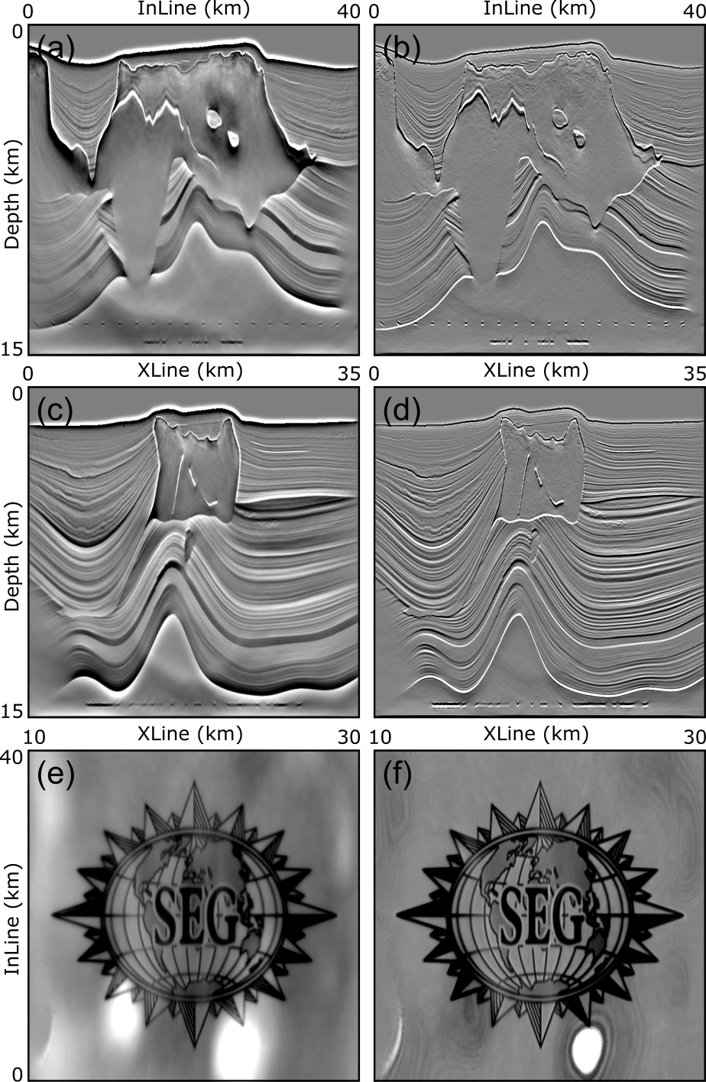
Figure 4 TTI RTM images a) an impedance image at the inline position 801, b) a reflectivity image at inline position 801, c) an impedance image at the crossline position 901, d) a reflectivity image at the crossline position 901, e) an impedance image at depth 14.3km, e) a reflectivity image at depth 14.3km.
The salt network was trained interactively for 30 epochs using 6 inlines (ILs) and 4 crosslines (XLs). The architecture type used was a binary E-Net with a loss function that uses a mix of Focal loss and Dice loss. The entire labelling and training process, including the generation of the probability cubes, top/base horizons, and geobody, took approximately 5 hours. The trained salt model achieved geologically plausible and consistent predictions throughout the study area. From the network prediction, we were automatically extracted the top/base horizons and geobody for salt.

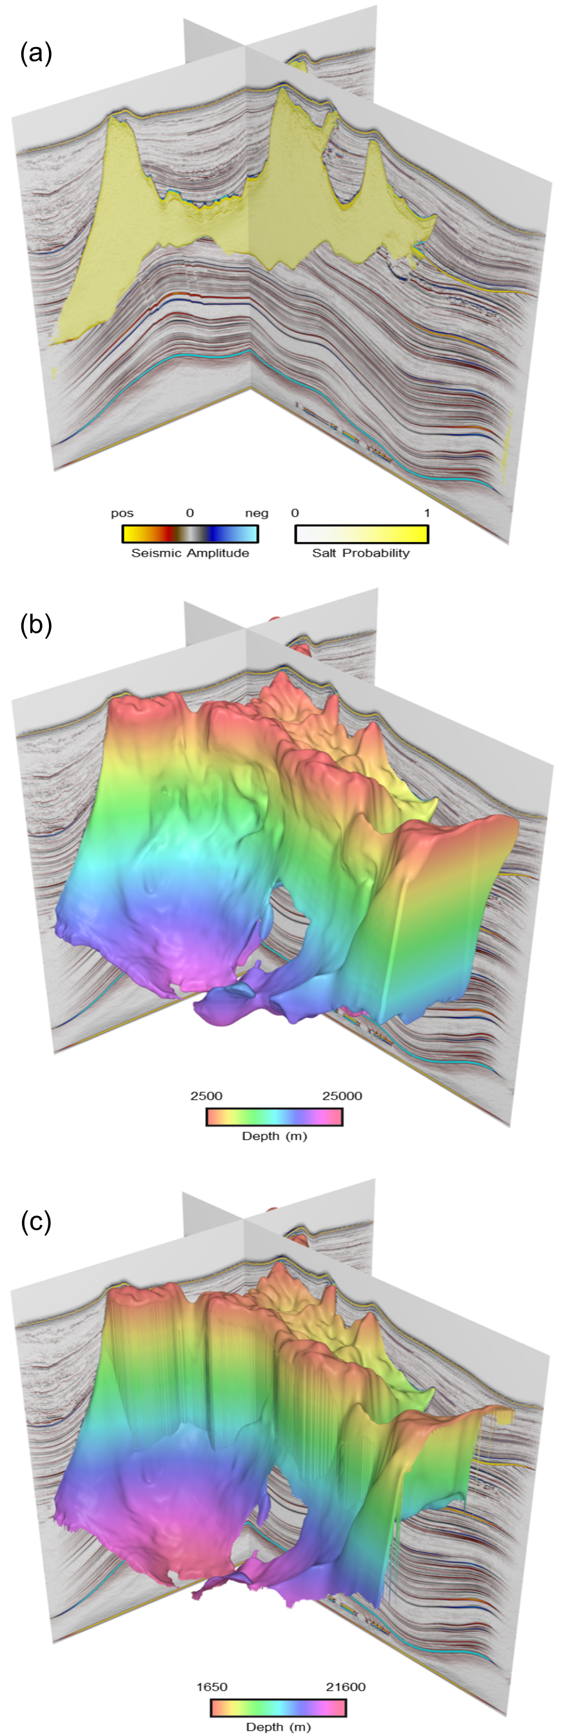
Figure 5 Interactive deep learning results on the 40 Hz RTM image that highlights the a) salt predictions, b) top of salt horizon, and c) salt geobody co-rendered with seismic amplitude. Note that the horizons and geobodies were automatically generated from the deep learning model during the export process.
Conclusions
In this study, we have successfully integrated high-performance computing (HPC), cloud platforms, and AI/ML to significantly enhance seismic imaging and interpretation processes. Our cloud-native Reverse Time Migration (RTM), supported by various AWS compute instances like Graviton3, has resulted in improved efficiency, resilience, and scalability for high-frequency imaging applications.
Additionally, we employed an interactive AI/ML approach for seismic interpretation, providing more accurate and faster geological predictions. The application of these methods in the SEAM TTI Subsalt example demonstrated their real-world effectiveness, showing the advantages of leveraging advanced technologies like HPC, cloud computing, and AI/ML to enhance the existing industry workflow.

Acknowledgments
We would like to express our gratitude to AWS, SeisWave and BluWare to give us the permission to publish this paper.
References
Baysal, E., Kosloff, D. D., & Sherwood, J. W. [1983], Reverse time migration. Geophysics, 48(11), 1514-1524.
McMechan, G. A. [1983], Migration by extrapolation of time-dependent boundary values. Geophysical Prospecting, 31(3), 413-420.
Tarantola, A. [1984], Inversion of seismic reflection data in the acoustic approximation. Geophysics, 49(8), 1259-1266.
Pratt, R. G., Shin, C., & Hick, G. J. [1998], Gauss-Newton and full Newton methods in frequency-space seismic waveform inversion. Geophysical Journal International, 133(2), 341-362.
Chenin, J., and Bedle, H. [2022], Unsupervised Machine Learning, Multi-Attribute Analysis for Identifying Low Saturation Gas Reservoirs within the Deepwater Gulf of Mexico, and Offshore Australia: Geosciences, 12, no. 3, 132.
Fehler, M. [2009], Technical & Operational Overview of SEAM Phase I Model: Presented at the 79th Annual International Meeting, SEG.
Wang, M. and Xu, S. [2015], Finite-difference time dispersion transforms for wave propagation: Geophysics, Vol. 80:6.
Zhang, Y., Ratcliffe, A., Robert, G. and Duan, L., [2014], Amplitude-preserving reverse time migration: From reflectivity to velocity and impedance inversion: Geophysics, 79:6, S271-S283.
Chopra, S., and Marfurt, K. J., [2018], Seismic facies classification using some unsupervised machine-learning methods: SEG Technical Program Expanded Abstracts 2018, 2056-2060.
Salamoff, S., Chenin, J., Lartigue, B., Phan, N. and Endresen, P., [2022], Detailed petroleum system insights using deep learning: A case study from the Scarborough Gas Field, offshore Australia: In SEG/AAPG International Meeting for Applied Geoscience & Energy

