Reservoir Characterization in the Bauna and Piracaba fields, Santos Basin
Ana Carla dos Santos Pinheiro¹, Francisco Romério Abrantes Júnior^{1,2}, Antonio Fernando Menezes Freire^{1,2}, Wagner Moreira Lupinacci^{1,2}
¹Exploratory Interpretation and Reservoir Characterization Group (GIECAR) – UFF
²National Institute of Petroleum Geophysics Science and Technology – INCT-GP

Copyright 2023, SBGf - Sociedade Brasileira de Geofísica
This paper was prepared for presentation during the 18th International Congress of the Brazilian Geophysical Society held in Rio de Janeiro, Brazil, 16-19 October 2023.
Contents of this paper were reviewed by the Technical Committee of the 18th International Congress of the Brazilian Geophysical Society and do not necessarily represent any position of the SBGf, its officers or members. Electronic reproduction or storage of any part of this paper for commercial purposes without the written consent of the Brazilian Geophysical Society is prohibited.

Abstract
The Santos Basin is located in the southeastern portion of the Brazilian margin, between the Altos de Cabo Frio and Florianópolis, which covers an area of about 350,000 ${km}^{2}$. This basin has a high diversification of reservoirs both in the pre-salt and in the post-salt, with many fields still under study and which have great production potential. The Marambaia Formation, of the Itamambuca Group, of the Eocene age, belongs to the low sea system phase with prograding wedges and coastal onlap. The main reservoirs of this formation are the turbidites of the Maresias Member. This study aimed to propose a workflow to map and characterize these turbidites in the Baúna and Piracaba fields. To achieve this purpose, the methodology was divided into interpretation and estimation of petrophysical properties in the wells, seismic well tie and use of RMS amplitude and relative acoustic impedance attributes. In several wells, the reservoirs do not exceed a few tens of meters in thickness, with this, the mapping of the turbidites was possible due to the inversion method chosen to increase the seismic resolution. The well logs showed a good correlation between the acoustic impedance and the porosity, and that reservoirs are two turbiditic lobes that have low acoustic impedance and high porosity.

Introduction
The reservoir characterization has become essential for the optimization process of hydrocarbon field management because it reduces the risks and costs of exploration and development. Characterization involves the production of a model that represents all the necessary features to depict the storage of hydrocarbons present in the field (Oil Field Glossary, 2006).
Well logs are indispensable tools for reservoir property characterization because they provide patterns for correlation between wells, geological mapping, and definition of the geometry of bodies and sedimentary environments. Each log measures a specific type of geophysical signal based on a physical property of the rock (Rider, 1996).
There has been growing interest in seismic inversion in recent years, principally because it allows for the inference of geological and petrophysical information from seismic data in the early stages of reservoir study (Simm e Bacon, 2014). The evolution of inversion techniques is driven by the increasing challenges of the oil industry. Currently, seismic data inversion for acoustic impedance is the most used technique to assist in reservoir characterization. It has proven to be highly efficient in estimating petrophysical parameters through the integration of well log data (Ferreira e Lupinacci, 2018; Lupinacci et al., 2020).
The present study focuses on the detailed characterization of the turbidite reservoirs in the Baúna and Piracaba fields. The studied reservoirs correspond to the Oligocene siliciclastic sandstones of the Marambaia Formation (Maresias Member), which are associated with a complex system turbiditic. The aim is to identify and characterize the geobody of the turbiditic system in terms of relative acoustic impedance and porosity.

Methodology
We used data from twelve wells and a seismic volume for this study. The seismic data employed is a post-stack time migrated (PSTM) 3D volume covering an area of 100 ${km}^{2}$ (Figure 1).
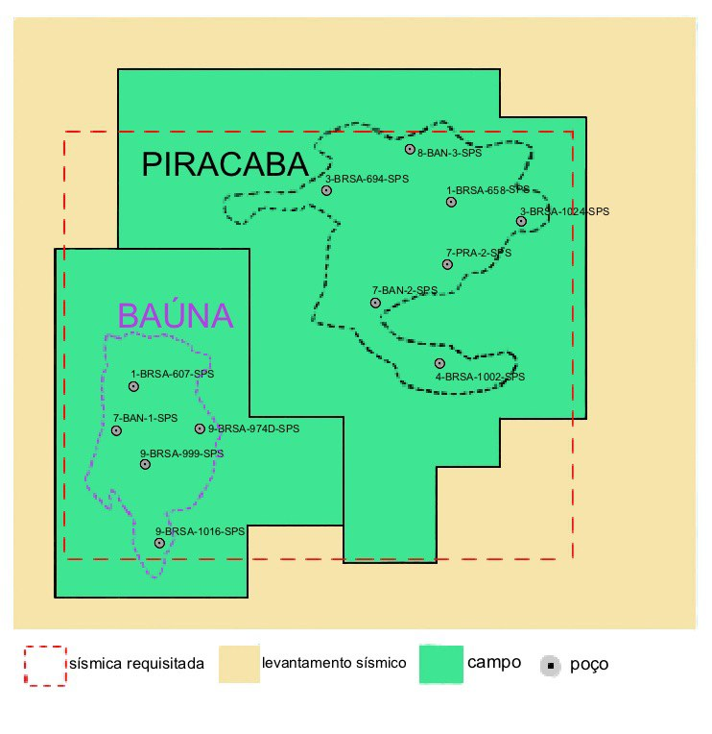
Figure 1: Location of the study area.

The methodology is divided into five steps:
- Interpretation of well logs
The well data evaluation aimed to define reservoir zones and estimate properties such as clay volume, porosity, and saturation. For this purpose, the following well logs were used: gamma ray (GR), caliper (CAL), neutron porosity (NPHI), bulk density (RHOB), shallow, medium, and deep resistivities (RES), and sonic (DTCO)
The initial estimation was made using the gamma ray (GR) log, which measures the radioactivity of rocks:
$$IGR=\frac{{GR}_{_log}-{GR}_{min}}{{GR}_{max}-{GR}_{min}},$$
where ${GR}_{log}$ is the value read from the log, ${GR}_{min}$ is the average of the minimum values read in a clean zone, and ${GR}_{max}$ is the average of the maximum values read in a shale zone. With the value of IGR, we can use empirical models to calculate the clay volume (Vclay). The most used models are: Linear, Larionov for recent and older rocks, Clavier, and Stieber (Schön, 2011). We used the Larionov method for recent rocks to estimate the clay volume (Vclay):
$$Vclay=0,083\left(2^{3,7*IGR}-1\right).$$
The next step involved calculating porosity and saturation. For this, neutron (NPHI), density (RHOB), clay volume (Vclay), and temperature logs were required. We choose the Neutron Density method to estimate porosity. Total and effective porosities were calculated by combining the clay volume with the neutron and density logs.
The Archie equation (Schön, 2011) used to estimate the water saturation (Sw):
$$S_{w}=\sqrt[n]{\frac{α R_{w}}{Φ^{m}R_{t}}},$$
where $R_{t}$ is the resistivity read from the log, $R_{w}$ is the resistivity of formation water, $Φ$ is the porosity, $m$ is the cementation exponent, $n$ is the saturation exponent, and $α$ is the tortuosity parameter. We used m=n=2 and $α$ =1. We identified a zone with 100% water saturation and Pickett Plot technique to obtain the value of $R_{w}$.

- Sensitivity analysis for acoustic inversion
This analysis aided in the interpretation of seismic inversion results. The acoustic impedance data were analyzed in relation to lithology and effective porosity.

- Seismic well tie
The third phase involved seismic well tie, aiming to correlate information extracted from well data with seismic attributes. For the seismic well tie, a synthetic seismic trace was generated for the wells using the convolutional model of reflectivity function with a zero-phase seismic pulse obtained from the frequency spectrum within a given seismic data window. We used a window from 1900 to 2250 ms for well to seismic tie. The reflectivity function of each well was obtained through the acoustic impedance log, which is calculated from the velocity and density logs.

- Application of RMS attribute and relative acoustic impedance
The RMS seismic attribute helped to better visualize the depositional system. The RMS is a stratigraphic attribute that has a good response to changes in rock properties.
In general, attributes related to the energy content of the seismic trace are used to distinguish different lithology types. High RMS amplitude values are commonly associated with lithological changes, channels, high-porosity rocks (porous sands), bright spots, and particularly gas-saturated sandstone zones. (Taner et al., 1979; Yushuang & Simiao, 2013).
- Seismic inversion and application of relative acoustic impedance
We performed a sparse-spike inversion to improve the identification of sandstone bodies. Through a sparse-spike inversion algorithm, the series of reflectivity coefficients that closely approximate the original seismic data is estimated using a minimum number of pulses (spikes) (Debeye & Riel, 1990). The inverse problem solution is not unique, meaning there are many series of reflection coefficients that, when convolved with the seismic pulse, reproduce the seismic data. Restrictions were applied to the inversion process to limit the solutions and reduce the non-uniqueness of the inverse problem. As a result, the obtained outcome provides a better geological and geophysical interpretation.

Results and Discussion
The evaluation of the well logs started with the pioneer well (1_BRSA_607_SPS), which provided results that served as a guide for assessing the other wells. This well exhibits three sandstone zones, surrounded by shale layers with well-defined boundaries. These zones were named ARN1, ARN2, and ARN3, and they show low and similar clay volume values, with an average of 1.77%.
The reservoir zones have low values of acoustic impedance, with the ARN_2 zone having the lowest AI values, around 4500 g/${cm}^{3}$*m/s. On the other hand, the shales have higher AI values compared to the sandstones. This demonstrates the potential of using acoustic impedance for lithology separation in the study area. The average water saturation value found for the three zones was 25%, and the total and effective porosities were 33% and 32%, respectively.

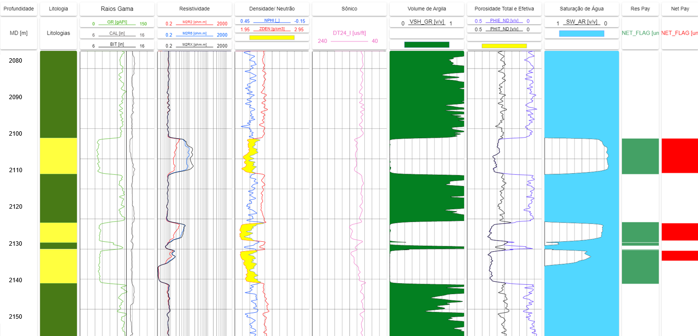
Figure 2: Interval 2100/2150 m from well 1-BRSA-607-SPS. Order of tracks from left to right: Lithologies (ANP); Gamma Ray, Caliper, and Bit Size; Shallow, Medium and Deep Resistivity; Density and Neutron Porosity; Sonic; Acoustic Impedance; Clay Volume; Total and Effective Porosity; Water Saturation; Net Reservoir; Net Pay.

We performed an acoustic impedance (AI) sensitivity analysis to identify lithologies in the range of interest. Figure 3 displays the acoustic impedance histograms of sandstones and shales from well 1-BRSA-607-SPS. The mean and standard deviation for AI values in the sandstones are 5200 g/${cm}^{3}$*m/s and 510, respectively. On the other hand, the shales have an average of 6720 g/${cm}^{3}$*m/s and a standard deviation of 317. This demonstrate the acoustic impedance ability to differentiate between sandstones and shales in the study area.
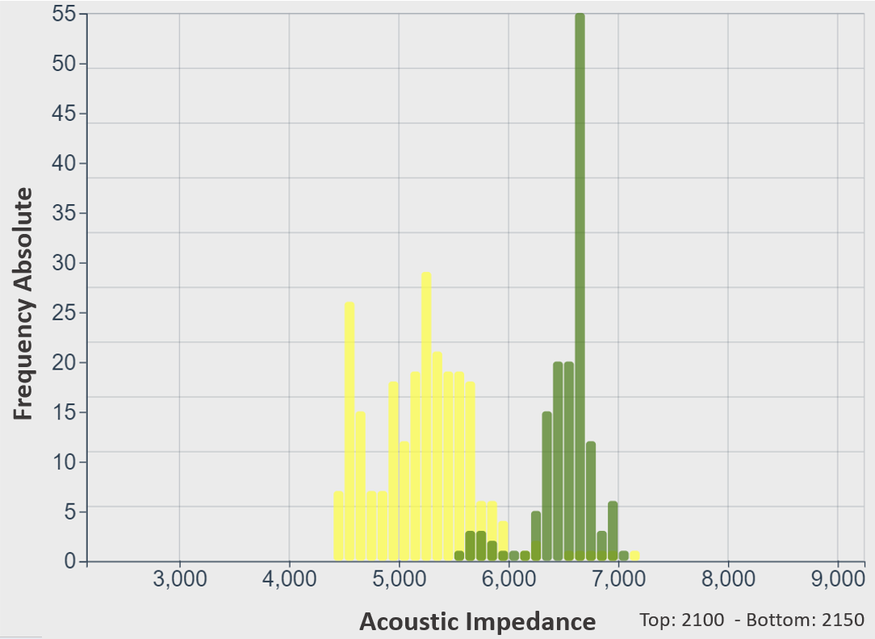
Figure 3: Histogram of acoustic impedance (X-axis) colored by lithology for all wells.

The crossplots of effective porosity versus acoustic impedance show that sandstones have high porosity and low AI values and shales have high acoustic impedance and low porosity values (Figure 4). Figures 3 and 4 prove the potential of IP to separate lithologies and identify regions with greater porosity.
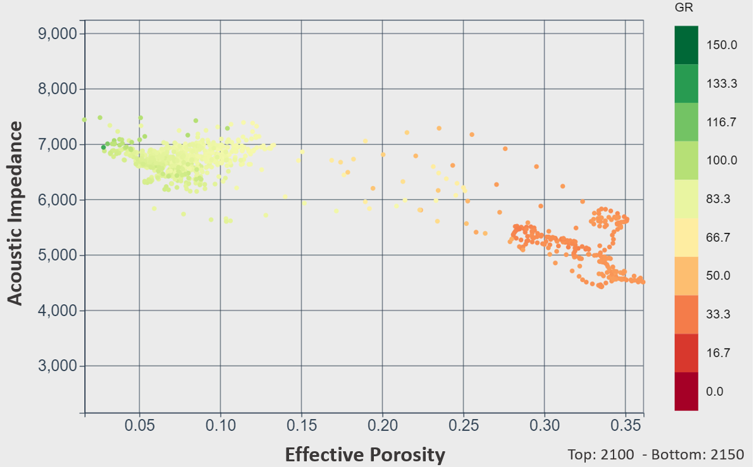
Figure 4: Crossplot Porosity versus Acoustic Impedance.

The seismic attributes RMS and relative acoustic impedance employed together allowed a better understanding of the depositional system. We have used these attributes to generate geobody and perform porosity and fluid saturation modeling (Lupinacci et al., 2021).
The RMS amplitude attribute highlighted the distribution of turbidites and helped to better understand the reservoir shapes in the Baúna and Piracaba fields. Figure 5 illustrates a time slice at 2080 ms of the RMS, where channel and two turbidite lobes are highlighted in the Marambaia Formation, of Eocene age. In the main lobe to the north, the feeder channel and its entire fan can be observed. In the turbidite deposit to the south, only the distal lobe is visible, and it is not possible to identify its feeder channel as it lies outside the limits of the database. Therefore, it is not possible to conclude whether the two lobes are fed by the same channel.
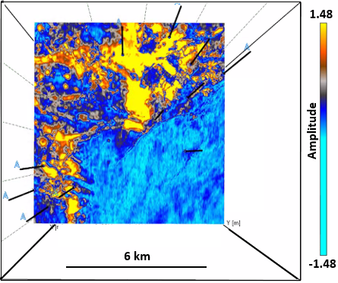
Figure 5: Time slice at 2080ms with RMS amplitude attribute.

For the analysis of the seismic inversion results, the relative acoustic impedance model is displayed in a time slice at 2080 ms (Figure 6). In the interval of interest, negative values of AI, represented by red, can correspond to the sandstones. The color mapping allows for the visualization and identification of potential sandstone reservoirs within the studied area.
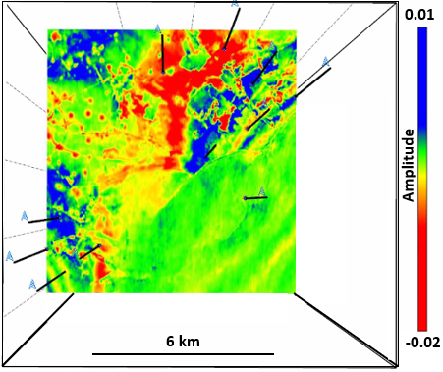
Figure 6: Time slice at 2080ms of the relative acoustic impedance.
The analysis of AI in conjunction with the RMS attribute (Figure 7) allows for a better interpretation. Here, we associate the best reservoirs with negative AI values and high RMS values (yellow color). In the Piracaba Field, the co-rendering of relative AI with the RMS attribute highlights lower AI values in the central region of the lobe. This can be explained by the energy of the system, where sandstones with coarser grain size and lower clay volume content are typically found in the central part of a turbidite system, while sediments of lower energy, such as finer and more clay-rich sands, are in the more distal part of the lobe.
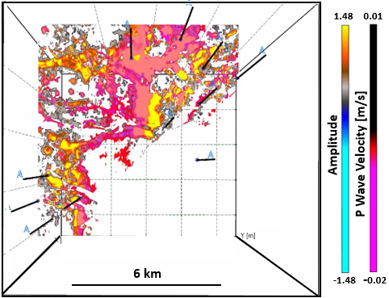
Figure 7: Co-rendering of the RMS attribute and the model of relative acoustic impedance.

In Figure 8, we observed that the relative acoustic impedance model highlights the central region of the turbidite lobe, indicating the best reservoir zones. According to the well evaluations, the thickness of the sandstone layers does not exceed 15 meters in any of the wells used in the project. The sparse-spike inversion technique improved the identification of these bodies, demonstrating its effectiveness for thin reservoirs. These zones are identified due to their low acoustic impedance.
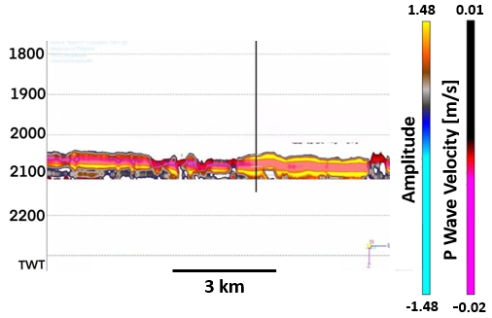
Figure 8: Co-rendering of the RMS attribute and the model of relative acoustic impedance.

Conclusions
By integrating seismic attributes and well logs, we detected and characterized the reservoirs of the Piracaba and Bauna fields. In the wells, one to three producing zones were identified, with thicknesses ranging from 12 to 45 meters. Comparing the two turbidite systems, the Baúna Field presents reservoirs with an average thickness of 25 meters, divided into two parts with intercalations of shale. On the other hand, the Piracaba Field has reservoirs with an average thickness of 14 meters, usually occurring within a single interval. Evaluating the reservoir properties, we found that they are sandy reservoirs with low clay volume, high effective porosity, and high oil saturation.
The RMS amplitude attribute highlighted the distribution of turbidite bodies and helped to better understand the shape of the reservoirs. With this attribute, we visualized the feeder channel, the lobe, and its entire spread in the Piracaba Field, while in the Baúna Field, only the distal part of the lobe could be observed. The co-rendering of relative acoustic impedance with the RMS attribute allowed for a better interpretation of the turbidite bodies. The best reservoirs were associated with negative AI values and high RMS values. In the Piracaba Field, this combination highlighted lower AI values in the central region of the lobe. However, in the Baúna Field, this conclusion was not possible due to the limited coverage area of the seismic data.

Acknowledgments
The authors would like to thank the National Agency of Petroleum, Natural Gas and Biofuels (ANP) for providing well data and AspenTech and Senergy for the programs and academic licenses that allowed this work to be carried out.

References
Debeye, H.W.J., Riel, P.V., 1990. LP-norm deconvolution. Geophys. Prospect. 38: P381–P404.
Ferreira, D.J.A., Lupinacci, W.M., 2018. An approach for three-dimensional quantitative carbonate reservoir characterization in the Pampo field, Campos Basin, offshore Brazil. AAPG Bulletin, 102(11), 2267-2282.Oil Field Glossary, Available at: <www.sbl.com>, accessed June 2020.
Lupinacci, W.M., Gomes, L.M.S., Ferreira, D.J.A., 2020. An integrated approach for carbonate reservoir characterization: a case study from the Linguado Field, Campos Basin. Brazilian Journal of Geology: 50 (4)
Lupinacci, W.M., Schanzembach, A., Freire, A.F.M., 2021. Modeling of Reservoir Properties Using Seismic Attributes and Evaluation of Well Logs: A Case Study in Bauna and Piracaba Oil Fields, Santos Basin, Brazil. Brazilian Journal of Geophysics: 39(1)
Rider, M. H. The geological interpretation of well logs. Hardcover, Gulf Publishing, 280 p.,1996.
Schön, J.H. Physical properties of rocks: Fundamentals and principles of petrophysics. Handbook of Geophysical Exploration, Seismic Exploration. Pergamon, Vol. 8, 494 p., 2011
Simm, R, Bacon, M, 2014. Seismic Amplitude: An Interpreter's Handbook. Cambridge University Press, 276p.
Taner, M. T., F. Koehler, and R. E. Sheriff, 1979, Complex seismic trace analysis: Geophysics, 44, 1041– 1063.
Yushuang, Hu., Simiao, Zhu., 2013. Predict channel sand body distribution characteristics of south eighth district based on RMS amplitude attributes & frequency division. Adv Mater Res 734: 404–407.

