Optimizing the 4D QI Process – a Brazilian turbidite case study
Lucia Dillon¹, Guenther Schwedersky¹, Cassiane Nunes², Leonildes de Melo Filho², Henrique Roisenberg¹, Alessandra Gomes³, ¹QIgeo, ²Repsol-Sinopec, ³Unicamp.

Copyright 2023, SBGf - Sociedade Brasileira de Geofísica
This paper was prepared for presentation during the 18th International Congress of the Brazilian Geophysical Society held in Rio de Janeiro, Brazil, 16-19 October 2023.
Contents of this paper were reviewed by the Technical Committee of the 18th International Congress of the Brazilian Geophysical Society and do not necessarily represent any position of the SBGf, its officers or members. Electronic reproduction or storage of any part of this paper for commercial purposes without the written consent of the Brazilian Geophysical Society is prohibited.

Abstract

The objective of this work was to optimize each stage of the macro process (3D/4D Quantitative Interpretation - QI), which includes: (a) probabilistic integrated modelling in terms of Statistical Rock Physics; (b) the use of different seismic data inversion methodologies (deterministic and/or stochastic) and (c) analysis and application of different methods for classification of seismic attributes in order to translate them in terms of the petrophysical properties of the reservoir. The pilot field chosen to demonstrate the proposed workflow is a Miocene Turbidite Field off-shore Brazil. In special, several simulations of Elastic Seismic Inversions, both Deterministic and Stochastic, were performed considering the most impacting sources of uncertainties in the inversion process. For the stochastic approach, seeking to optimize the information available from seismic data, a large cluster with more than 9000 cores was used to generate hundreds of simulations in this seismic inversion processes. However, another challenge was to analyze these hundreds of generated simulations, identifying the most likely and representative. The promising solution found was the use of Multidimensional Scaling (MDS) methodology. Through the projected dimensionality reduction established by the MDS method, it was possible to better analyze results, optimizing the interpretations and, effectively, making viable the evaluation of the cumulative uncertainties intrinsic to the whole process of 4D reservoir characterization.

Introduction
Stochastic Elastic Inversion technology has emerged as an excellent option to support the reservoir characterization process. This technology allows to consider the combination of all available information, as well as the specific knowledge of the interpreter. All this information can be tested in terms of dozens of inversion simulations, which intrinsically guides towards a more accurate result as well as generates a more realistic mapping of the cumulative uncertainties inherent to the process.
The optimization of results in such inversion processes is a function of the viability in generating a huge number of realizations. In this approach, what some time ago was impossible due to the computational limitations, today is perfectly feasible (Pendrel and Schouten, 2020).
For this work, a large Cluster - with more than 9000 cores - was used to generate hundreds of simulations in stochastic seismic inversion processes applied to a Miocene Turbidite Field offshore Brazil. For this pilot area, it was available two seismic 3D acquisitions (2005 and 2012) to better characterize the 4D QI process.
In this context, an important challenge is how to make an analysis of this huge number of simulations. The appropriate solution we found was the use Multidimensional Scaling (MDS) processes. This methodology allows the evaluation of differences and similarities between the countless volumes of properties (simulations) generated. Then, through a clustering process of the different volumes already projected through the dimensionality reduction established by the MDS method, it was possible to better analyze results, optimizing the 3D and 4D interpretations and, effectively, making also viable the evaluation of the cumulative uncertainties intrinsic to the whole process.

Methods
Pilot Area
The pilot oil field chosen to demonstrate the proposed study is a Miocene Turbidite field off-shore Brazil, under water depths ranging from 1000m to 2150m and occupying an area more than 500km2. The sandstones were accumulated in large depressive sediment capture areas, where the reservoir facies are formed by fine to medium sandstones, with porosity range between 20 – 30%, and variable clay content. Seismic data from 2005 and 2012 contain 3D cell: 6,25m x 12,5 m and 47 Wells with log acquisition were available.

Rock Physics Analysis
Rock Physics Modelling (RPM) is key step for the Quantitative Interpretation Process. Rock Physics Models (RPM) were also the basic tools to simulate and extrapolate 4D (what if) scenarios not yet sampled by wells, such as variation in the type of fluids and pore pressure in the porous medium. From the analysis of well data, sedimentological descriptions, petrophysical and mineralogical information, it was clear that the “Unconsolidated Model” as described by Dvorkin and Nur, 1996, was the most appropriate RPM, but different parametrizations must be assumed depending on the type of sandstone sequence, mostly due to the grain size and clay content variations. Figure 1 illustrates the elastic response of this reservoir. In this figure, the cross-plot shows a correlation between P Impedance (PI) versus the Vp/Vs (ratio between P and S velocities). The RPM models templates, calibrated for this specific lithologies, were also plotted considering that the pore pressure (Pp) is varying from 16 MPa to 32 MPa and the Brine saturation (Sw) could also vary from 12% to 100 %. The reservoir sandstones were separated in three facies (brown, orange and pink). In special, the pink dots refer to sandstones classified as “clean sandstones” and are predominantly coming from well 03. The green dots are from the shale intervals. In figure 2a, the cross-plot domain shows a correlation between S Impedance (SI) versus the Acoustic Impedance (PI), simulating 5 different probable scenarios of 4D variations related simultaneously to pore pressure (Pp) and water saturation (Sw). The PI and SI variations found, for each of the 5 scenarios, are plotted in figure 2b.

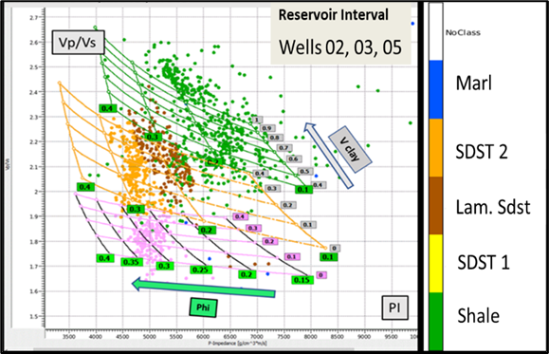
Figure 1
RPM templates varying % of clay and porosity.

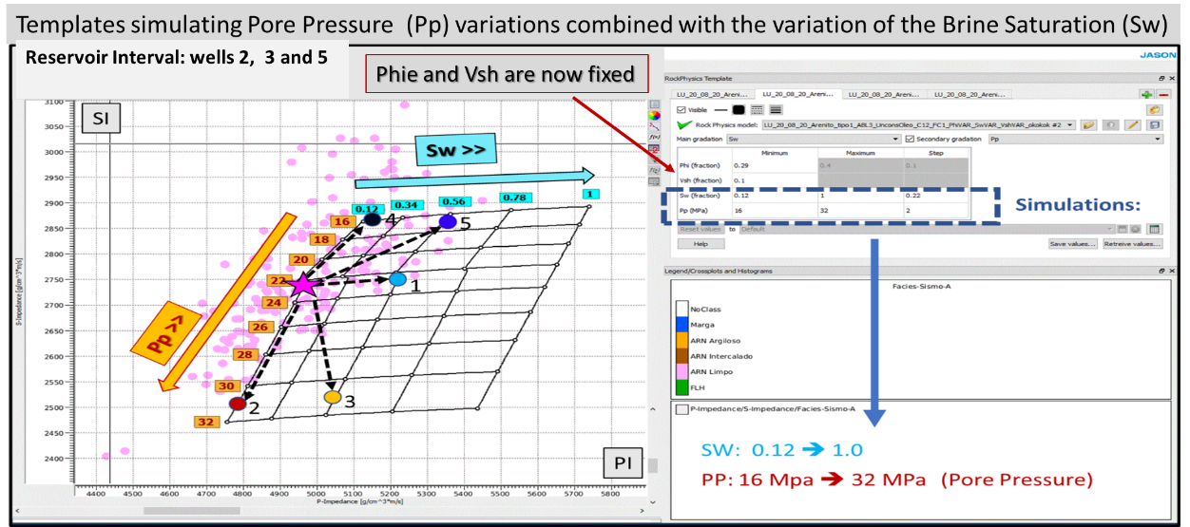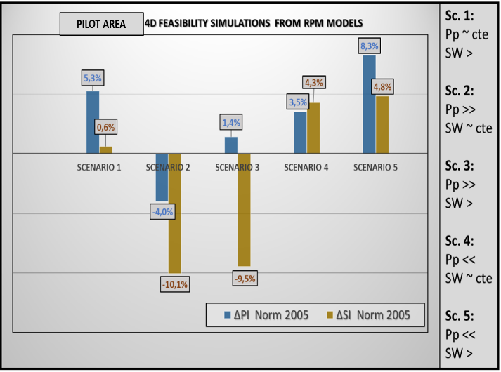
Figure 2a Figure 2b
2(a) RPM Templates varying Pore pressure and Water saturation. Five different “what if” scenarios were analyzed. 2(b) Observed Normalized PI and SI (P and S Impedances) for each of the five assumed scenarios.

Stochastic Elastic Inversion
In this work, a direct transformation of the input seismic data into reservoir properties is based on a stochastic approach where different geological and geophysical information are expressed in terms of probability density functions (PDF) and combined in a multidimensional PDF. An algorithm based on the Markov Chain Monte Carlo (MCMC) method is then used to sample this multivariate distribution. For many years, since the first proposals of Stochastic Inversions (Haas and Dubrule,1994), at that time based on Sequential Gaussian Simulations, the computational efficiency was a bottle neck which avoided the proper use of the stochastic approach. However, now the computation efficiency is in a level that turns the whole process viable. For this project, we had access to a HPC AIRIS, a supercomputer dedicated to O&G Innovation in Brazil with 240 CPU nodes and more than 9000 cores. In terms of computational time, one hundred of stochastic simulations were run in one hour. In a comparative way, just one simulation in a workstation takes 4 hours. This allowed to test many important features of the stochastic inversion. In theory, any type of information can be incorporated into the process: the seismic information itself, facies and their a priori proportions, variograms, multivariate probability density functions and rock physics models (RPM). To explore the uncertainty related to those possibilities, several deterministic and stochastic inversions were performed, both acoustic and elastic, testing different parametrizations, also changing the seismic attributes conditioning the classification, the prior information and so on. Results examples are shown in the Figure 3. In this figure if one compares the deterministic and stochastic results for PI and facies simulation, the improvement related to the stochastic methods is evident.

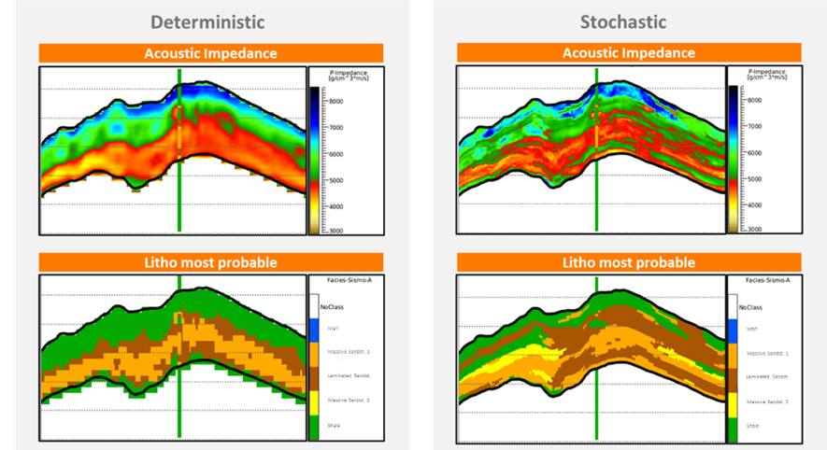

Figure 3
Comparison of results for Deterministic and Stochastic Inversions: Acoustic Impedance and Most Probable Facies classification.

Data Analysis
MDS are very useful in geosciences, in terms of visualization of uncertainties, by comparing the distances between different models simulated statistically (Caers, 2011). After the generation of a huge number of stochastic inversion simulations for the pilot area, we made the option to select the best representative models using the Multidimensional Scaling Methodology (MDS). In fact, our analyzes showed us that the MDS technology is, really, very suitable to achieve this goal. Besides that, MDS may be also useful to analyze the behavior of the results as a function of the numbers of realizations (Figure 4). In this example, what is shown is the MDS plot of simulations run with the same parameters but varying the number of realizations, from 1 to 200. After 50 realizations the average starts to stabilize, indicating that enough realizations have been reached.

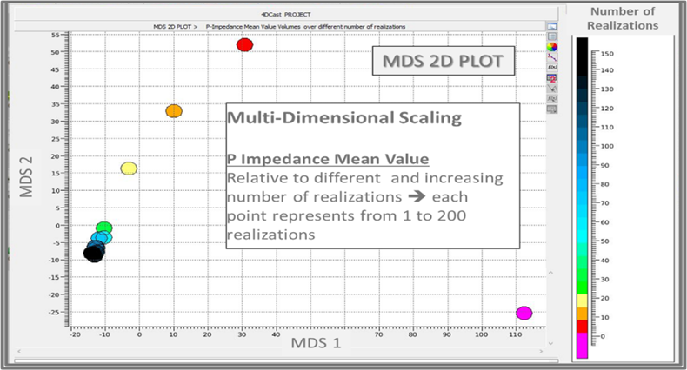
Figure 4
MDS (Multi-Dimensional Scaling) Plot: For this figure example, the proposal was to evaluate the impact of the number of realizations on the Stochastic Inversion Process.

All the QI procedures, including the deterministic and stochastic inversions had been done for both the 3D and 4D analysis. The 3D and 4D QI analysis took in account all the possibilities in terms of different inversion technologies and implemented workflows.
What was clearly observed is that:
(1) the most consistent and coherent continuity of the results were obtained for the 4D Stochastic Inversion, which presents higher definition as well as a much smaller amount of spurious noise.
(2) Stochastic Inversion shows a much better connection with the conclusions of the 4D feasibility studies previously carried out.
(3) these results are also in better agreement with the predictions of pore pressure and water saturation variations indicated by the maps generated in the reservoir flow simulation process, based on history matching information. It is worth to mention that, during the production, from 2005-2012, the reservoir of the pilot field has been over pressurized.

In fact, much of the 4D analysis was performed in terms of stratal slices of the reservoir as a function of the geological system composed of superimposed channels.
As an example of the obtained results, figure 5 (b) (central map), shows a good example where, normalized PI (P Impedance) variation is correctly indicating the 4D effect. It can be observed that the 4D attribute map, representative of the reservoir base, is well indicating the water percentual increase (blue color) as well as de pore pressure increase (red color) in pore space.
Also, in figure 5, to make clearer the 4D effects, to make the results clearer, the reservoir simulation maps can be seen (Repsol&Sinopec Information): figure 5 (a) on the left side, representing the income of water and figure 5 (c) on the right side, representing the pore pressure variations.

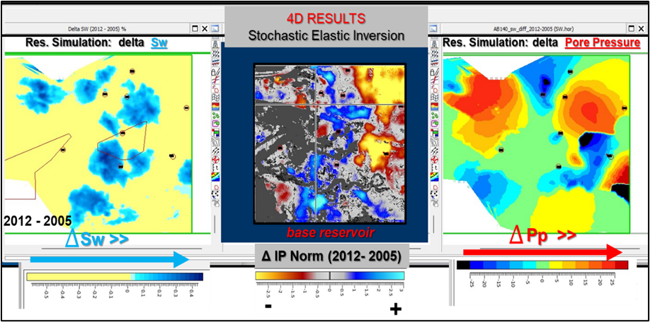
(a) (b) (c)
Figure 5
a) Left Side: Reservoir Simulation for Sw changes (2005 – 2012) , (b) Central: Stratal Slice representative of the Reservoir Base related to the Normalized PI (P Impedance) changes observed between base and monitor seismic acquisition ( 2005 – 2012), (c) Right Side: Reservoir Simulation for Pore Pressure changes (2005 – 2012).

Final Remarks

- For the 4D QI (Quantitative Interpretation) analysis, the procedures based on deterministic elastic inversion approach are faster in terms of computation time but gives results with lower resolution.
- The stochastic approach - based on stochastic elastic inversions - has the advantage to incorporate many kinds of information and gives resolution beyond the seismic information as well as it allows to generate an estimate of the global uncertainties involved in the process.
- The MDS technology proved to be an optimal choice to evaluate and incorporate the uncertainties in the Quantitative Interpretation Process.

Acknowledgment
This project was developed with the Brazilian ANP research and development incentive law nº 9.478, 06/08/1997 and the authors thank Repsol Sinopec Brasil for all support to this work. The authors also thank CGG for providing the Stochastic Inversion (Cluster) license, as well as the geophysicist Felipe Melo for technical support regarding the use of Stochastic Inversion in the cluster (HPC) environment.

References
Caers, J. (2011). Modeling Uncertainty in the Earth Sciences. Wiley-Blackwell.
Dvorkin, J, & Nur, A. (1996). Elasticity of high-porosity sandstones: Theory for two North Sea data sets. Geophysics, 61(5), 1363–1370. https://doi.org/10.1190/1.1444059
Haas, A, & Dubrule, O. (1994). Geostatistical Inversion – a sequential method of stochastic reservoir modeling constrained by seismic data. First Break, 12(11), 561–569. https://doi.org/10.3997/1365-2397.1994034
Pendrel, J, & Schouten, H. (2020). Facies — The drivers for modern inversions. The Leading Edge, 39(2), 102–109. https://doi.org/10.1190/tle39020102.1

