Revisiting the Reservoir-Triggered Seismicity (RTS) at Nova Ponte Reservoir, Minas Gerais, Brazil
Lucas V. Barros, Juraci M. de Carvalho, Diogo Farrapo Albuquerque, Darlan P. Fontenele and Vinícius de Miranda Pellussi.
Seismological Observatory, University of Brasília (SIS-UnB).

Copyright 2023, SBGf - Sociedade Brasileira de Geofísica
This paper was prepared for presentation during the 18th International Congress of the Brazilian Geophysical Society held in Rio de Janeiro, Brazil, 16-19 October 2023.
Contents of this paper were reviewed by the Technical Committee of the 18th International Congress of the Brazilian Geophysical Society and do not necessarily represent any position of the SBGf, its officers or members. Electronic reproduction or storage of any part of this paper for commercial purposes without the written consent of the Brazilian Geophysical Society is prohibited.

Abstract
Nova Ponte (NP) is one of the 26 proven cases of RTS in Brazil. It triggered the second largest magnitude (4.0 mb) and Intensity VI (MM) in May 1998. From 1988 to 1993, NP was monitored with only one station, and from 1994 to 2013, it was used a local seismographic network (up to 8 stations). More recently, with regional stations belonging to the Brazilian Seismographic Network (BSN). The NP seismicity occurred mainly in two clusters, inside and outside the lake, forming two main seismic areas. The three largest events were detected in 1995 (Mag. 3.5), 1998 (Mag. 4.0) and, more recently, in December 2019 (Mag. 3.0). All of them were located on the margin of the lake at depths ranging from 2.0 km to 3.0 km. In the last three years, 7 events were detected, with magnitudes ranging from 2.0 to 3.0. The latter was noticed by the local inhabitants and was recorded by 30 stations of the BSN. In this work, we revisited the NP reservoir seismicity, reinterpreted the previous seismicity from 1994 to 1999 and updated the RTS observed in the last 23 years. The focal mechanism by waveform envelope inversion was estimated to the last main event occurred in December 2019. Considering only hypocenters with good location, determined in previous studies, it was possible to better examine the event distribution in relation to the fault’s parameters. Considering all focal mechanism estimated for the NP reservoir area, we can conclude that the area is submitted to a rough E-W compressional stress, concordant with theoretical studies in the region.

Introduction
The Reservoir Triggered Seismicity (RTS) at Nova Ponte (NP) was studied by Chimpliganond (2002), who presented its spatial and temporal characteristics between 1994 and 1999. Assumpção et al. (2002) described NP seismicity among other 15 RTS cases in Brazil. Gomide (1999) presented the NP RTS and its hydraulic diffusivity based in the seismicity migration on the reservoir area. Assumpção et al. (1997) presented two composite focal mechanisms for two seismic areas in the reservoir. Marza et al. (1997) also tried to obtain focal mechanism solutions for the same two seismic areas identified in NP. Marza et al. (1999) studied the precursory seismicity pattern associated to the NP main shock of May 22, 1998 (M 4.0, MMI VI). Veloso and Veloso (1997) presented a macrosseismic map for the M 3.5 main shock earthquake (04/21/995).
Brazil presents an expressive number of RTS cases (26), and NP is a proven case (Fig.1 and 2). With a dam of 142 m height and volume of 12.8 km³, NP reservoir triggered the second biggest magnitude in Brazil, 4.0 mb and VI (MM), in May 1998. Reservoir with this size in Brazil have around 60% of probability of presenting RTS (Barros et al., 2018).
In this work, we summarize the most important characteristics of the RTS in Brazil. Also, the past seismicity occurred at NP reservoir, studied by Chimpliganond (2002) and Assumpção et al. (2002), is reinterpreted using a better event selection. We present an update related to the seismicity observed in the last 23 years. A new focal mechanism estimated using envelop waveform inversion is presented for the last main shock occurred in December 2019. Finally, we discuss the space-temporal epicentral distribution in the context of faulting type.

Characteristics of RTS in Brazil
According to the two more complete studies of the Brazilian RTS cases (Assumpção et al. 2002; Barros et al. 2018), there is a possible correlation between RTS and some reservoir characteristics, including geology, stress regime, dam height and reservoir volume, and previous natural seismicity.
A correlation was observed between the previous natural seismicity and the probability of RTS, being regions with natural seismicity two times more prone to RTS than regions with no previous seismicity (Fig. 1).
Dam height: clearly the RTS increases with the reservoir height and volume, not only in Brazil but in the world. The probability of RTS is 2% for heights between 20 m and 50 m, 8% between 50 m and 100 m, and 65% for dams higher than 100 m.
Reservoir volume: 26% of the reservoirs with volumes between 1.0 km³ and 10 km³ triggered earthquakes, and this number increases to 47% for volumes larger than 10 km³.
Geology: no clear correlation with geology was found. However, dams built on igneous rocks tend to be slightly more prone to RTS compared with those built on sedimentary rocks, but the difference is not statistically significant.
Geological Province: no difference was found among the three main types of geological provinces (cratonic basement, Neoproterozoic fold belts, and intracratonic Phanerozoic basins).
Magnitude x reservoir size: although dam height and volume are the most influential characteristics for RTS, the maximum magnitude does not show any clear correlation with dam height or reservoir size, like other cases worldwide (see Fig. 2).
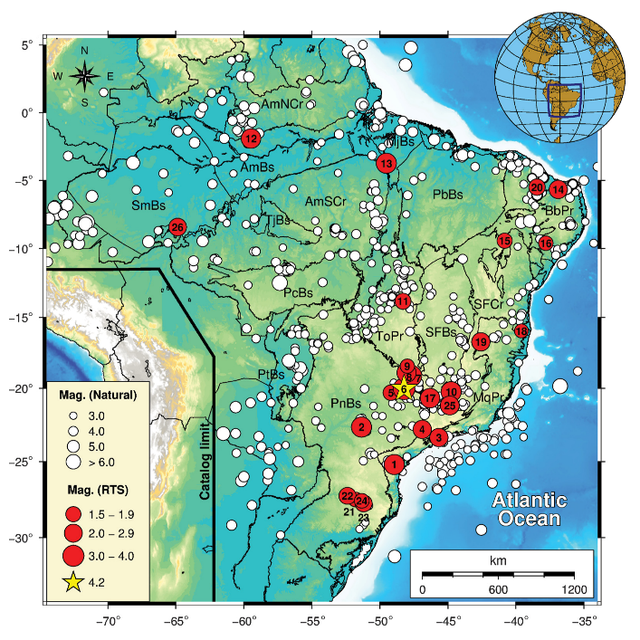
Figure 1 – RTS cases in Brazil (red circles, numbered according to Fig.2). White circles denote the natural seismicity. The yellow star is the largest RTS case (4.2 mb and MMI VI-VII). The blue square is the NP reservoir. The main geological provinces are shown as follows: AmPr, Amazon basin; AmCr, Amazon craton; PbBs, Parnaíba basin; BpPr, Borborema Province (fold belts); PcBs, Parecis basin; ToPr, Tocantins Province (fold belts); SFCr, São Francisco craton; PnBs, Paraná basin; MqPr, Mantiqueira Province (fold belts). Map extracted from Barros et al. (2018, p. 3047).
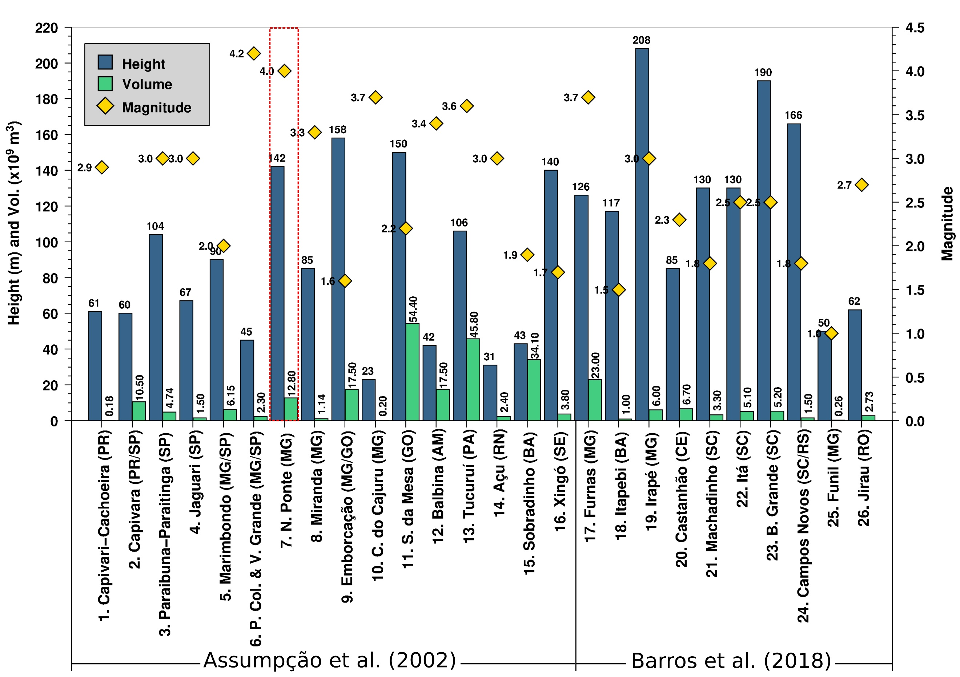
Figure 2 – Brazilian reservoirs with RTS. The numbers before each reservoir name are according to Fig.1. The magnitude indicated by yellow diamond is for the main event in each reservoir. Nova Ponte reservoir (7) is indicated by the dashed line (4.0 mb). Reservoirs are presented in chronological order (left to the right). The first case (Capivari–Cachoeira - PR) was observed in 1970 and the last one (Jirau - RO) in 2014. Blue bars denote reservoir height and green bars the volume in km³.

RTS in Nova Ponte
The NP reservoir is located on the limit of Paraná Basin and Tocantins Province (Fig. 1). Close to the NP reservoir, within a radius of about 200 km, there are more four cases of RTS (Fig. 1), including the case of the biggest magnitude observed in Brazil (4.2 mb and intensity VI-VII), that occurred between the two neighbor reservoirs of Porto Colombia and Volta Grande (Veloso, 1992), although in this location there is also an expressive number of reservoirs with large dimensions, more prone, therefore, to the occurrence of RTS.
The NP reservoir seismicity was monitored locally five years before impoundment (one station only) and six years before the beginning of the seismicity (in 1994), when it was deployed a local network of five stations. That increase to up eight stations, until 2012, when it was discontinued the cooperation between University of Brasília (UnB) and CEMIG (owner of NP reservoir) for seismic monitoring. The NP seismicity occurs mainly in two clusters, inside and outside the lake, forming two main seismic areas.
The biggest events, detected in 1995 (M 3.5) and 1998 (M 4.0), occurred both on the margin of the lake, and depths from 2.0 km to 3.0 km. In the last three years (up to 2019), 7 events were detected, with magnitudes ranging from 2.0 to 3.0. The latter (M 3.0) was felt by the local inhabitants and was recorded by 30 stations of the Brazilian Seismographic Network (BSN) located up to 1,000 km away.

Data and results
We used the event database of Chimpliganond (2002), composed of 386 events, located with the software Hypo 71 (Lee and Lahr, 1975), using a local velocity model determined by geophysics, geology, and the information present on the local seismicity.
With the objective of reducing the dispersion in the hypocenter distribution of database (C and B location quality), we used only good quality events (type B) in a total of 81 events. According to Lee and Lahr (1975), the selected events present the following quality indicators: horizontal location error (EH) ≤ 2.5 km; vertical location error (EZ) ≤ 5 km; azimuthal gap ≤ 135º; number of phases (N) > 6 (mostly N = 8); minimum distance (Dmin) < 2 km; and residue RMS < 0.3 second.
From December 1999 to 2012 more events were detected in NP, but they are still under investigation. After this period, events with magnitudes ranging from 2.0 to 3.0 were detected by stations located in neighboring reservoirs and, more recently, by BSN. The biggest observed magnitude, 3.0 mR, was recorded by 30 BSN stations.
Figure 3 shows the vertical waveforms recorded by 12 stations of BSN (8) and the Seismological Observatory (4). This event was felt by the population of Nova Ponte. The waveforms from 5 stations were used for envelope inversion (Fig. 4).
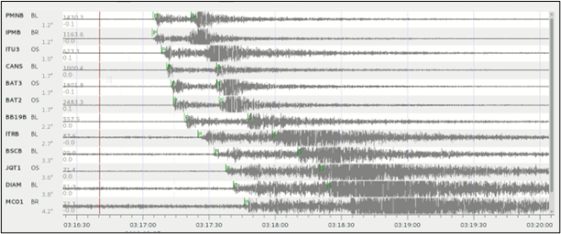
Figure 3 - Vertical waveforms in12 stations of the BSN (8) and Seismological Observatory network (4), located up to 500 km of the earthquake source, occurred on 12/27/2019, magnitude 3.0 mR.
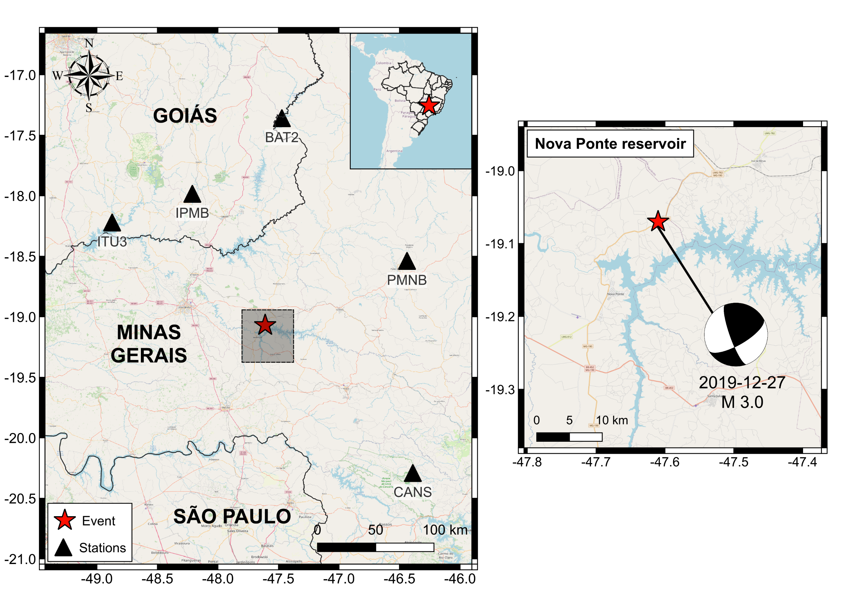
Figure 4 – Nova Ponte reservoir. The square denotes the study area. Black triangles denote the stations used in the envelop waveform inversion of M 3.0 event on 12/27/2019 (red star), and the beach ball corresponds to the focal mechanism solution.

Envelop waveform inversion for Moment Tensor
The envelop waveform inversion for Moment Tensor (MT) is an alternative methodology to the standard waveform inversion that is more robust with respect to inappropriate velocity models. The method is built on an empirical basis assuming that the source is 100% DC. The information about focal mechanism is encoded in the variation of the envelope shapes and amplitudes among the seismogram components (Carvalho et al., 2019).
Here it was applied to data of a M3.0 event, using data of the five closest stations of BSN (Fig. 4), such distances range from 130 km to 190 km. The inversion was made in the frequency band of 0.8 to 1.0 Hz. The waveform envelopes are shown on Fig. 5. As we can see there is a good correlation between synthetics (red) and observed (black).
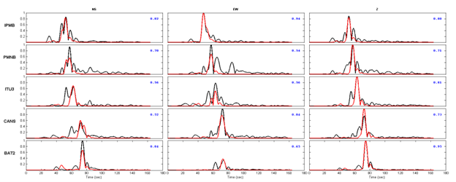
Figure 5 – Waveforms envelop in 5 stations of the BSN. The stations’ distance ranges from 130 to 190 km. The inversion was made in the frequency band of 0.8 Hz to 1.0 Hz.
Figure 6 presents all events located by Chimpliganond (2002). Initial seismicity was observed in the south branch of the lake, named Area 1 (1994), in a shallow part of the lake. In 1995 the events migrate in the direction to the dam (Area 2 in this Figure). On the right of each area is presented a zoom for better visualization.
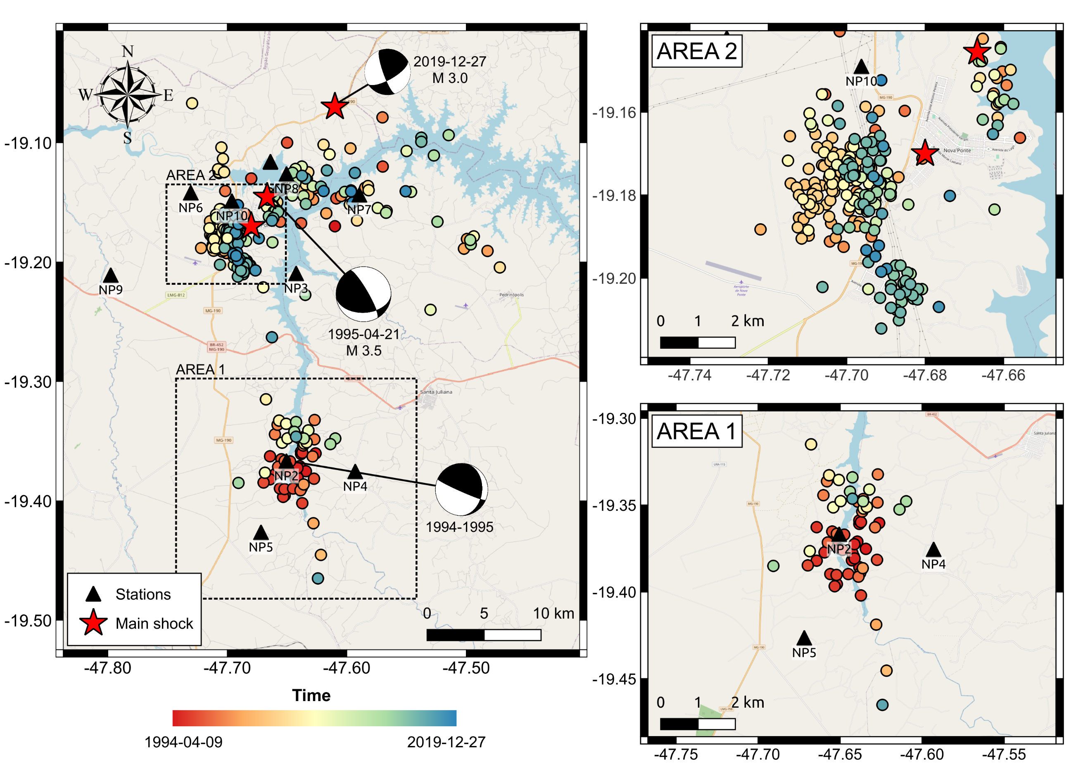
Figure 6a – RTS in Nova Ponte reservoir map. Stations (triangles), main events (red stars). The circle colors are according to the occurrence time. Here is shown all the events of Chimpliganond (2002) database detected from 1994 to 1999. The beach balls in Area 1 and Area 2 are composite focal mechanisms by Assumpção et al. (1997) for seismic activities occurred in 1994 and 1995-1996 in these areas, respectively, and for M3.0 of December 27, 2019 (this work).
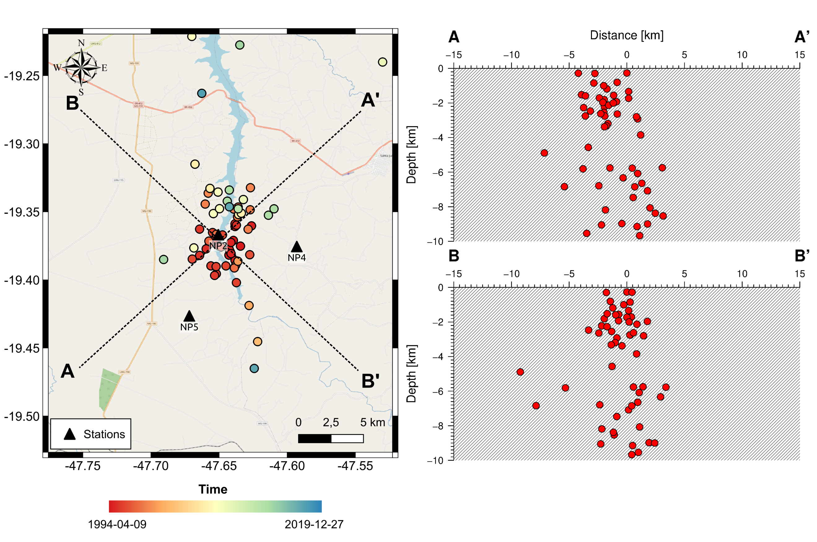
Figure 6b – Profiles A-A’ and B-B’ of the seismicity in Area 1.
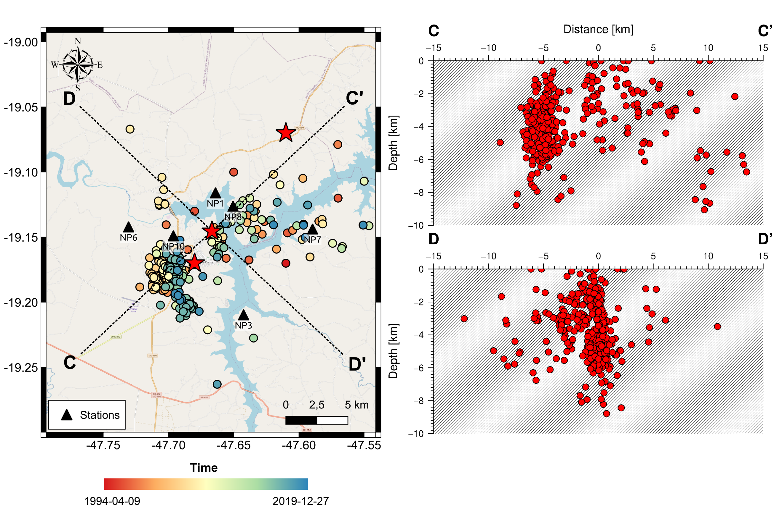
Figure 6c – Profiles C-C’ and D-D’ of the seismicity in Area 2.
Now, considering a plot of only quality B events (Fig. 7), we can see that the dispersion in epicenters distribution present in Fig. 6 can be related with the location data quality. In Area 1 (Fig. 7), we can see two parallels lineaments with a trend N-S, and a migration from east to the west.
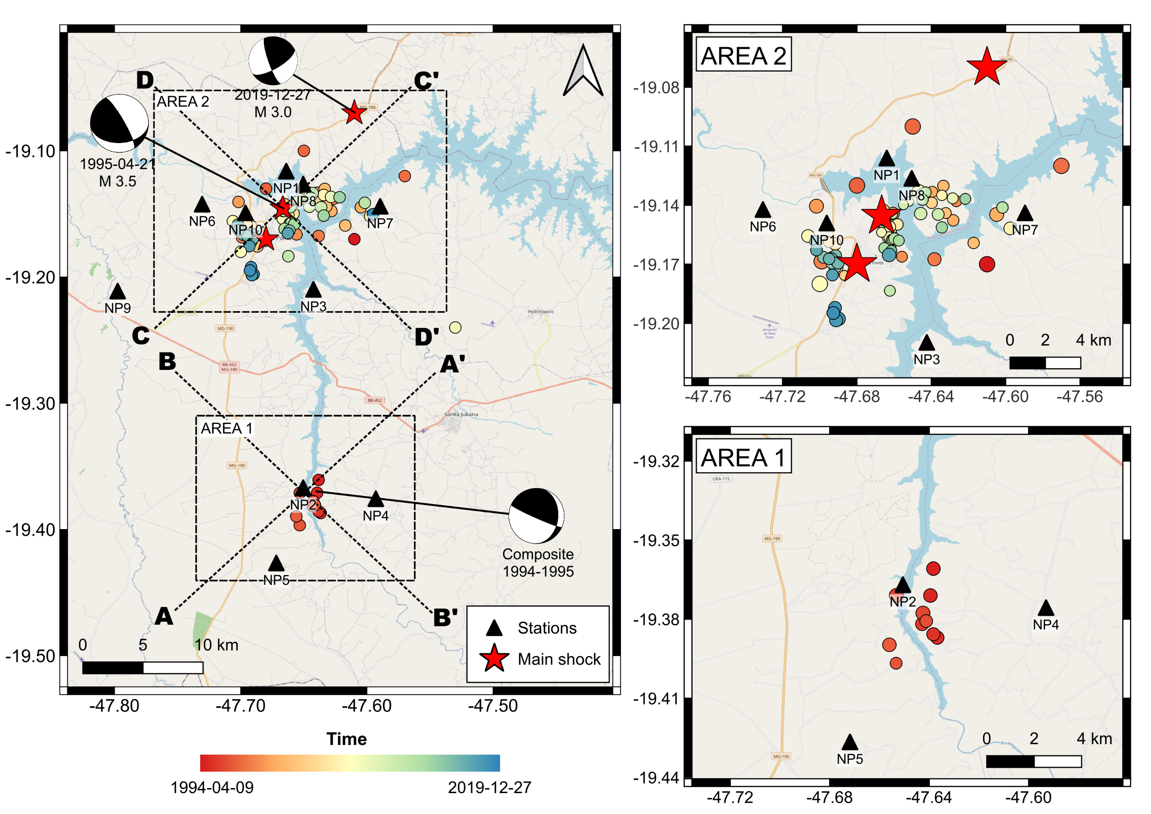
Figure 7a – Epicenters of quality B events only. On the right is a zoom of the Figures on the left.
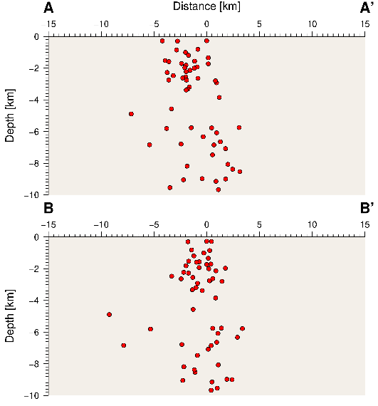
Figure 7b – Profiles A-A’ and B-B’ of the seismicity in Area 1.
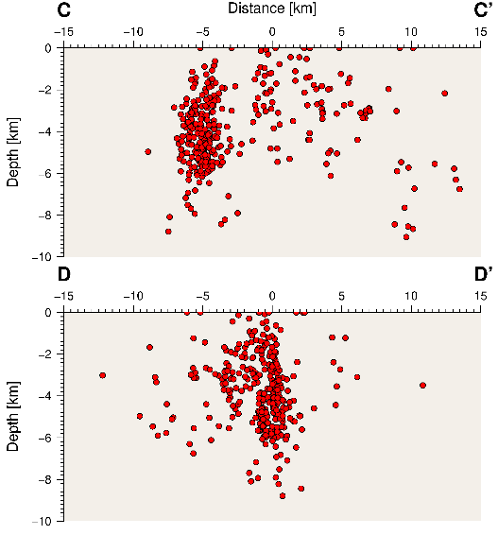
Figure 7c – Profiles C-C’ and D-D’ of the seismicity in Area 2 for quality B events.

Discussion and Conclusions
In the Nova Ponte reservoir, performing a more precise analysis of the seismicity distribution, with better quality data, only events with type B location (Lee at Lahar, 1975), it was possible to identify that the earthquakes in Area 1 occurred over two parallel faults of N-S orientation, with an epicentral migration from the east to west. The earthquakes occurred parallel to the river course, probably concordant with lineaments in the area. The maximum depths decreased from about 12 km to 3 km, more compatible with RTS depths in Brazil (e.g., Areado - MG, Jirau - Ro and Funil - MG cases) studied with a dense local network. This seismicity was of the initial type, beginning in 1994 and vanishing in 1995, when the seismicity migrated to close to the dam.
The focal mechanism to Area 1, despite the inaccuracy of the polarity’s readings, presents a nodal plane concordant with the fault trace described by epicenters. The composite focal mechanism for this area presents a trust fault mechanism with compressional axis in the direction NE-SW (Assumpção et al. 1997).
The event distribution for 1995 composite focal mechanism (Area 2) detected by a telemetric network with digital recordings, shows a WSW–ENE alignment. The mechanism of Assumpção et al. (1997) is a reverse fault with a strike-slip component, predominantly reverse fault with a component of strike-slip with NE-SW P axis. One of the nodal planes has a strike similar SW-NE orientation.
The new focal mechanism by envelope waveform inversion presents a reverse fault with a strike-slip component, compressional P axis in the E-W and strike in NE-SW direction.
Important aspects should be highlighted in relation to the Nova Ponte RTS:
i) Variation of the event focal depths in space and time should be attributed to a process of water diffusion in depth, with a consequent release of tensions due to the reactivation of pre-existing faults.
ii) The expressive seismic migration in several areas of the reservoir, in 1994 Area 1 was more active than Area 2, and from 1995 it occurred a decrease in the seismicity of Area 1 and an increase in the activity of Area 2 (Fig. 6 and 7).
iii) The maximum depths of the seismicity were 3 km for Area 1 and 6 km for Area 2, if we consider only quality B events. However, for all data base the depths are 6 km and 12 km, little high for RTS in Brazil.
iv) The nodal plane solutions, despite not having a good correlation with the epicentral distribution, indicate focal mechanisms with compressional axis oriented mainly in the NE-SW direction.

References
Assumpcão, M.; Marza, V. I.; Barros, L. V.; Chimpliganond, C. N.; Soares, J. E. P.; Carvalho, J. M.; Caixeta, D. F.; Amorim, A. & Cabral, E. 2002. Reservoir induced seismicity in Brazil. Pure and Applied Geophysics, v. 159, p. 597–617.
Assumpção, M.; Barbosa, J. R.; Berrocal, J.; Bassine, A. M.; Marza, V. I.; Huelsen, M. G. V. & Ribotta, L. C. 1997. Seismicity patterns and focal mechanisms in SE Brazil. Rev. Bras. Geof, 15: 119-132.
Barros, L. V. Assumpção, M., Ribotta, L.C., Ferreira, V.M., Carvalho, J.M., Bowen, M.M.D. and Albuquerque, D.F.2018. Reservoir-triggered seismicity in Brazil: Statistical characteristics in a Midplate environment. Bulletin of the Seismological Society of America, v. 108, n. 5, p. 3046–3061, November 2018.
Carvalho, J.M., Barros, L.V., Zahradník, J., 2019. Inversion for Focal Mechanisms Using Waveform Envelopes and Inaccurate Velocity Models: Examples from Brazil. Bulletin of the Seismological Society of America, Vol. 109, No. 1, pp. 138–151, February 2019, doi: 10.1785/0120180119.
Chimpliganond, C.N., 2002. Caracterizacão da Sismicidade Induzida no reservatório de Nova Ponte, Minas Gerais, Brasil – Dissertacão de Mestrado Instituto de Geociências da Universidade de Brasilia, 133 páginas.
Lee, W. H. K. & Lahr, J. C. 1975. HYP071 (Revised): a computer program for determining hypocenter, magnitude, and first motion pattern of local earthquakes. U.S.Geol. Survey, Open- File Report, 75-331.
Marza, V. I.; Veloso, J. A. V.; Carvalho, J. M.; Barros, L. V.; & Gomide, L. C. 1997. Reservoir induced seismicity at Nova Ponte (MG): Revisited, Anais do 5o Congresso Internacional da SBGf, p. 968-971.
Marza, V. I.; Barros, L. V.; Soares, J. E. P.; Carvalho, J. M.; Fontenele, D. P.; Chimpliganond, C. N.; Caixeta, D. F.; Gomes, I. P.; Furtado, G. O.; Carim, A. L.; Souza, I. F., Caliman, E. H. & Barros, J. B. 1999a. Some aspects of reservoir - induced seismicity in Brazil. Proc 23rd Brazilian Cong. An Large Dams, Belo Horizonte, Brazil, 1, 199-211.
Marza, V. I.; Barros, L. V.; Soares, J. E. P.; Carvalho, J. M.; Chipliganond, C. N. & Caixeta, D. F. 1999b. A precursory seismicity pattern associated to the Nova Ponte (MG) reservoir induced main shock of 1998 May 22 (mR =' 4,0). Proc. 6'h'Int. Congr. Brazilian Geophys. Soc., Rio de Janeiro, Brazil. 4pp (CD-ROM).
Veloso, J.A.V., 1992. Terremotos induzido pelo homem, Ciência Hoje Ciência Hoje 14, 66 -72.
Veloso, J. A. V. & Veloso A., 1995. Mapa de Intensidade de Nova Ponte. Manuscrito não publicado

