Petrophysical Evaluation to Optimize Stimulation Design in Pimienta Formation

Douglas J. Betancourt¹, Claudio Rabe*², Mauricio Hernandez ¹; Jesus P. Salazar²; Efren Solorzano³, 1. Central University of Venezuela, 2. Baker Hughes 3. University of Oriente

Copyright 2023, SBGf - Sociedade Brasileira de Geofísica
This paper was prepared for presentation during the 18th International Congress of the Brazilian Geophysical Society held in Rio de Janeiro, Brazil, 16-19 October 2023.
Contents of this paper were reviewed by the Technical Committee of the 18th International Congress of the Brazilian Geophysical Society and do not necessarily represent any position of the SBGf, its officers or members. Electronic reproduction or storage of any part of this paper for commercial purposes without the written consent of the Brazilian Geophysical Society is prohibited.

Abstract
Shale plays have become even more important as governments are encouraging domestic production to increase energy security. However, these plays are complex and require detailed characterization to design an optimum production strategy. For example, designing an appropriate stimulation program requires a detailed rock elastic analysis, porosity, permeability, brittleness, TOC evaluation, sealing/fault proximity evaluation and natural fracture characterization (Salazar et al, 2022; Salazar et al., 2021; Rabe et al., 2021). To achieve this goal, the reservoir characterization must include proppant type and concentration, the injection rate and treatment size, horizontal spacing optimization, and well trajectory design. This paper presents a case study of an integrated characterization of the productivity potential of light crude oil in the carbonate-shale of the Pimienta formation in the Titoniense Upper Jurassic layer.
The study involves extensive laboratory tests, logs, and field measurements to characterize the reservoir and to outline a suitable hydraulic fracturing design. The reservoir characterization includes lithofacies and pore classification using X-ray Diffraction, Scanning Electron microscopy, and thin sections. The petrophysical model includes the facies model, porosity, water saturation and permeability analysis.
The results indicate an expected TOC of approximately 2.3%, type II, with a thermal maturity ranging between 0.85 and 1.1%. The mineralogy analysis indicate that mudstone, wackestone and packstone constituted 72% of the carbonate and 11% of clay containing illite, montmorillonite, glauconite and kaolinite. Permeability in the reservoir ranged between 1,600 to 2,000 nD, with total porosity ranging between 5.2 and 9.6%. The results shows that the best interval for stimulation is in the calcareous limestone facies in the middle to the bottom intervals.

Introduction

Shale oil and gas reservoirs are defined as a system of organically rich, low-permeability clay rocks that act as generators, storage, trap, and seal at the same time (Hoxha and Rabe, 2021). For these reservoirs to be profitable, it is necessary to induce higher permeability by hydraulic multi-fracturing operations.
The recent development of unconventional plays of oil and gas shales was recently discovered in the Burro-Picachos area, similar formations comparable to Eagle Ford, in the Haynesville and Niobrara areas in the United States. This unconventional reservoir shows to be a potential opportunity to generate hydrogen (Lima and Hamzagic, 2022) and storage CO₂ after reservoir depletion (Iqbal et al., 2022; Lima and Hamzagic, 2022).
The objective of this study is to propose an integrated methodology to evaluate the Superior Jurassic Pimienta fm (Salazar et al., 2021). As unconventional resource in Mexico, it is estimated that the size of the gas resource is about: P10 = 171 MMMpcg, P50 = 67 MMMpcg. and P90 = 7 MMMpcg, the probability of geological success (PG) is about 81% to find wet gas.

Method and Results

The proposed methodology starts with the formation evaluation step, where various open-hole log data was gathered and checked for QC/QA analysis. The quality data comprises the analysis of Gamma Ray, Spectral Gamma ray, Caliper and bit size, neutron porosity, photoelectric, bulk density logs, acoustic and shear transit time, and resistivity logs. Next, these data was interpreted to investigate reservoir characterization and stimulation design.
In this study, A petrophysical characterization to evaluate optimum zones selection and stimulation design optimization was developed. The first step comprises the data set evaluation where one open-hole log data, laboratory tests and field measurements were gathered and checked for QC/QA analysis. All data evaluated includes total gamma ray, spectral gamma ray, caliber and bit size, neutron porosity, Photoelectric, Bulk density logs, compresional and shear waves, and resistivity logs. Next, these data were interpreted to formation evaluation, geomechanical model and for production evaluation.
In unconventional reservoirs (Shale Oil) that produce in carbonate rocks, an exhaustive and systematic Advanced Petrophysical Characterization is necessary to obtain variables and properties that, when integrated, strengthen the static model and dynamic model, reservoir, and production; reason why we consider the following work methodology.

Study location

The Pimienta formation is in the southern portion of the Burgos Basin, Mexico. The Figure 1 shows the location of the studies Well-B, Well-A and Well-A wells in the Burgos Formation. The same unconventional resources extend to the Tampico-Misantla basin. Burgos Basin present reserves of approximately 10.8 MMMbcpce and, with substantial reserves. In the south exists another important basin is the Tampico Misantla Basin, with 34.9 MMMbpce.

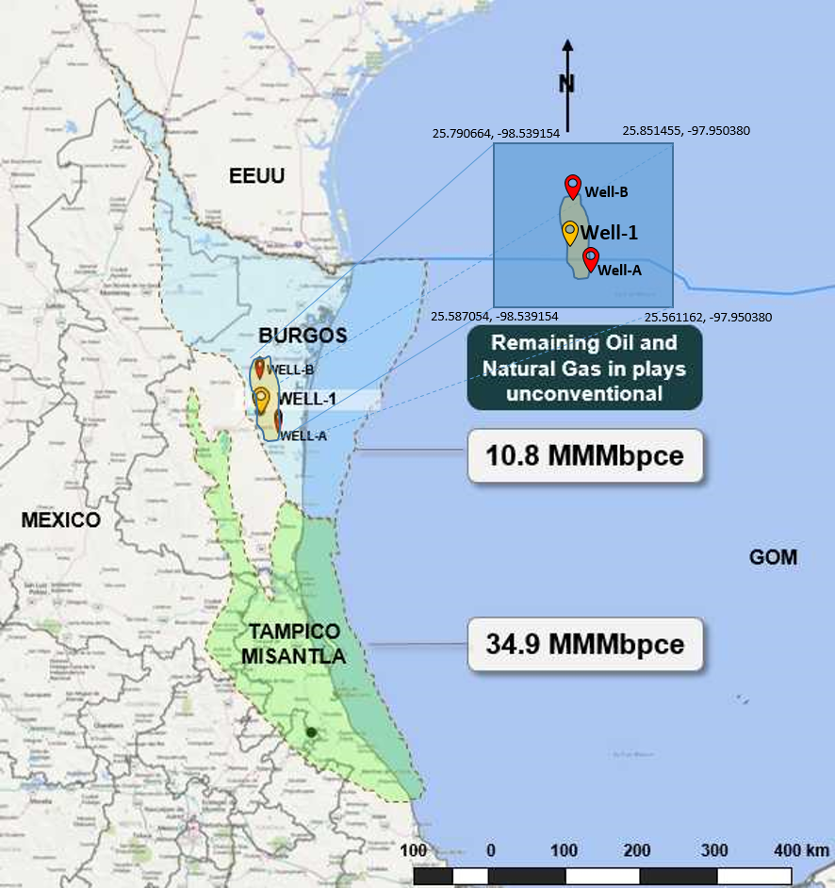
Figure 1. Regional map, field location and studied wells location.

The stratigraphic column of Pimienta fm. consists of the Lower Oligocene, which is made up of calcareous light gray shale, the Lower Eocene is constituted by light, gray, calcareous shales, in which at the bottom of formation traces of light gray sandstones, with fine to medium quartz grains and dark lithics been identified. The Upper/Lower Paleocene is made of light gray shale, calcareous. Traces of light gray sandstones, from fine grains to quartz media and dark lithic material were identified. Sub-rounded, regularly classified, and regularly consolidated in a clay matrix and calcareous cement with light impregnation of oil with yellow fluorescence.
Upwards, the Pimienta Formation gradually passes into Lower Tamaulipas Formation (Belt, 1925). This was originally described as fine-grained, compact limestone with well-marked beddings, predominately gray in color. It concludes many chert lenses and nodules of irregular shape at its top.
Upper Cretaceous is constituted by the Méndez Formation. This formation consists mainly of greenish-gray marls and in parts reddish brown and traces of light gray bentonite towards the top, while in the lower part it presents a good percentage of greenish-gray marl and light gray-calcareous shale.
San Felipe Formation is made of mudstone, gray, green and light brown wackestone, with microfractures sealed by calcite, pyrite, and light oil impregnation. Agua Nueva is made by mudstone and light brown and dark gray wackestone, clayey, presents microfractures sealed by calcite, pyrite, and light oil impregnation. The Middle Cretaceous is made of Upper Tamaulipas Formation, constituted by mudstone to wackestone cream gray, brown, dark gray in clay parts presents microfractures sealed by calcites, pyrite, and light impregnation.

Thin section analysis

Thin sections were done using 10 intervals of the selected core samples. Plug samples 2.5 cm in diameter were drilled from the core to make cast thin section. Petrographically, this interval is made up of: packstone and locally clayey-bituminous wackestone, dominated by sacocomas (Lombardia angulata and Eothrix Alpina) and, to a lesser extent, ammonites, bivalve fragments, and phosphatized fish remains. Part of the bioclastic fraction looks well preserved, with large skeletons.
Megascopically it is made up of thick packages of microcrystalline and mesocrystalline dolomites, Interspersed with these fossiliferous mudstone dolomitized bodies, clay-bituminous mudstone with remains of radiolarians, sporadic vertebrae and spines. Bioclasts are highly fragmented, detrital quartz.
The matrix is ​​represented by clays rich in organic matter and a very fine-grained bioclastic fraction composed of highly fragmented sacocomas remains (possibly due to fish predation). Few cemented microfractures have been observed.
Bioclast pakstone, with abundant sacocomas. Scattered slime-sized quartz grains are observed, as well as scattered pyrite. The matrix is ​​made up of clays rich in organic matter and a very fine-grained bioclastic fraction made up of fragments of sacocomas. Scattered crystals of microcrystalline dolomite. No type of porosity is observed.
The sedimentary environment is interpreted as an external carbonate ramp with anoxia events, characterized by the inhibition of carbonate production, the sedimentation of clays and the preservation of organic matter.
SEM/EDS Analysis

For the present study, fourth-five (45) SEM tests were executed in which 10 samples have been considered presentative. The results of the EDS analysis show the existence of high concentration of oxygen, with median value equal to 42%, siliceous equal to 39%, aluminum is about 4.8%, potassium is about 1.42%, calcium is about 3.84%, iron in 6.5%, and magnesium is about 1.29%.

Mineralogy
The mineral composition of the rock was obtained from laboratory analysis of rock samples using 14 samples for X-Ray diffraction (XRD. The analysis of the 14 samples at different depths indicated a majority fraction of calcite 49%, sands 44% and clays. The mineralogy also identified that the main clay minerals are: 7% of smectite, 4% of illite/mica, x 1% of kaolinite and 1% of clorite. The distribution of minerals concentration in depth is present in Figure 6. For member A from 78% of smectite, 15% of illite/mica, x 0% of kaolinite and 6.11% of clorite, for member B from 95% of smectite, 3.2% of illite/mica, x 1.6% of kaolinite and 0% of clorite and for member C from 84% of smectite, 4.8% of illite/mica, x 1.04% of kaolinite and 0% of chlorite.
Cross-plots of concentration of Thorium (Th) vs Potassium (k) were made from the NGT records, defining the predominant type of autogenic clays such as Montmorillonite, Illite, chlorite in the Pimienta formation. Typically, the presence of fine clastic deposits or clay rich rock formation, such as shale, claystone, mudstone, indicates high response of gamma ray, while the existence of coarse-grained sandstone and carbonate rock indicates low response of gamma radiation, which displays higher water-transmitting capacity (Schon 2011; Chou et al. 2014).
Given the presence of these autogenic clays in ​​interest, it must be mitigated in the drilling plan, to avoid problems such as migration of the present fluids, reduction of the K / φ and fracturing of the rocks. Therefore, we will have an unstable hole, production of fines and formation damage.
Afterward, potassium–thorium (K–Th) cross plot was constructed to identify the clay mineral associations as well as the identification of micas and feldspar. In addition, a Th/U ratio was generated to link depositional environment to geochemical composition. Th/U and Th/K cross plots were used to evaluate compositional changes. The results indicated majority of montmonilonita, illite, mixed-clayer clay. Micas were also identified. For member A from 78% of smectite, 15% of illite/mica, x 0% of kaolinite and 6.11% of clorite, for member B from 95% of smectite, 3.2% of illite/mica, x 1.6% of kaolinite and 0% of clorite and for member C from 84% of smectite, 4.8% of illite/mica, x 1.04% of kaolinite and 0% of clorite (Figure 8). The clay analysis indicated high content of swelling clays. The main mineralogical composition is by montmorillonite is about 85.6%, 7.6% of illite, kaolinite is about 0.8% and 2.3% of another minerals.
As part of advanced petrophysical characterization, we were struck by the difference between X-ray diffraction vs. petrography. The percentages of its minerals were graphed, based on the study of cores carried out using different methodologies, so its expected different results, resulting in diverse mineralogical models. These different methodologies were able to explain the different results in %. For our brittleness calculations were chosen to use the mineralogy as key method for determining % of each mineral.
Anomalies are observed between X-ray and petrographic by counting points (thin layers) for the mitigation of volumetric calculations. It is recommended to correlate the mineralogical volumes obtained from the petrophysical evaluation with the petrographic analysis.

The review of the petrographic description of thin layers obtained helps to define the parameters associated with the completion of the well. Brittleness index obtained by mineralogy will present a high error rate (overestimation). It is recommended to use the brittleness index (Rickman Eq.).
The paleontological analysis describes the Upper Jurassic Lower/Upper Tithonian in its lithology as a dark gray, brown, clayey mudstone with a carbonaceous appearance. It presents microfractures sealed by calcite, recrystallized, and partially dolomitized, it presents a slight oil impregnation with light yellow fluorescence. 20% black, carbonaceous, slightly calcareous shale. Traces of bentonite, greenish grey. Planktonic fauna: Pyritized radiolaria Cradicollaria of pavula. Environment: External ramp-basin.
In the area where well A was drilled, a sedimentary environment associated with Rampa Externa-Cuenca was identified, based on the analysis of the lithological facies and faunal content as described in paleontology. The main facies are:
Facies 1: Mudstone/Wackestone of radiolarians in silicified parts, increased fractures sealed by calcite, disseminated pyrite, and dolomite.
Facies 2: Wackestone/Packstone of Saccocomas recrystallized by calcite, bands of recrystallized calcite, fractures sealed by calcite, and presence of dolomite with fine quartz crystals.

Facies 3: Silty Wackestone/Mudstone with recrystallized bioclasts, fractures sealed by calcite, and the presence of fine quartz crystals.Petrophysical Properties
The laboratory petrophysical tests comprises 37 tests of porosity and water saturation. The total porosity average is 7.7%, water saturation average is 25.4%. For member A the porosity/Sw is 5.11% / 40.12%, for member B is 9.42% / 27.4% and for member C is 8.1% / 27.2.
Vshale
The clay volume (commonly denoted by Vsh) is calculated using the available mineralogy and EDS analysis from laboratory and mudlloging reports from geological visual cavings analysis from the study well, and this index was determined from gamma ray log.
The results of Vshale indicated values between 2.7% and 10.4%. For member A the vshale vary from from 2.6% to 10.9%, for member B, vshale range from 3.4% to 11.9% and vshale range for member C from 2.2% to 9.4%.
Fluid Saturation
Archie (1942) equation with mVariable; n=2 has been used for water saturation computation. The results show that water saturation measured from laboratory is about to be with an average value of 31.4%. The reservoir profile is indicating water saturation ranging between 12.7% and 58.8% for member A, 14.4% to 90% to member B and 18% to 38% member C is 10.7% to 53.6%. Permeability was determined by using core samples. The permeameter results indicated that in the reservoir, the values ranged between 1,600 to 2,000 nD (Figure 2).
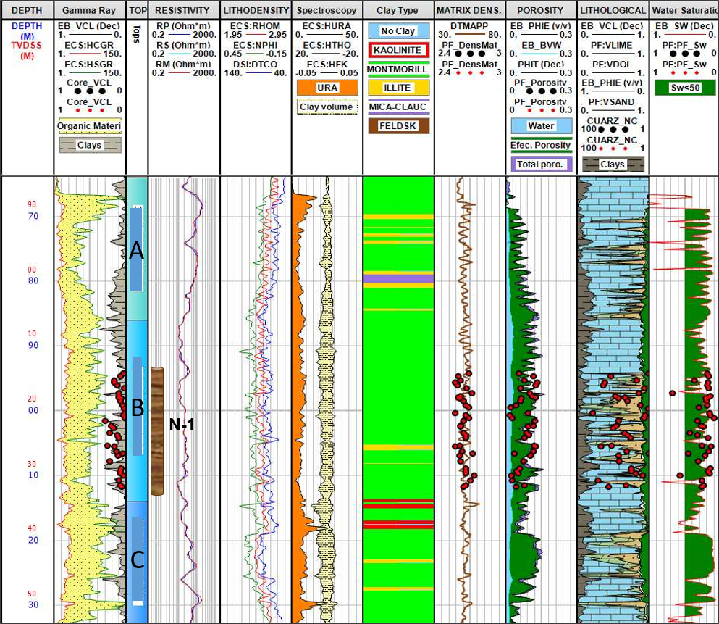
Figure 2. Well-A – Petrophysical Evaluation

Pore ​​Throat Radius Determination using Mercury Intrusion Porosimeter.

The capillary pressure tests were conducted on the shale samples. A progressive increment of the applied pressure was accompanied by a progressive increment of the mercury invasion inside the pores, i.e., the higher the pressure, the smaller the pore-throat radius invaded. The summation of the total invaded pore space volume provides the porosity of the studied rock samples.
Plotting the mercury porosity against the measured invaded pore-throat diameter together with the pore-throat volume frequency enabled the further distinction of the studied samples into four types of injection curves. Pore ​​throat opening radius It can be defined as the size of the pore throats obtained through capillary pressure tests corresponding to a given saturation of the non-wetting fluid (mercury). Ri is a function of inlet pressure and pore throat choice and is an excellent measure of the interconnectivity of pore throats in a rock with intergranular porosity. It can be obtained using the following relationship:
Ten (10) core plugs from Pimienta fm. were collected for mercury intrusion experiments. The maximum mercury intrusion pressure is 80 MPa, and the corresponding minimum pore radius which can be identified is about 9nm.
Determination of rock types
The type of rock is determined based on the pore throat radius values ​​and integrating with the petrographic analyzes, which allows establishing a permeability-porosity relationship (K / Phi) and irreducible water saturation.
The well can be subdivided by identifying and characterizing rock types into units that have similar and predictable flow characteristics. These flow units can be identified from the calculation of the pore throat radius at a given percentage of pore volume, using the equations of Winland (1972) and Pittman (1992) and represented by graphs.
The integration of the Advanced Petrophysics of the Well-A well is shown below in Figure 4, where the correlations using logs were calibrated with lab. tests from Pimienta formation. The results are indicating majority of pores are nanoporous (brown color), Microporous (yellow color) and Mesoporous (green color). The observed microfacies correspomds to mudstone-wackestone and packstone. It is observed that the best properties are found in Medium Pimienta towards to the Lower Pimienta Section (Figure 3).
Petrophysics and Rock Physics Correlation

The integration of rock physics & petrophysics considers correlating the elastic properties. The existing correlation between porosity and acoustic impedance obtained from core data and logs in the Pimienta formation indicates a robust transformation for its application to seismic inversion results, VSP calibration, among other utilities. In carbonate rocks, an increase in AI is related to a reduction in Porosity. The decrease in IA is related to an increase in Porosity as observed in Cayenne between its intercalations by the clay minerals present (Figure 4).

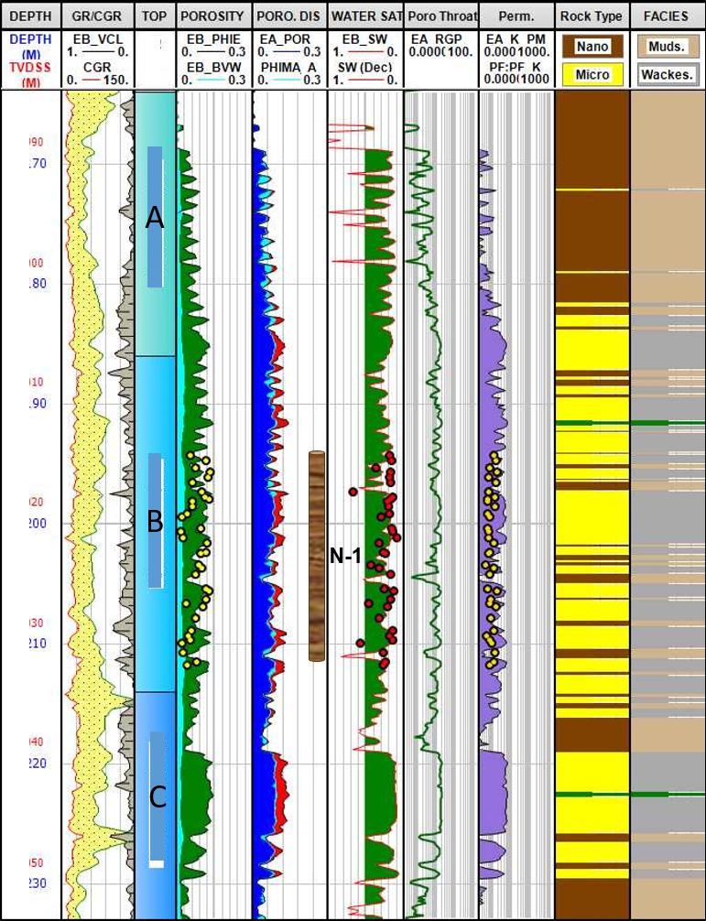
Figure 3 Rock type and facies

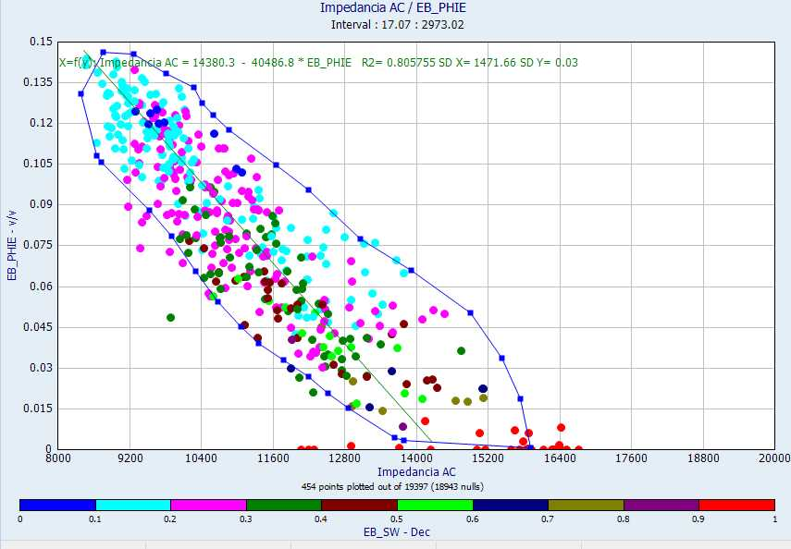
Figure 4. Well-A – Acoustic Impedance P-wave

Relative Permeability and Pore Throat Analysis

From the bottom pressure and fluid production data, in the period from August 13th, 2018, to January 31st, 2019, the bottom pressure variation curve lasted 18.7 days, of which 14.1 days (338.4 hrs) correspond to the pressure increase test with surface closure. Before the increased pressure test, the well was flowed for 4.6 days. The oil consumption was measure before closing the well for production evaluation, reaching out 1022 bd, gas production was about 420 mpcd, and water reach out 255 bd, after which the well was allowed to flow through a 14/64”.
The analysis shows a constant correlation between production per surface closure pressure equal to 0.0225 bbl / psia. The induced fracture parameters calculated by non-linear regression are of the order: Effective mean fracture length (Xf) = 20.1 m, fracture height (Hf) = 63 m, number of fractures contributing (N) = 3.0. Regarding well parameters, a horizontal section distance to the base of the reservoir Zw = 38.5 m, length of the effective horizontal producer interval (Lw) = 138 m was calculated. The calculated initial pressure is Pi = 5740 psia, flow capacity k * h = 123.1 mD-ft and effective permeability of the matrix-fracture system of Ko = 0.536 mD, total damage St = -6.2. The presence of reservoir limits is not observed during the development of the derivative.
Integrating this calculation of effective permeability Ko = 0.536mD defined by the interpretation of surface pressure curve, and the results, calibration of the absolute permeability model.
Cutoff values

Below in Figure 5 are presented the cross-plots of TOC vs IH vs PHIE / Type of Kerogen, PHIE vs Sw vs VCL / FFV (Magnetic Resonance) to determine the cut-off values to be used for Well A. As results of the analysis, we have the cuts for unconventional deposits:

TOC ≥ 1%, Sw ≤ 65%
HI ≥ 50, Vsh ≤ 30%
Φ≥3%

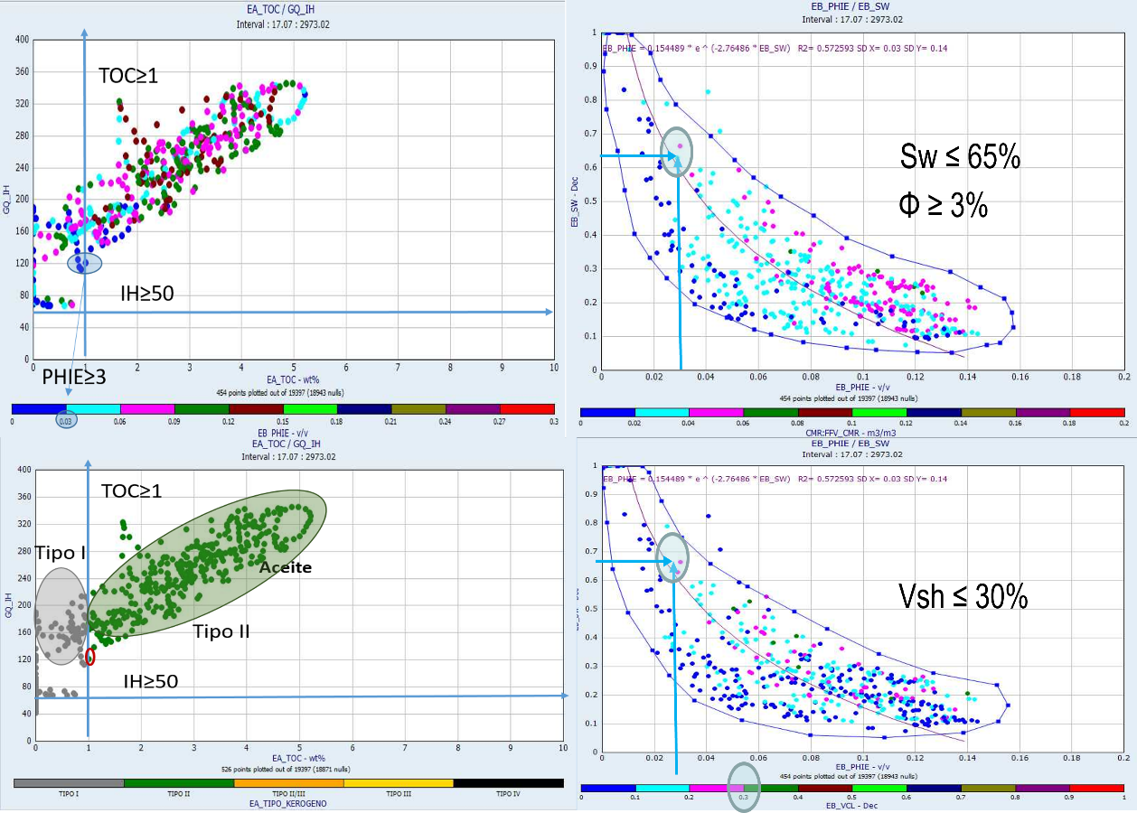
Figure 5. Cutoff unconventional reservoirs – TOC vs PHIE

Results
There are petrophysical parameters obtained, previous studies carried out on VCD, (core analysis, formation water sample: (31,000 ppm - 33,000 ppm - 110,000 ppm), such as the saturation exponent (n:1.8 - 2), tortuosity ( a:1), and the resistivity of the formation water (Rw: 0.025), cementation exponent (mV Gómez Rivero) and bottom temperature 118⁰C.
The average values of the petrophysical properties obtained from core samples: φ= 7.7 %, Sw= 25.4 % VSH: 11.5% ρmat: 2.64 gr/cc, and KPERM= 0.00024 mD are calibrated with the existing petrophysical models at the Medium Pimienta level. The acoustic impedance is low and corresponds to high porosities. The results are indicating that best properties are found in Medium Pimienta towards to the Lower Pimienta Section.Conclusions
The methodology used in this study was developed to identify sweet spot intervals in multi-stage hydraulic fracturing operations in the Pimienta fm.
The petrophysical characterization and integration of the rock’s physics in the study reservoir was effective to identify best intervals for stimulation, but still requiring the combination with geochemical and geomechanical properties to refine such intervals.
The results indicated an expected TOC of approximately 2.3%, type II, with a thermal maturity ranging between 0.85 and 1.1%. The mineralogy analysis indicated that mudstone, wackestone and packstone constituted 72% of the carbonate and 11% of clay containing illite, montmorillonite, glauconite and kaolinite. Permeability in the reservoir ranged between 1,600 to 2,000 nD, with total porosity ranging between 5.2 and 9.6%. The results shows that the best interval for stimulation was in the calcareous limestone facies in the middle to the bottom intervals.

Acknowledgments
The authors wish to thank and acknowledge PEMEX for granting access to use their data and CNH for permission to publish the results from the study.
References
Hoxha, B. M. and Rabe. C. 2021. What shale you are talking!. Abu Dhabi International Petroleum Exhibition & Conference. SPE-207412-MS. Abu Dhabi, UAE, November.
Iqbal, O., Padmanabhan, E., Hughes, A., Abdulkareen, F. A., Rabe, C. and Mumtaz, M., 2022. The competitive adsorption of CO₂ and CH₄ and pore structure characterization: Implication for enhanced gas recovery and carbon sequestration. Second International Meeting for Applied Geoscience & Energy. Image 22. SEG-AAPG Meeting, Houston. Aug, 28th – Sep 01.
Jarvie, D. M., Hill, R. J., Ruble, T. E. and Pollastro, R. M. 2007. Unconventional shale -gas systems: The Mississippian Barnett Shale of north-central Texas as one model for thermogenic shale –gas assessment, AAPG Bulletin, 91(4), pp. 475–499. 10.1306/2F12190606068
Lima, L. J. B. and Hamzagic, M. 2022. The reengineering of the disengineering of oil and gas wells. Revista Científica Multidisciplinar Núcleo do Conhecimento. Year. 07. Ed. 07. Vol. 03. p. 23-68. July.
Lima, L. J. B. and Hamzagic, M. 2022. Strategies for the energy transition: literature review. Revista Científica Multidisciplinar Núcleo do Conhecimento. Year. 07. Ed. 06. Vol. 08. p. 96-120. June.
Mavko, G., Mukerji, T., Dvorkin, J., 2009. The rock physics handbook, tools for seismic analysis of porous media. Cambridge University Press, 2nd Edition. ISBN-10: 0521861365.
Rabe, C., Salazar, J. P., Rechden, R., Della-Pascua, F. and Stael, G. 2021. Brittleness modeling selects optimum stimulation zone in shale source rocks in the Whangai Formation. New Zealand. AAPG Bulletin. V. 105. No 2. February. pp. 329-355.
Rickman, R., Mullen, M., Petre, J., Grieser, W. and Kundert, D. 2008. A practical use of shale petrophysics for stimulation design optimization: All shale plays are not clones of the Barnett Shale. Society of Petroleum Engineers Annual Technical Conference and Exhibition. Denver. Colorado 21–24 September. SPE-115258-MS, 11 p., doi: 10.2118/115258-MS
Salazar, P. J., Rabe, C. and Papa, A. 2022. An Approach to integrate Petrophysical and Rock Physics Modeling for Hydraulic Stimulation in Carbonate Reservoirs. ICE – AAPG International Conference & Exhibition. 19-22 April. Cartagena. Colombia.
Salazar, J. P., Betancourt, D. J., Rabe, C., Iqbal, O. and Sardelli, E. 2021. Geomechanical and petrophysical interpretation in Shale Formations: A case study in Pimienta, México. 17th International Congress of Geophysical Brazilian Society. August 2021, Rio de Janeiro, Brazil.
Gómez Rivero, “a practical method for determining cementation exponents and some otherparameters as an aid in well log analysis”. The Log Analyst, October 1976.
T.Ibrahin Elkewidy And Djebbar Tiab, SPE 40038 “ Application of Conventional Well Logs to Characterize Naturally Fractured Reservoirs with their Hidraulic (Flow) Units; a novel approach”
Djebbar Tiab And Erle C. Donaldson, 2003 “Theory and practice of Measuring reservoir rock and fluid transport properties”
Pittman, Edward D. (1992), “relationship of porosity and permeability to various parameters derived from mercury injection – capillary pressure curves for sandstone”, The American Association of Petroleum Geologists Bulletin, Tulsa, U.S.A., pp. 191-198.
W. Jennings Jr and F. Jerry Lucia; SPE BUREAU OF ECONOMIC GEOLOGY. SPE 71336. “Predicting permeability from well logs in carbonates with a link to geology for inter well permeability mapping.”
Q.R. Passey, Creiney J.B. Kulla, and J.D Strold. 1990. “A practical model for Organic, richness fron porosity and resistivity logs”.

