Fracability and Permeability Evaluation in Carbonate formations: A case study, offshore Brazil
Jesus P. Salazar and Claudio Rabe, Baker Hughes

Copyright 2023, SBGf - Sociedade Brasileira de Geofísica
This paper was prepared for presentation during the 18th International Congress of the Brazilian Geophysical Society held in Rio de Janeiro, Brazil, 16-19 October 2023.
Contents of this paper were reviewed by the Technical Committee of the 18th International Congress of the Brazilian Geophysical Society and do not necessarily represent any position of the SBGf, its officers or members. Electronic reproduction or storage of any part of this paper for commercial purposes without the written consent of the Brazilian Geophysical Society is prohibited.

Abstract
Rock fracability is one of the main geomechanical parameters to determine the effectiveness of the hydraulic stimulation process because it defines how easy a formation can be hydraulically fractured. This property can be estimated using different mathematical models, which include brittleness, fracture toughness and fracture gradient. All of these properties can also be obtained using borehole measurements by wireline or logging-while-drilling (LWD) technologies.
In terms of petrophysical properties, permeability in one of the main properties because it defines the capacity of the rock of producing fluids. It is important to mention that permeability cannot be measured directly using a geophysical technology, however it can be estimated from different reading that are performed inside the wellbore, such as Nuclear Magnetic Resonance (NMR), which uses different correlations to get a permeability from porosity and the fluid distribution inside the pore space.
This study suggests the integration between rock fracability and permeability in order to improve the definition of the best zones for executing acidizing and hydraulic fracture stimulation in carbonate reservoirs and to optimize the strategy for defining sweet spots intervals.

Introduction
The integration of geomechanical and petrophysical models has been proved to be a very important successfully strategy for production optimization in carbonate reservoirs. This integration is critical to define the completion strategy as well as the required surface pressure to stimulate the formation (Paris et. al).
In this study, the estimation of the rock fracability and permeability is performed using wireline information in a well from a carbonate Formation in Santos basin, offshore Brazil (Figure 1). The available information includes conventional and NMR logs as well as results of analysis performed in core rock samples in the laboratory.
Rock fracability is based on the Yuang et. al (2010) approach, which suggests a correlation with brittleness, fracture toughness and the gradient of fracture. Brittleness calculation is based on the Rickman et. al (2008) methodology, which they suggest that the brittleness concept should combine Poisson’s ratio and Young’s modulus derived from acoustic log data. Their model assumes that rocks with high brittleness show high Young’s modulus and low Poisson’s ratio. Consequently, rocks with low brittleness show low Young’s modulus and high Poisson’s ratio.
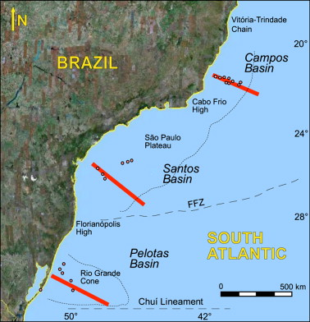
Figure 1. Santos Basin location (Contreras et. al; 2010).
Fracture toughness is estimated from bulk density, compressional transit time and the shale volume of the formation. At last, the gradient of the fracture is the minimum horizontal stress The most common source of Fracture gradient is leak-off tests. The permeability estimation is obtained using NMR log data and by the Timur-Coates equation, which relates permeability with porosity and the ratio between movable and irreducible fluid. This permeability is calibrated with the rock permeability tests (permeameter tests using core samples)
This study considers the integration of the rock fracability interpretation with the formation permeability analysis with the objective of better select the intervals for acidizing and hydraulic stimulation based on, not only geomechanical analysis, but also in petrophysical and formation evaluation properties.

Method
The available well log information includes spectral gamma ray, resistivity, neutron porosity, bulk density, compressional and shear acoustic velocity and nuclear magnetic resonance logs. These information are used to estimate geomechanical and petrophysical properties, such as fracability and permeability, to perform the proposed analysis. The available logs information is shown in Figure 2.
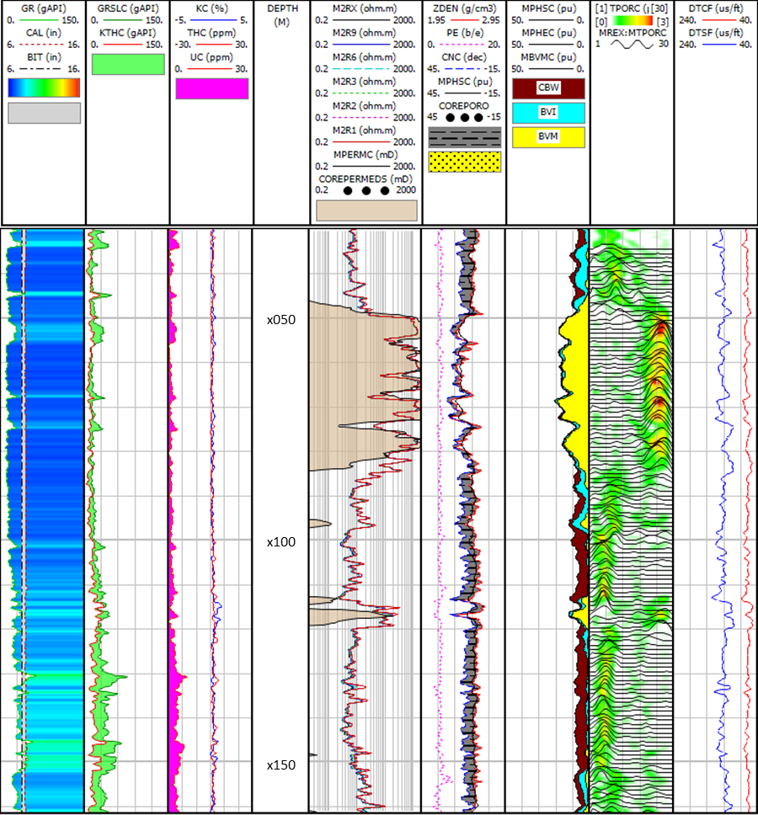
Figure 2. Available well log information.
The rock fracability, which defines how easily a carbonate formation can be fractured in hydraulic fracturing operation is calculated based on brittleness, fracture toughness and fracture gradient as proposed by Yuang et. al (2017). The authors suggested the following equation:
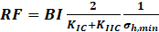 (1)
where RF is the rock fracability, BI is the brittleness index, KIC and KIIC are both tensile and shear fracture toughness and 𝜎_{h,mim} is the fracture gradient. Brittleness describes the ability of a rock to initiate and propagate a fracture. Rickman et al (2008) approach suggest that brittle material have high Young’s modulus and low Poisson’s ratio. Based on this, this geomechanical property can be estimated following the equation:
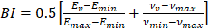 (2)
where E_{v} is the average Young’s modulus, E_{min} and E_{max} are minimum and maximum Young’s modulus respectively, 𝝂_{v} is the average Poisson’s ratio and 𝝂_{min} and 𝝂_{max} are the minimum and maximum Poisson’s ratio respectively. Young’s modulus is obtained from acoustic log data, specifically from formation compressional velocity as described in the next equation:
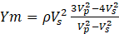 (3)
where 𝜌 is the bulk density, V_{p} is the compressional velocity and V_{s} is the shear velocity.
Poisson’s ratio is also obtained from acoustic log data as described in the next equation:
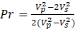 (4)
Fracture toughness describes the intrinsic resistance that a mineral offers to be pulled apart or deformed or the resistance of rock to tensile failure (Balme et al., 2004). This property is an important consideration in hydraulic fracture design (Belyadi et al., 2017) because it is an essential parameter to design fracturability fluids. This property is estimated from Yuan et al. (2017), which established correlations between fracture toughness, logging data and clay content using a multi-regression method. The logging data includes bulk density and acoustic logs. The shale content was estimated using the gamma ray log response. These correlations can be written as:
K_{IC} = 0.45𝞺 – 0.151e^{Vsh} +0.201Ln(DT) – 0.877 (5)
K_{IIC} = 2.121𝞺 – 0.245e^{Vsh} +1.152Ln(DT) – 8.378 (6)
where KIC indicates the resistance of the material to tensile failure, KIIC indicates the resistance of the material to shear failure, 𝜌 represents the bulk density, Vsh is the shale content and DT is the compressional acoustic transit time.
A low fracture toughness value indicates that the materials are undergoing brittle fractures, while high value of fracture toughness is a signal of ductility. So, it is possible to conclude that formations with low Poisson’s ratio, low fracture Toughness and high Young’s modulus are typically the best candidates for using the completion fluid called “slick water”. These fluids are characterized by having very low viscosity and low Shear modulus.
The fracture gradient, or minimum horizontal stress, is obtained by leaf-off tests and can be estimated by using poroelastic equations.
NMR measures the time decay of the magnetization of the hydrogen nucleus contained inside the rock pore space after being perturbed by an external magnetic field. This time decay is transformed to a T₂ distribution that provides information related with different petrophysical properties of the formation, such as porosity, fluid distribution and permeability.
Different T₂ cutoffs are defined to obtain information about the fluid distribution inside the pore space. These T₂ cutoffs can be described as the limit time between the clay bound water, the irreducible water and the movable fluid. Usually, a value of 3.3 ms is used for clay bound water and 33 ms or 92 ms are used to determine the irreducible water and movable fluid. The specific value depends of the formation type, i.e., sandstone or carbonate. In the case of carbonate formations, the 3.3 ms value could define the limit time for micro-porosity. The area under the T₂ distribution define the total porosity of the rock. Figure 3 shows the process of obtaining the fluid distribution from NMR measurements.
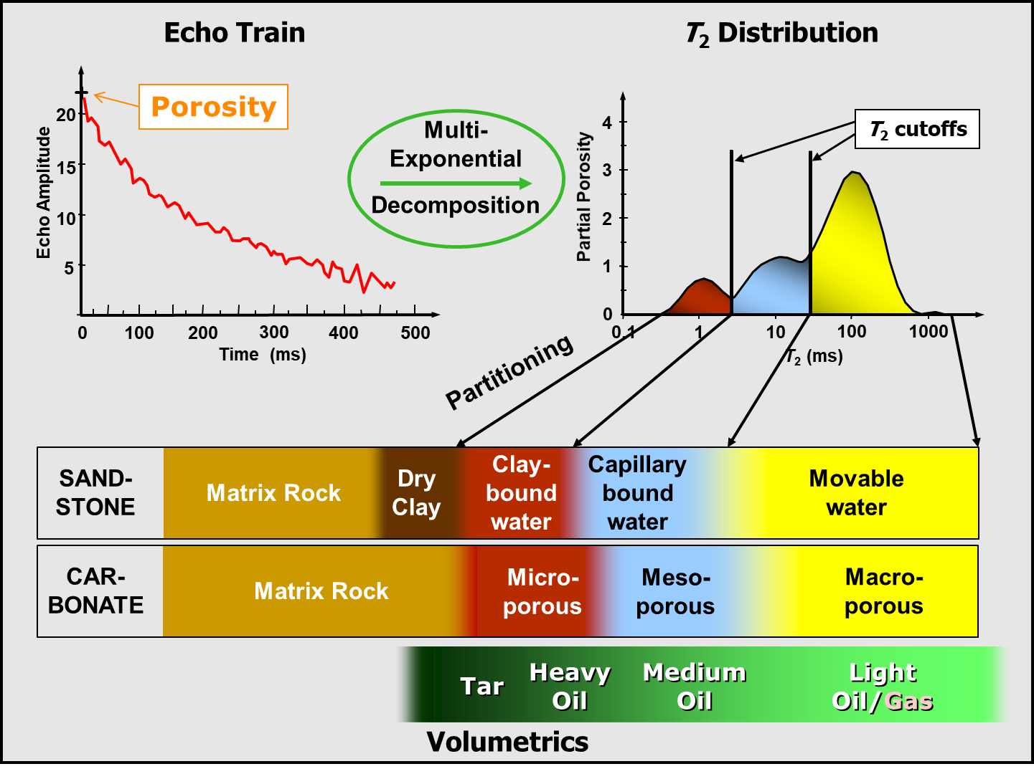
Figure 3. Process of obtaining fluid distribution from NMR measurements.
Another important petrophysical property provided by NMR is the permeability. This property is usually estimated from porosity, irreducible water and movable fluid using the Timur-Coates equation, which can be describe as:
(7)

where 𝛷 is the porosity of the formation, BVM is the movable fluid and BVI is the irreducible fluid. The a,b and c parameters are defined depending of the formation. The standard values for them are 10, 4 and 2 respectively. Permeability obtained from Timur-Coates equation should be calibrated using the laboratory results from analysis performed in core rock samples.
Results
As mentioned before, the available information includes petrophysical well logs and core samples analysis performed in the lab, such as porosity and permeability. The well log is used to generate curves of rock fracability and formation permeability. The lab analysis is used to calibrate the estimation of the petrophysical properties.
It is important to estimate brittleness, fracture toughness and gradient of fracture to estimate the rock fracability. Brittleness is estimated using Eq. 2, which relates brittleness with Young’s modulus and Poisson’s ratio, which are estimated from Eq. 3 and Eq. 4 respectively. The maximum and minimum value for Young’s modulus and Poisson’s ratio are obtained from their histograms, which are shown in Figure 4 and Figure 5. Based on these histograms, of defined values are 15 MPa and 80 MPa for Young’s modulus and 0.20 and 0.40 for Poisson’s ratio.
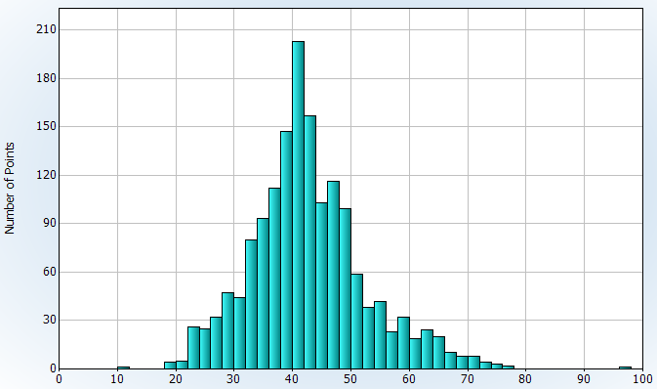
Figure 4. Histogram for Young’s modulus (MPa)
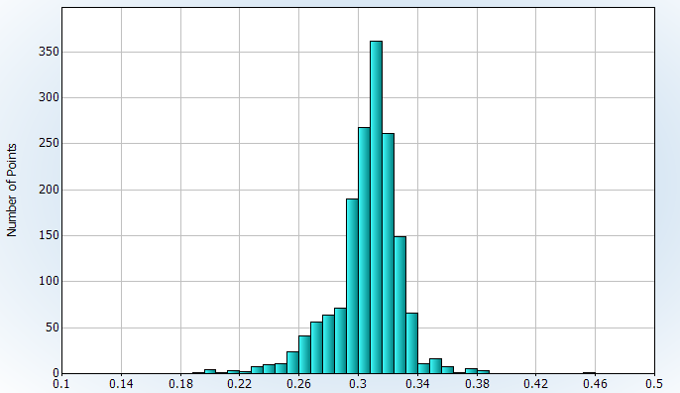
Figure 5. Histogram for Poisson’s ratio.
A cross-plot between Young’s modulus and Poisson’s ratio is shown in Figure 6, with graphical representation of the brittleness index in z-axe. Light brown and dark blue points correspond to more brittle material and cyan ones to ductile material (less brittle).
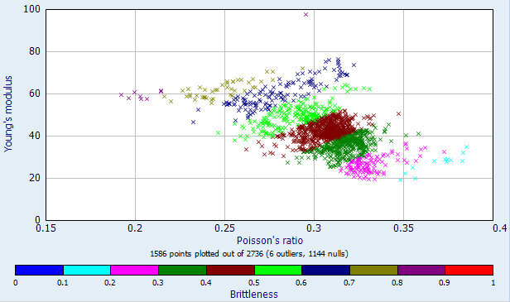
Figure 6. Young’s modulus and Poisson’s ratio crossplot with Brittleness in z-axe.
Eq. 5 and Eq. 6 are used to calculate the resistance of the material to tensile fracture and shear failure, K_{IC} and K_{IIC} respectivelly from logs. The shale volume used in these equations was calculated from gamma ray and neutron-density combination.
The minimum horizontal Stress magnitude (Shmin) in the study area was derived directly from depth intervals where leak-off tests (LOT) were performed during drilling operations after setting casing. The tests involve pressurizing an isolated section of the wellbore rock by injecting fluid at a constant pumping rate until fracture initiation occurs . Fracture initiation causes a sharp drop in pressure providing a diagnostic test of the fracture gradient. The discrete test measurements were converted to gradient values to generate an Shmin log a function of depth in the well. The LOT analysis provides a lower bound of Shmin of 12.4 ppg. The LOT derived S_{hmin} values were validated against drilling events in the study well. Once brittleness, fracture toughness and gradient of fracture are estimated, the fracability can be obtained based on Eq. 1. The results are shown in Figure 7.
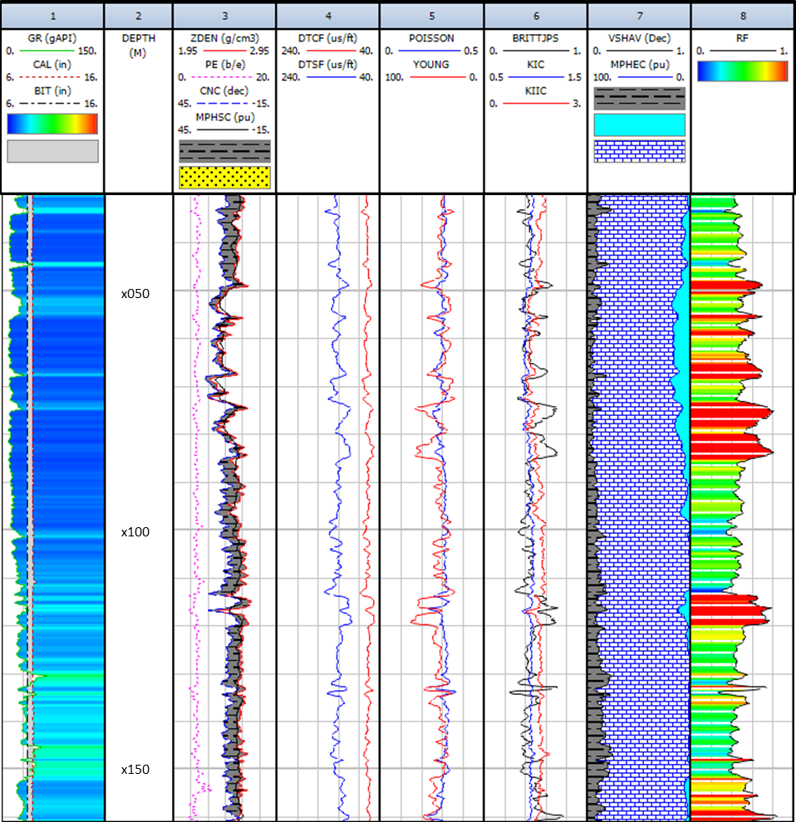
Figure 7. Complete plot of the fracability results, which is presented in the ninth track. It is also presented all the parameters used to generate it.
Based on the concept of fracability, the best intervals for fracturing operations are those indicated in red and/or orange, because these have the highest fracability.
In terms of petrophysics, the permeability is obtained from NMR measurements using the Timur-Coates equation presented described in Eq. 7. This predicted permeability is adjusted using the results of the analysis performed in core rock samples in the lab. The results are shown in Figure 8, showing the comparison with core permeability and with core porosity after the adjustment.
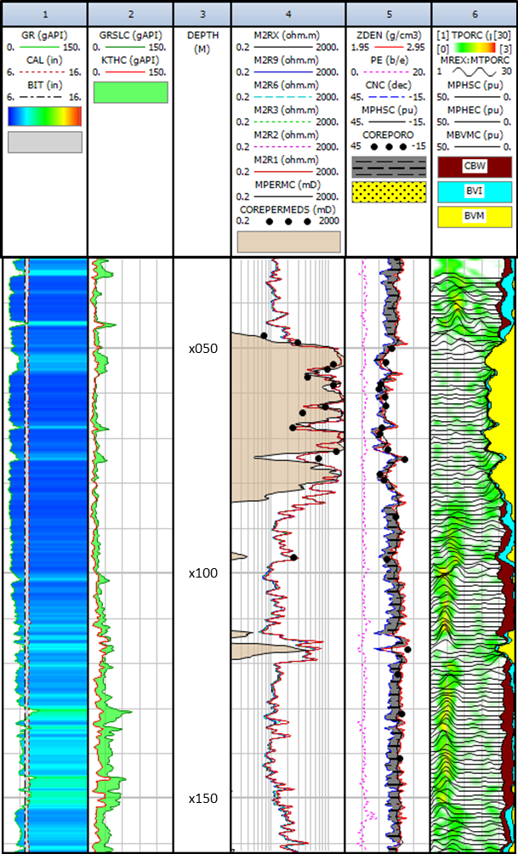

Figure 8. Permeability results from NMR. The comparison with core analysis results is shown in track 4 for permeability and track 5 for porosity.
The permeability predicted using Timur-Coates equation presents good correlation when compared with lab analysis performed in rock samples. Porosity also shows good correlation when the same comparison is performed.
In order to perform a geomechanical and petrophysical integrated interpretation, the results can be plotted together, including rock fracability, formation porosity and permeability as shown in Figure 9.
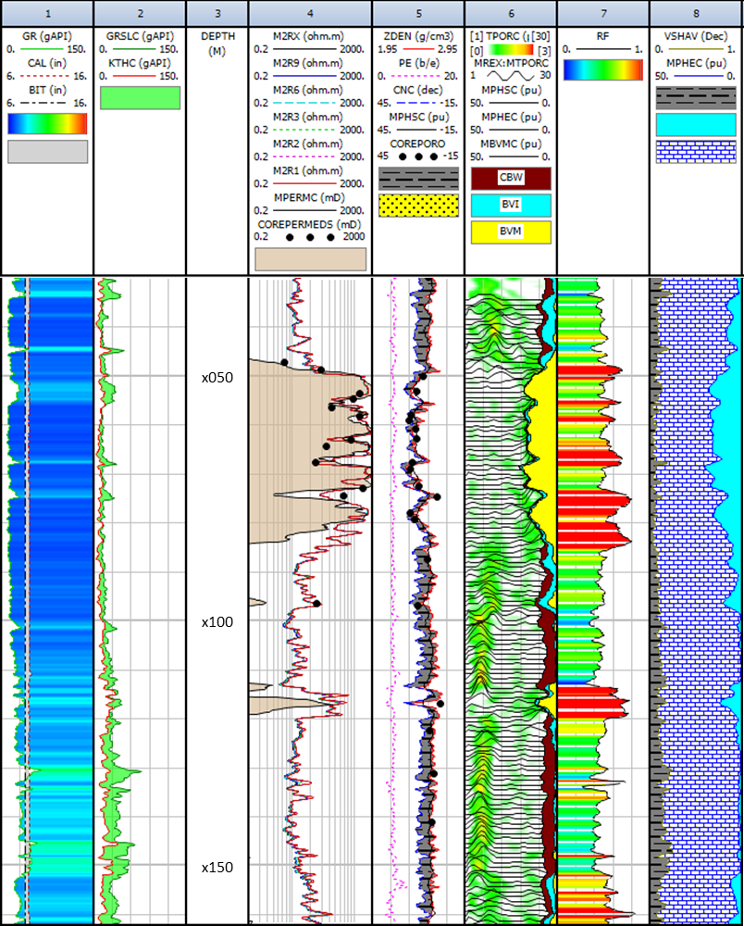

Figure 9. Geomechanical and petrophysical results and calibration.
The results in the interval between X046 and X084 shows an average porosity around 15 % and an average permeability around 700 mD, which suggests to have good fluid storage capacity and good flow capacity. The rest of the section do not present so good permeability properties favorable.
In terms of rock fracability, a mixture of high and medium values can be observed. However, due to the high permeability, it is not sense to stimulate mechanically and chemically this interval because the objective of this operation is precisely to improve permeability in non-permeable zones.
One good candidate for hydraulic stimulation and acidizing can be the interval between X112 and X120, which presents low permeability and an average porosity of 9%. Based on the NMR analysis, this interval seems to have free fluid. The high rock fracability range between 0.75 until 1.00 suggests to be a good candidate for stimulatoion.
Another interval to be evaluated is between X151and X161, which has high rock fracability superior to 0.78 with 7% on average porosity, including 3% average micro-porositynot free fluid. This interval could be suggested as potential candidate for hydraulic stimulation, depending of the fluid occupied inside the pore space.

Conclusions
The proposed methology suggest that mechanical and chemical stimulation in the carbonate pre-salt reservoir requires a geomechanical and petrophysical integrated study for selecting potential zones of stimulation by acidizing and fracturing.
The proposed methodology shows to be valuable no just unconventional reservoirs but can be extended to carbonate rocks.
Detail characterization of the natural fracture system is critical to evaluate open fractures systems, vuggs and caverns, so acoustic and resistivity images show to be valuable information as well.

Acknowledgments
The authors wish to thank and acknowledge Brazilian ANP (Petroleum National Agency) for granting access to use this data and for permission to publish the results of this study and Baker Hughes for all the support to execute this interpretation.
References

BALME, M.R., ROCCHI, V., JONES, C., SAMMONDS, P.R., MEREDITH, P.G., BOON, S., (2004). Fracture toughness measurements on igneous rocks using a high-pressure, high-temperature rock fracture mechanism cell. Journal of Volcanology and Geothermal Research, Volume 132, Issues 2-3, pp. 159-172.

BELYADI, H., FATHI, E., BELYADI, F. (2017). Hydraulic fracturability in unconventional reservoirs. Gulf Professional Publishing. Oxford, UK. 421p.

CONTRERAS, J., ZÜHLKE, R., BOWMAN, S. and BECHSÄDT, T. (2010). “Seismic stratigraphy and subsidence analysis of the southern Brazilian margin (Campos, Santos and Pelotas basins)”. Marine and Petroleum Geology, V27, Issue 9, 1952-1980, October 2010.

FATAH, T. Y. A., RABE, C., SALAZAR, J. P.; RECHDEN FILHO, R. C., (2016), “Estimating Brittleness Index Using Mineralogy and TOC in the Whangai Formation, New Zealand”, Paper IBP1956_16, Rio Oil & Gas Expo and Conference, 24-27 October.

HUCKA, V., DAS, B., “Brittleness determination of rocks by different methods”. Int. J. Rock Mech. Min. Sci. & Geomech. Abstr. 11: 389-92, 1974.

RABE, C., SALAZAR, J.P., RECHDEN F., DELLA-PASQUA, F., STAEL, G., PIERANTONI, L. (2021). Brittleness modeling selects optimum stimulation zone in shale source rocks in the Whangai Formation, New Zealand. AAPG Bulletin 105(2):329-355

SALAZAR, J.P. and ROMERO, P. (2001). “NMR measurements in carbonate samples and core-log correlation using artifitial neural nets”. SPE Annual Technical Conference and Exhibition, SPE-71701-MS. September 30 – October 3, 2001.

RICKMAN, R., MULLEN, M., PETRE, E., GRIESER, B. and KUNDERT, D., (2008). “A practical use of shale petrophysics for stimulation design optimization: All shale plays are nor clones of the Barnett Shale”. SPE 115258, Proc. Ann. Tech. Conf., Denver, Co.

SALAZAR., J. P.; RABE, C. and RECHDEN FILHO, R. C. (2017). “Some Effects of Petrophysics and Geomechanics in Unconventional Reservoir Stimulation, New Zealand”. Paper UR38 First EAGE/AMGP/AMGE Latin-American Seminar in Unconventional Resources, 23-24 November, Mexico City, Mexico, 2017.

YUAN, J., LIU, S., FENG, Y., DENG, J., XIE, Q., LU, Z., (2017). An improved fracability-evaluation method for shale reservoir based on new fracture toughness-prediction models. SPE Journal 22 (5).

ZOBACK, M.,D., (2010)Reservoir Geomechanics, Cambridge University Press, 1st Edition, 2010.

