**Deblending of simultaneous source acquisition using Iterative Source Separation with Priors for Deep-water OBN in Santos Basin, offshore Brazil**

Mohammad Ghazey, Mahmoud Ahmed, Dmitri Skorinski, Atef Khalifa, Marcela Ortin, Rajiv Kumar, Yousif Kamil, (SLB).

Copyright 2023, SBGf - Sociedade Brasileira de Geofísica

This paper was prepared for presentation during the 18th International Congress of the Brazilian Geophysical Society held in Rio de Janeiro, Brazil, 16-19 October 2023.

Contents of this paper were reviewed by the Technical Committee of the 18th International Congress of the Brazilian Geophysical Society and do not necessarily represent any position of the SBGf, its officers or members. Electronic reproduction or storage of any part of this paper for commercial purposes without the written consent of the Brazilian Geophysical Society is prohibited.

# Abstract

In deep water ocean-bottom nodes (OBN) surveys, simultaneous source acquisition has been proven to increase acquisition efficiency in terms of cost reduction, time saving and potential for increasing spatial sampling density. In this work we demonstrate how to successfully separate primary and interference energy in an OBN survey, in Santos Basin, offshore Brazil. This project was acquired with a single source vessel, with three gun-arrays, with a firing interval of 7 seconds and a pseudo random dither range of +/- 100 ms. To separate different shots, a multistage iterative source separation with priors framework was used. This framework progressively models the primary signal while eliminating the interference in a signal-safe manner.

# Introduction

In conventional acquisition, the time interval between two consecutive shots is the same as the maximum time required to record all the data to produce an appropriate image of the target. This timing together with the shot sampling are constraints to the acquisition. The combination of the two will result in the speed the source vessel must maintain during the acquisition, with a lower vessel speed requiring more time to acquire a certain number of shots. Therefore, if we relax the constraint on the time interval between shots, the acquisition becomes more efficient. Acquisition with simultaneous source shooting allows the time interval between shots to be minimized, with two or more shots recorded at the same time. The blended shots are separated later in the early pre-processing steps, where primary shot (N) is separated from previous interfering shots (N-k) and next interfering shots (N+k) using deblending techniques, where k can be any number of shots.

The separation of simultaneous source acquisition is usually done in the pre-processing stage with a conventional processing sequence thereafter. Separation can be performed in different ways, with some requiring certain acquisition specifications as the work of Beasley et al., 1998, which is based on spatially separated sources.

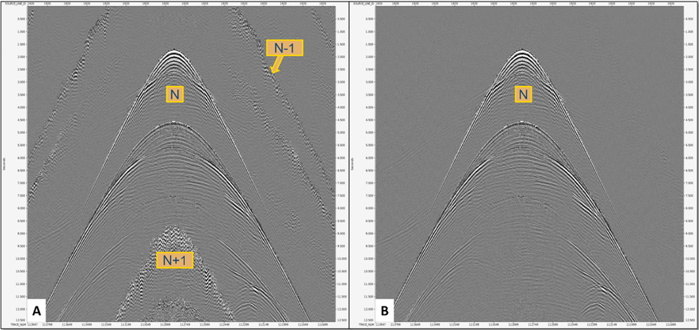

***Figure 1:*** *receiver domain P component* *gather in* ***(A)*** *raw, where previous shot (N-1) and next shot (N+1) interfere with primary shot (N).* ***(B)*** *shows only the primary shot (N) after shot separation using ISSP.*

Another common way to separate interference shots is based on the difference of delay times between interfering sources (Lynn et al., 1987). When collecting traces into a domain that includes many firings of each source, the signal from a particular source will appear as coherent while signals from the other sources will appear as incoherent. Therefore, we can use coherency as a separation criterion (Stefani et al. (2007); Moore et al. (2008)). In practical acquisition scenarios, such as the one presented in this paper, the acquisition design is suboptimal; thus, resulting in clustered strong interference noise on top of weak signal, commonly known as strong-over-weak phenomenon. In this scenario, coherency-based criteria alone are not enough to produce optimal source separation results (Kumar et al., 2023). To stabilize source separation, we propose the use of the multistage iterative source separation with priors (MS-ISSP) framework (Kamil et al., 2021, Kumar et al., 2023) where the idea is to perform source separation in multiple stages starting with the strongest signal present in the data. Moreover, in each stage we incorporate various suites of physics-driven priors, which enhances the coherency of the signal in the transform domain. Using real data from deep-water ocean-bottom nodes in Santos Basin, offshore Brazil, we demonstrate the efficacy of MS-ISSP in dealing with sub-optimal acquisition while performing the source-separation.

# Method

The multi-stage iterative source separation and processing (MS-ISSP) technique is distinguished by its ability to handle sparse data, operate in an iterative mode, and incorporate priors. This technique is organized into multiple stages, each stage focuses on iteratively separating one mode of the source-separated signals, starting with the strongest coherent mode and followed by weaker ones. In each stage, a unique set of priors is employed to enhance the corresponding signal mode, such as employing different moveout correction techniques to mitigate interference noise.

In the initial stage, prior information is applied iteratively to enhance the strongest signal mode in the presence of interference noise. The process commences with an initial estimate of deblended data, which may be initialized as zero. The deblended signal model is then multiplied by the blending matrix to explain the current data estimation. This estimation is subtracted from the input data, resulting in a residual. The residual is subsequently realigned with the source and scaled by a step length factor to facilitate convergence. The scaled residual is then added to the current deblended model. Stage-dependent prior information is applied to this result before transforming it into a sparsity-promoting domain, followed by thresholding using the exponential thresholding operator. The outcome of the thresholding operation is then converted back to its original domain, where the prior information is removed, representing the updated deblended signal estimate. The threshold value is progressively decreased in each iteration using a continuation fashion approach. The number of iterations is controlled by an amplitude stopping criteria; after each iteration, the residual RMS amplitudes are calculated and compared to the RMS amplitudes of the previous iteration, if the values are higher than the threshold value, more iterations will be conducted until this difference become less than the threshold value. At the end of the first stage, an estimate of the signal model for the targeted mode of interest is obtained by multiplying it with the blending matrix. This estimation is utilized to derive the interference model. Both the signal mode and interference models for this stage are subtracted from the input data, resulting in a residual that serves as the input signal for the subsequent stage. In the subsequent stage, the objective is to deblend the second strongest signal mode present in the data. Priors specifically designed to enhance the coherency of this mode in the transformed domain are applied. Similar iterations to the first stage are performed, where a stage-dependent prior is employed at each iteration.

Upon completion of all stages, the final deblending estimate is obtained by summing the signal mode estimates from different stages, resulting in a comprehensive deblending outcome. For further insights into MS-ISSP technology, interested readers are encouraged to explore the works of Kamil et al. (2021) and Kumar et al. (2021).

**Case study**

This survey was acquired with OBN technology using 3000 nodes and a total area of ~1000 km2 located in the Santos basin, offshore Brazil, where the water bottom depth ranges around 2 km. The acquisition configuration consists of one vessel with triple sources and a flip-flap-flop shooting pattern. Sources are 50 m apart from each other with a shot point interval of 16.67 m. The minimum time between two consecutive shots (intershot) is seven (7) seconds with random dithering of +/- 100 ms.

Input data to deblending were prepared through different steps including sorting data to common receiver domain and validation of the GPS time header recorded in the field for primary and interfering sources. Another key factor for transform efficiency and integrity is data sampling, as it provides frequency splitting to the input data allowing the transform to work on a small range of frequencies each time, preventing any interaction between signals of different frequency ranges.

A multi-stage ISSP deblending technique was used to separate the interference shots from the primary shot the approach. The approach here uses a three-stage strategy where a linear moveout is applied at the first stage to iteratively extract the direct arrival. This is followed by using normal moveout correction to improve the sparsity of the reflection and refraction events and finally no moveout is used to deal with all other events such as diffraction energy. Figure 1-A (Left) shows an example of a receiver domain gather before MS-ISSP application, where pervious shots (N-1) and next shot (N+1) are interfering with the primary shot (N). Figure 1-B (Right) shows only the primary shot (N) after separation from interfering shots after MS-ISSP application.

This MS-ISSP methodology allows signal estimation to proceed step by step, helps to avoid over running iterations and preventing the occurrence of any washout zones.

MS-ISSP produced optimal source-separation results for deblending of different node components, including horizontal components such as X and Y (Figure 2). In Figure 2-A shows an example of a time-slice at 11 seconds for a single node with recordings from all sources for P, Z, Y and X components, respectively, from left to right. The next shot (non-coherent energy in the center of the node) and previous shot (randomized energy at the edge of the node) are interfering with the primary shot. Figure 2-B shows the same display after ISSP application, where the primary shot is now deblended and no interfering energy can be noticed. The difference before and after ISSP application is displayed in Figure 2-C.

# *Figure 2: Time-slice at 11 seconds for P, Z, Y and X components respectively from left to right for a single node. In (A) before MS-ISSP application, (B) after MS-ISSP application and in (C) the difference.*

The peak absolute amplitude QCs (Figure 3-A and 3-B) for P-component were performed over a full trace window as one of the global QCs for the full survey to ensure the integrity of the process. A huge reduction in amplitude level can be noticed in both maps and histogram distribution as a result of removing high amplitude interfering energy.

# Conclusions

Simultaneous source acquisition provides benefits when compared to conventional acquisition, such as shorter acquisition time and lower cost while maintaining the data quality, enabled by the algorithms that allow for the reliable separation of different shots during data processing.

***Figure 3:*** *Peak absolute amplitude map over full trace window (extracted from pre-migration stack volume)* ***(A)*** *before MS-ISSP application.* ***(B)*** *after MS-ISSP application.*

In this OBN case study in Santos basin, offshore Brazil, we have observed how iterative source separation with priors was able to separate the different shots even when the dither used during the acquisition was in the +/- 100 ms range, which limits the randomization of the interference signal in the shot taken as primary.

ISSP ran on the raw input data using a multistage technique to efficiently separate signals from one source from the interference from other sources. Each mode was targeted with a separate moveout option, which allows that particular mode to be more coherent and easily separated.

Different QCs in time and image domains were conducted to validate the integrity of the process, including shot gather, time stacks and depth migrations as various amplitude and frequency attributes in different windows of the aforementioned domains.

Not only the hydrophone and geophone components of this multicomponent dataset were separated successfully, but also the horizontal geophone components that record the converted waves were also well separated, as the presented QCs show.

# Acknowledgments

We thank SLB for the permission to publish this work and Petrobras, Shell and Petrogal for the authorization of using the data shown in this abstract.

**References**

Kumar, R., Kamil, Y., Bilsby, P., Narayan, A., Mahdad, A., Brouwer, W. G., ... & Watterson, P. (2023). “Inversion-based multistage seismic data processing with physics-driven priors.” The Leading Edge, 42(1), 52-60.

Amin, Yousif Izzeldin Kamil; Kumar, Rajiv; Mahdad, Araz; Bilsby, Phillip; Narayan, Anu; Gerrit Brouwer, Wouter; Misbah, Amr; Vassallo, Massimiliano. (2021). "Robust multistage separation of simultaneous sources using priors: Challenges and strategies" SEG/AAPG/SEPM First International Meeting for Applied Geoscience & Energy, 2021.

Moore, I., Dragoset, B., Ommundsen, T., Wilson, D., Ward, C., and Eke, D., [2008] Simultaneous source separation using dithered sources. SEG Technical Program Expanded Abstracts 2008: pp. 2806-2810.

Beasley, C., Chambers, R.E., and Jiang, Z., [1998] A new look at simultaneous sources. SEG Technical Program Expanded Abstracts 1998: pp. 133-135.