Quantitative Seismic Interpretation for Identification and Characterization of Diabase Intrusions in Gaviões Cluster Area, Parnaíba Basin.
Eduardo dos Reis Leaubon^{1,2}; Julio Cesar dos Santos Vital¹; Bruna Maia Imbuzeiro¹; Filipe Vidal Cunha Santa Rosa de Oliveira¹; Cleverson Guizan Silva¹; Wagner Moreira Lupinacci^{1,3}; Antonio Fernando Menezes Freire^{1,3}
¹Exploratory Interpretation and Reservoir Characterization Group (GIECAR)/Universidade Federal Fluminense (UFF)
²Regulatory Agency of Oil, Gas and Biofuel of Brazil (ANP)
³National Institute of Science and Technology of Petroleum Geophysics (INCFT-GP/CNPq)

Copyright 2023, SBGf - Sociedade Brasileira de Geofísica
This paper was prepared for presentation during the 18th International Congress of the Brazilian Geophysical Society held in Rio de Janeiro, Brazil, 16-19 October 2023.
Contents of this paper were reviewed by the Technical Committee of the 18th International Congress of the Brazilian Geophysical Society and do not necessarily represent any position of the SBGf, its officers or members. Electronic reproduction or storage of any part of this paper for commercial purposes without the written consent of the Brazilian Geophysical Society is prohibited.

Abstract
The Parnaíba Basin has been gaining great importance in the Brazilian gas market. Its atypical petroleum system is constrained by the maturation of source rocks induced by heat from magmatic intrusions. Therefore, understanding these intrusions is extremely important to comprehend the petroleum system of the Parnaíba Basin and other similar basins, such as Solimões, Amazonas and Paraná. This work aims to integrate data from different scales to infer the seismic characteristics of this evident seismic reflector of the basin, mainly in relation to its acoustic impedance properties, where previous studies have inferred variations in chemical and mineralogical composition in the sills. Through the analysis of XRF (X-Ray Fluorescence) and the detailed description of core samples from well 4-OGX-49-MA, UFF researchers identified four subzones within the main sill. These zones were classified from the top to the bottom as zones red, yellow, gray, and green, having distinct mineralogy and chemical composition, with intercalations between high- and low-density values from the top to the bottom caused by the "Barriguda" feature, present in the Parnaíba Main sill. By integrating seismic and petrophysical data with these previously established data, it was possible to identify that these zones are presented in seismic sections with intercalations in amplitude values caused by the strong acoustic impedance inside the sill, due to the density differences proved by mineralogy and geochemistry.

Introduction
The Parque dos Gaviões Complex, in the Parnaíba Basin, is currently the onshore region in Brazil that produces the most natural gas volume, behind only fields located in the Pre-Salt polygon (ANP, 2021). Located in the Parnaíba Basin, an intracratonic Paleozoic basin, its main exploratory target is hydrocarbons related to the presence of magmatic intrusions, as in practically all other Paleozoic basins in Brazil (Thomaz Filho et al., 2008). In the Parnaíba Basin, two magmatism events occurred, according to Aguiar (1971) and Trosdtorf Junior et al. (2014), generating variety when it comes to the geometry and geology of igneous bodies in sedimentary layers (Fig, 1). Such bodies forced gas generation when they intruded into the source rocks layers, originally immatures because of the Parnaíba Basin is a relatively shallow basin. At the same time, by forcing gas generation due to their high temperatures, diabase sills, through jumps, formed structural highs that trapped the gas (Trosdtorf Junior et al., 2014) in the porous sand layers of the Mesodevonian-Eocarboniferous sequence, thus creating what is known, according to Miranda (2018), as an atypical petroleum system (Fig. 1).
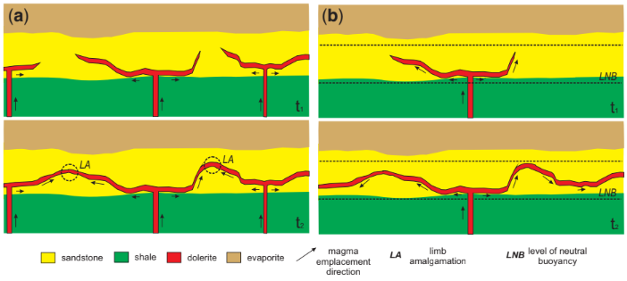
Figure 1: Geological Scheme of Magmatic Intrusions in Paleozoic Intracratonic Basins in NE Brazil.
Several advances in knowledge regarding intrusions and the technologies used for their imaging and identification in the subsurface have been developed over the years, intensifying even more since the past decade with the expansion of interest in frontier basins. For example, Trosdtorf Junior et al. (2014) and Imbuzeiro (2021, 2023) used digital well logs to identify igneous bodies in the Parnaíba Basin, which present characteristic and variable behavior along the sills. The Brazilian National Agency of Petroleum, Natural Gas, and Biofuels (ANP) has also developed regional seismic acquisition campaigns to identify igneous bodies on a large scale, making such data public. Eneva Gás Natural has also been the main company in the region regarding the bidding of blocks, seismic acquisition and interpretation projects, drilling of new wells, and generation of electric power through natural gas. To assist in the identification of these igneous bodies, we interpreted the 2D post-stack (0303_2D_PEDREIRAS and 0303_PN_FAZ_ SANTA_ VITORIA) seismic data in conjunction with other geological data such as digital well logs and geochemical analyzes of drilling cutting samples from the wells 4-OGX-49-MA and 3-PGN-5-MA for seismic characterization of the main Sill in the region. All these data were evaluated in the Gaviões Cluster area, illustrated in Figure 2.

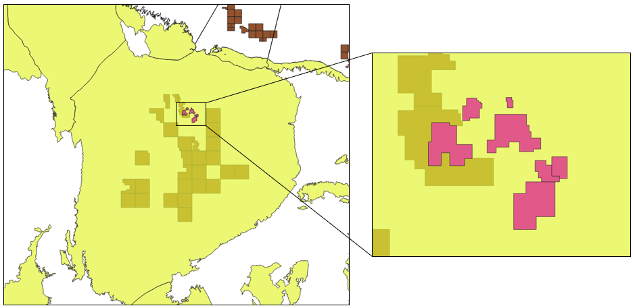
Figure 2: Parnaíba Basin with plateau area of interest (Cluster dos Gaviões).

Seismic Frequency Spectrum Analysis and Tunning Thickness Calculation
Before integrating seismic, petrophysical, and rock data, we performed a seismic resolution analysis to identify whether we have the necessary resolution for upscaling. The method that best suited our work was the Tuning Thickness method proposed by Widess (1973). The dominant frequency was calculated multiplying the peak frequency of the seismic data by 1.3 (Figure 3). Additionally, we extracted the P-wave velocity data from well 4-OGX-49-MA within the diabase intrusion interval and calculated their average to obtain the wavelength, which is calculated as the ratio of the average P-wave velocity to the dominant frequency [λ (Wavelength) = VP Average / Fd]. Finally, we calculated the Tuning Thickness which is simply the λ/4, which resulted in a value of 80.31 meters (Table 1). This tuning thickness value is sufficient to relate the seismic data and well electrofacies, and even indirectly with geochemical/mineralogical data, making possible the final integrated upscaling.
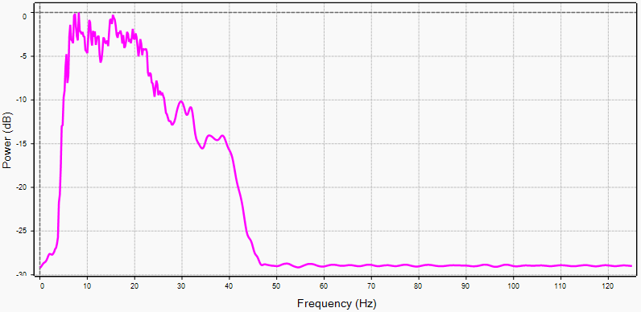
Figure 3: Frequency spectrum analysis of R0303-0047 seismic for data integration.
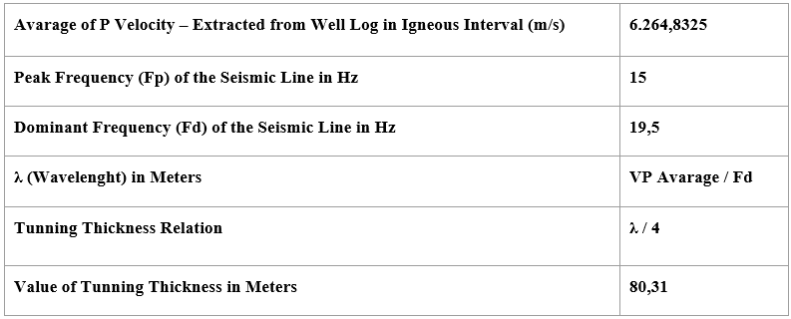
Table 1: Tunning thickness value in meters from previously obtained, calculated and analyzed values.

Well Log Analysis and Eletrofacies Classification
After applying such methodologies to the seismic data, a geophysical analysis of the well logs was performed. The well 4-OGX-49-MA was delimited only in the Main sill interval for its petrophysical characterization. By extracting data from the RHOZ, PEFZ, DTCO, and GR curves, a spreadsheet was created as a database for manipulating log values. From the sonic log curve, P-wave velocities were estimated, which, multiplied by the density profile, gave rise to the Acoustic Impedance log. In addition, some spikes that did not match the real data values were also eliminated.
After performing quality control on the database, the values of the logs were separated into three seismic zones based on geological and geochemical analysis pre-established by Imbuzeiro (2021, 2023). These zones were established qualitatively, using XRF, well logs and seismic analyses.
Zone 1: At the top of the Main sill, moderate values of all elements indicate a zone without mineralogical variation, associated with plagioclase and pyroxenes/amphiboles.
Zone 2: In the Barriguda feature, where the GR increases and the density decreases, is observed a incompatible elements crystallization interval, marked by the increase of Potassium (K), Rubidium (Rb), Phosphorus (P), Yttrium (Y) and Zirconium (Zr) values.
Zone 3: Marked by high RHOZ values, with higher concentration of Iron (Fe) and Titanium (Ti), suggesting the occurrence of magnetite and ilmenite. And the Zone Rich in Magnesium (Mg), associated with magnesian olivine at the base of the sill.
Once the database was organized, the spreadsheet file was applied in a Python script developed for statistical analysis. Through the code, it was possible to create probability histograms for each chosen log of well 4-OGX-49-MA and analyze their electrofacies, as well as make the necessary petrophysical interpretations as seen in the histograms below (Fig. 4).
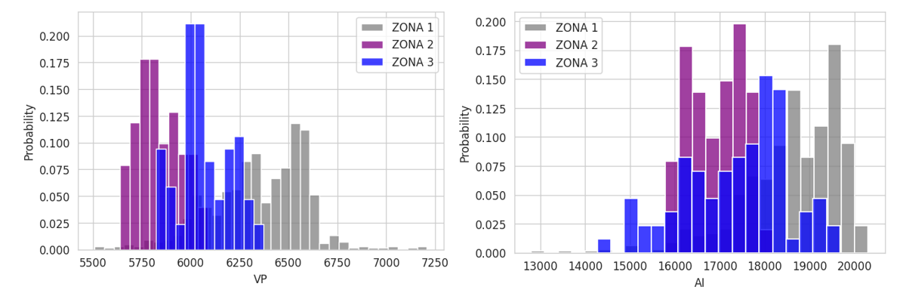
Figure 4: Histograms of VP e AI for 4-OGX-49-MA Well separated by interpreted zones.
Seismic Well Tie and Initial Integration of Data
After processing both seismic and well log data and partially identifying the horizons that represent the Main sill in the seismic, we moved on to the step of well-seismic tie to correlate digital and geochemical curves with seismic and attempt to expand such information to a regional scale of the basin through seismic lines. In Figure 5, we see the seismic well tie window of well 4-OGX-49-MA, with the curves of gamma ray, sonic, density, acoustic impedance, and reflectivity coefficient, respectively. This well had VSP data, that is, the checkshot, which made the tie more reliable and facilitated the process. We can also see the wavelet chosen for the convolution of the reflectivity coefficient and the generation of the synthetic seismogram from the well data. The green horizontal lines represent the anchors that performed the necessary lengthening’s for the tie between the synthetic and seismic data.
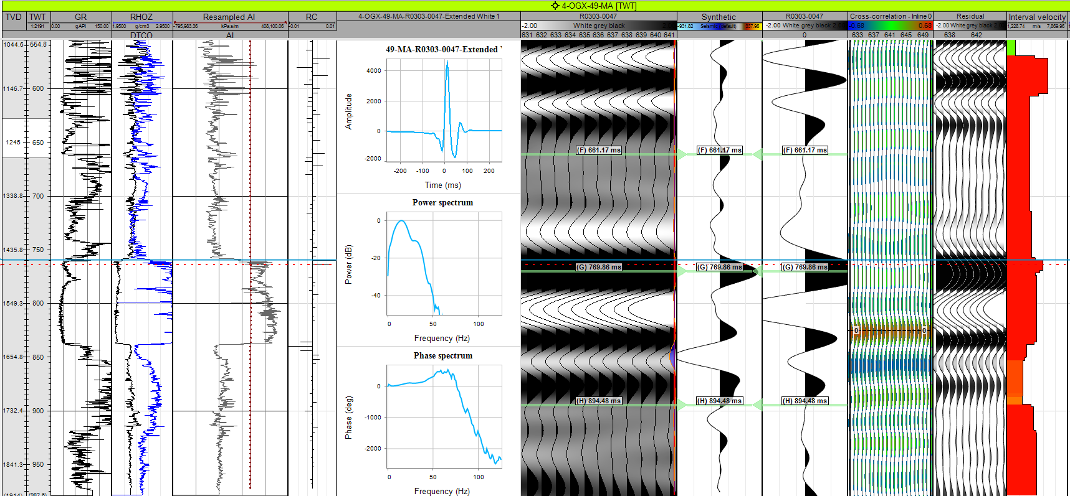
Figure 5: Seismic Well Tie window of 4-OGX-49-MA Well with seismic R0303-0047.
The method used for the tie was the trial and error method, which consists of the following steps: depth-time conversion and sonic calibration, creation of the acoustic impedance log through sonic and density, estimation of the amplitude spectrum, and obtaining the zero-phase wavelet, generation of the synthetic through the convolution of the wavelet with the RC extracted from the acoustic impedance log, correlation of the synthetic trace with the seismic trace, and applying the displacement between the sections where it is desired to correlate the synthetic and the seismic data.
Qualitative Interpretation and Seismic Colored Inversion
After tying the well to the seismic data, a qualitative manual interpretation of the sill horizons was performed, from now on with much more confidence than interpretations that could have been made prior to seismic-well tie. From the logs plotted along with the well 4-OGX-49-MA in the seismic data, the extension of the Main sill was identified, as shown in Figure 6, with the horizons found through the seismic-well tie propagated through the intersection between seismic lines. The red horizons represent the top of the Main diabase sill in the region, and the purple horizons represent the sill base (Fig. 6).
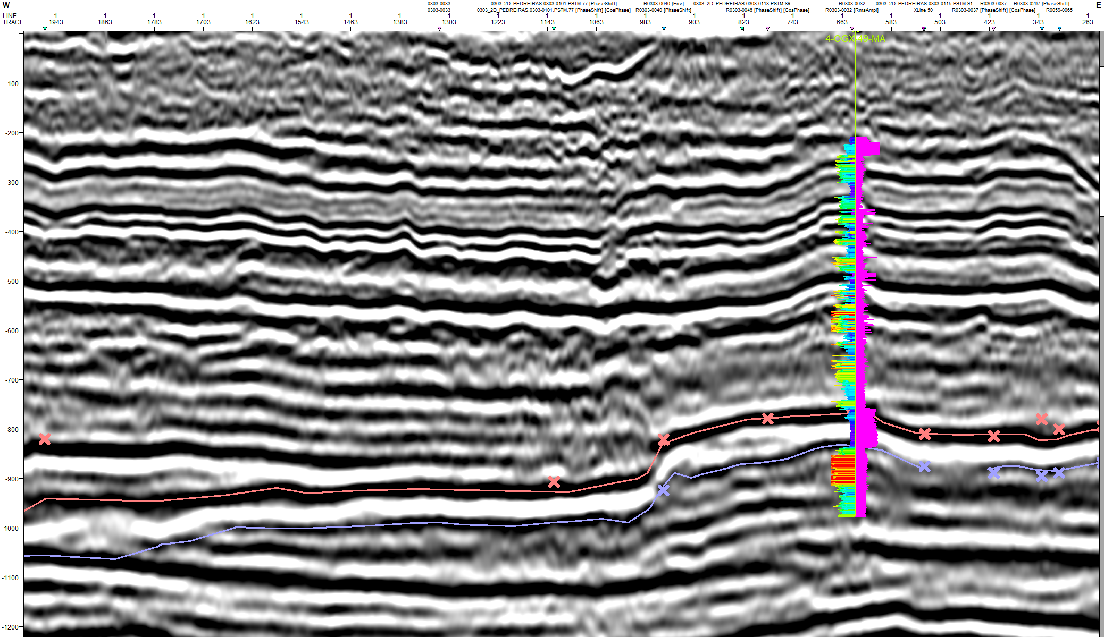
Figure 6: Seismic section R0303-0047 interpretated and the well 4-OGX-49-MA logs of GR and AI (purple).
The color seismic inversion is achieved through deconvolution of the data and input of the acoustic impedance from the well tied into the section. In Figure 7, we can see the Colored Inversion result applied to section R0303-0047, with the corresponding interpolated layers and relative acoustic impedance values. At the top of the Main sill (green peak, indicating AI values of 10,000 to 12,500), the internal differentiation of acoustic impedance, with varying shades of green, orange, and yellow (i.e., ranging from 5,000 to 10,000 AI), suggests the internal geochemical/mineralogical zones within the sill. The same can be seen at the base, where the relative acoustic impedance contrasts ranges from blue (higher density, due to a higher concentration of ferromagnesian minerals) to purple (showing the direct contrast with the sedimentary layer), i.e., ranging from -10,000 to -5,000 AI.
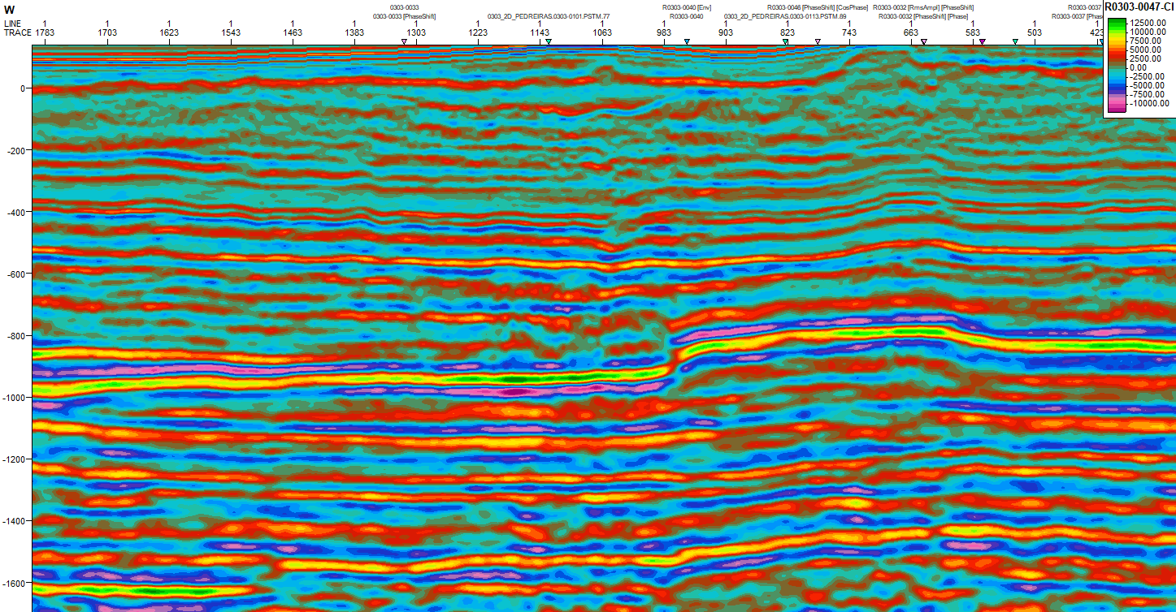
Figure 7: Seismic Section R0303-0047 with colored inversion applied. The hot colors represent the higher values of AI and cold colors represents lower values of AI.

Surfaces and Final Integration of Data
After interpreting the entire seismic dataset, we created the structural maps representing the top and base of the sill (Figure 8) The horizons interpretation and grid interpolation, using the nearest neighbors, was done with the Petrel software. The interpolated surfaces are represented in time (TWT). The production fields in Parque dos Gaviões Cluster (white polygons in figure 8) are located at higher areas of both top and bottom of the sills, indicating the sill’s jumps to upper sedimentary intervals. Therefore, they are the regions of highest exploratory interest in the basin, with the highest concentration of wells.
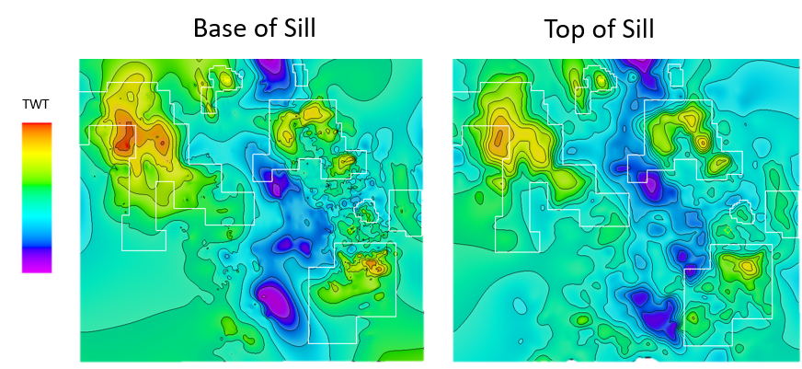
Figure 8: Base and Top of Sill surfaces in TWT, with hot colors representing higher areas and cold colors representing deeper areas. White polygons represent the Parque dos Gaviões Cluster.
Finally, it was also possible to qualitatively integrate all the interpreted data (geochemical/mineralogical zones, logs, and seismic), upscaling from the mineralogical/geochemical data from the well 3-PGN-5-MA to the macro scale regional 2D seismic (Fig. 9).
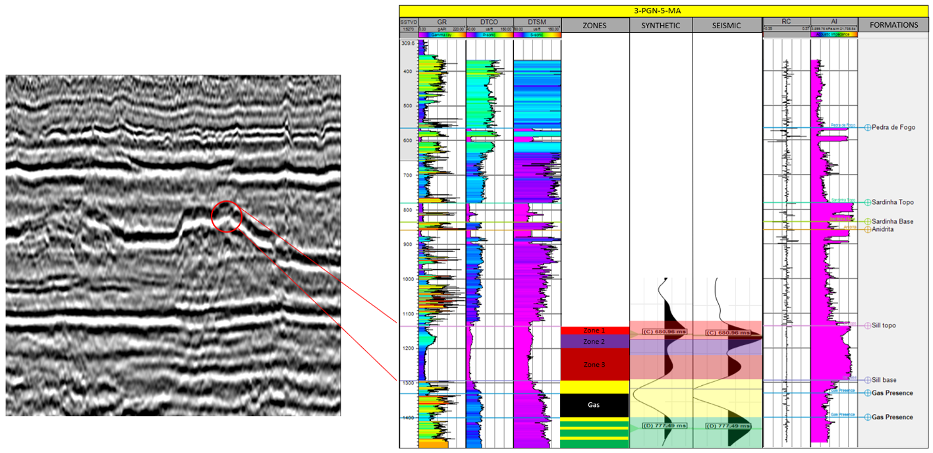
Figure 9: Final correlation between geochemical, geological, and geophysical data, focusing in the well 3-PGN-5-MA results.

Conclusions
Following the proposed workflow, it was possible to conclude that although the integration of data for the identification and characterization of the Main sill could be compromised due to the upscaling that would be necessary from geochemical data to the seismic scale, several pieces of information could be obtained from it with the help of well-seismic tie, petrophysical and facies analysis, and even attribute application. Thus, the internal differentiation of the Main sill in the Parque dos Gaviões area was identified through the three methods facilitating regional interpretation and bringing higher reliability in relation to the identification and characterization of diabase sills.

Acknowledgments
Acknowledgment to the G&G group at the Geological Assessment Superintendence (ANP) for all the assistance provided, for granting access to the REATE data and for all the knowledge that has been passed on to me until today. To the members of GIECAR and my advisor for all the support and guidance. Petrobrás, which funded the project, and Eneva for providing the cuttings samples. The authors also thanks the National Institute of Science and Technology of Petroleum Geophysics (INCFT-GP/CNPq).

References.
ANP. Boletim da Produção de Petróleo e Gás Natural. 2021.
AGUIAR, F. G. Revisão geológica da bacia paleozóica do Parnaíba. In: Congresso Brasileiro de Geologia. 1971.
DE MIRANDA, Frederico S. et al. Atypical igneous-sedimentary petroleum systems of the Parnaíba Basin, Brazil: seismic, well logs and cores. Geological Society, London, Special Publications, v. 472, n. 1, p. 341-360, 2018.
IMBUZEIRO, Bruna M. et al. CARACTERIZAÇÃO DE ELETROFACIES E QUIMIOFACIES EM SOLEIRAS DE DIABÁSIO DA BACIA DO PARNAÍBA, Departamento de Geologia e Geofísica 2021.
THOMAZ FILHO, A., MIZUSAKI, A. M. P., ANTONIOLI, L. Magmatismo nas Bacias Sedimentares e sua Influência na Geologia do Petróleo. Revista Brasileira de Geociências, v.38, n.15, p. 128-137, 2008.
TROSDTORF, I. J, MORAIS NETO, J. M., SANTOS, S. F. & PORTELA FILHO, C. V., Diques e soleiras na Bacia do Parnaíba: geometria e padrões de alojamento. B. Geociências. Petrobras, Rio de Janeiro, v. 22, n. 2, p. 261-287, 2014.
WIDESS, M. B. How thin is a thin bed?. Geophysics, v. 38, n. 6, p. 1176-1180, 1973.

